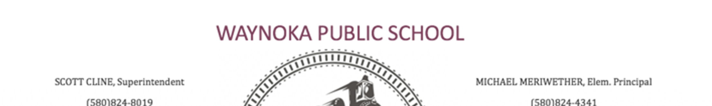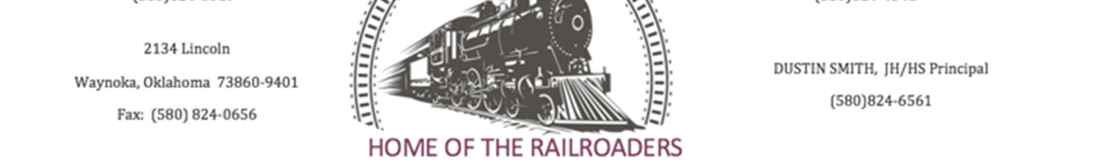
Waynoka Board of Education Regular Meeting
Monday, November 5, 2018 6:00 PM
Waynoka Board of Education Room
2142 Lincoln Street
Waynoka, OK 73860

- Determination of quorum and call to order

- Statement of Open Meeting Law

3. Roll call of members

- All of the following items will be approved by one vote unless any board member desires to have a separate vote on any or all of these items. The consent agenda consists of the discussion, consideration, and approval of the following items:

4.A. Minutes of previous meeting(s)

4.B. General Fund Report

4.C. Building Fund Report

4.D. Activity Fund Report

4.E. Child Nutrition Fund Report

4.F. Bond Fund #31 Report

4.G. Bond Fund #32 Report

4.H. General Fund Encumbrances

4.I. Building Fund Encumbrances

4.J. Child Nutrition Fund Encumbrances

4.K. Bond Fund #31 Encumbrances

4.L. Change Orders

5. Other Reports
A. Superintendent
B. Principal
- Presentation of annual dropout and college remediation report for the 2017-2018 school year

- Discussion and possible action to enter into a contract for the installation of above ground storm shelters at school housing

- Vote to approve or not to approve to adopt and or amend Board Policies

8.A. CBB Policy forbidding The Supplanting Of Federal Funds And Grant Monies For Local Revenue

8.B. CBBA Grant Policies and Procedures

8.C. CBBB Internal Controls

8.D. CLB Equipment Accountability

8.E. COB Procurement

8.F. COB-R Procurement (Regulation)

8.G. DAAC Federal Programs Complaint Resolution

8.H. DBD Conflicts Of Interest

8.I. DDC Employee Resignations And Reference Requests

8.J. DPAO Director Of Federal Programs

8.K. EHBH Alternative Education

8.L. FD Student Residency

8.M. FD-P Student Residency Dispute Procedures

8.N. FDAH Education Of Migratory Children

8.O. FFACD NEW 2018 Medical Marijuana

9. Vote to approve or not to approve fund raiser requests for 2018-2019 school year
1. Band

10. Proposed executive session to discuss the following personnel decisions in compliance with 25 O.S. 307 (B)(1)
1. Resignations received to date
2. Discuss extra duty pay schedule for the 2018-2019 school year

- Vote to convene in executive session

- Acknowledge the board has returned to open session

- Executive Session Minutes Compliance Announcement

- Vote to approve or not to approve resignations received to date

- Vote to approve or not to approve extra duty pay schedule for the 2018-2019 school year

16. New Business

17. Vote to adjourn

This agenda was posted on the window of the entrance to Waynoka Public Schools (west door)

Name of person posting this Notice: _______________________________

Date: _____________________. Time: __________________________

If you need any special assistance to enter the premises or if you need any special considerations for any portion of this meeting, please call 580-824-8019 at least 10 hours prior to the start of the meeting.

