Spin Club

Where you Learn to Twirl and Spin Flags

With Ella Fegley

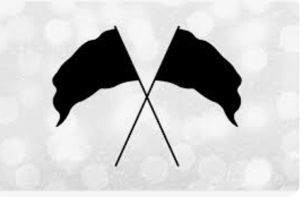

What: Spin Club

When: Every Thursday in January and February

from 4-4:45

(1/5,1/12,1/19,1/26,2/2.2/9,2/16)

Where: Concord Middle Auxiliary Gym

Who: 6th, 7th, 8th grade students interested.

(Limited to 15 students, first come first serve basis)

Hosted by Ella Fegley (Concord High student)

Sponsored by Laurie Taylor (IB Coordinator) and Veronica Hulin (ElA Reach Coach)

---------------------------------------------------------------------------------------------------

I give My student, ______________________________________________

permission to attend this club. I understand that I must

provide transportation for pick up promptly at 4:45. I also

understand that if the student is late two times they will not

continue participating.

_____________________________________ ____________________________

Parent/Guardian Signature Contact Number