Have you ever had an interest in the tabletop roleplaying game Dungeons and Dragons?
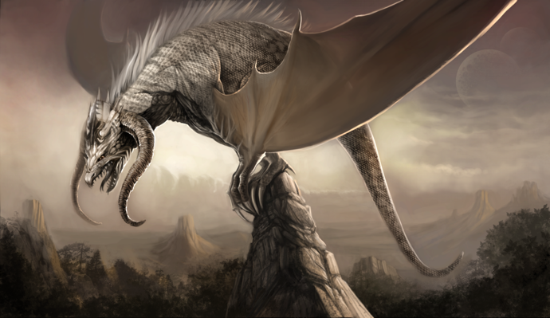

What: Dungeons and Dragons

When: Every Tuesday in January and February
from 4-4:45
(1/10,1/17,1/24.1/31,2/6.2/13,)

Where: Concord Middle Media Center

Who: 6th, 7th, 8th grade students interested.
(Limited to 8 students, first come first serve basis)

Hosted by Desmond Monte (Concord High Sophomore)
Sponsored by Laurie Taylor (IB Coordinator)

---------------------------------------------------------------------------------------------------

I give My student, ______________________________________________

permission to attend this club. I understand that I must

provide transportation for pick up promptly at 4:45. I also

understand that if the student is late two times they will not

continue participating.

_____________________________________ ____________________________
Parent/Guardian Signature Contact Number

