cO nl r-=1

.:r
  - Postal ServicerM

CERTIFIED MAILM RECEIPT
(Domestic Mail Only; No Insurance Coverage Provided)

r-=1
Certified Fee

D Return Receipt Fee
D (Endorsement Required)
D r--------T
Restricted Delivery Fee
0 (Endorsement Required)

nl r--------- --1'
..ll Total Postage & Fees $ ----
:2._ !

/
c)
/

ru -------- s
rc:::----- Rev. James Pauley ·

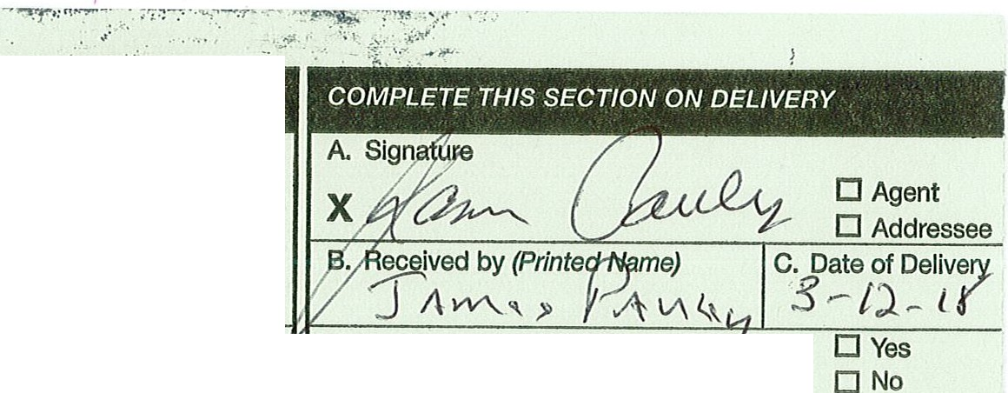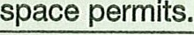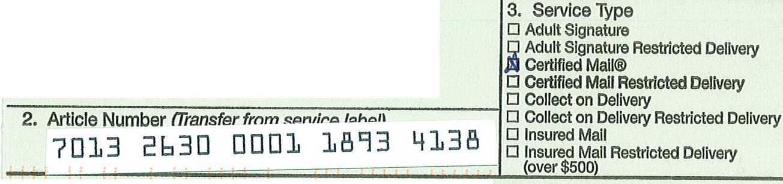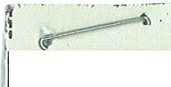ITl r-=1 D 1"'-
h,,_,,- ·-·=-····=-·:------· Faith Christian Academy

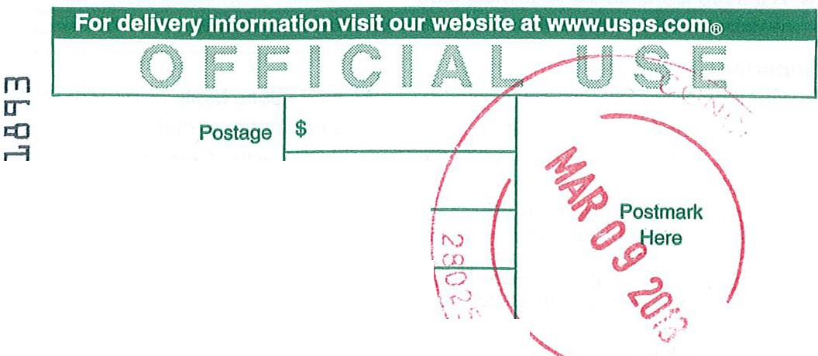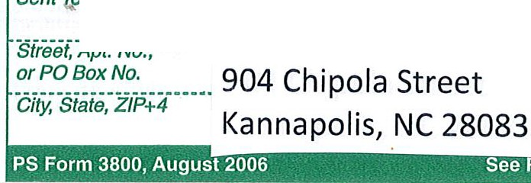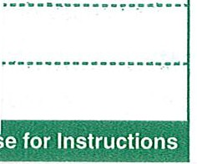SENDER: COMPLETE THIS SECTION

    - Complete items 1;2 - 'Jt3.
    - Print your name and addfess on the reverse so that we can return the card to you.
    - Attach this card to the back of the mailpiece,
or on the front if
- Artic le Addressed to:
Kev. James Pauley
Faiti'J Christian Academy
904 Chipofa Street
Kannapolis, NC 28083

111111111 11111111II 1111111111111 111111 11111111
9590 9402 2292 6225 2453 33

• PS Form 3811, July 2015 PSN 7530-02-000-9053

D. Is delivery address different from · 1?
If YES, enter delivery address below:

0 Priority Mail Express®
0 Registered MaiiTM
0 Registered Mall Restricted Delivery
Cl Return Receipt for
Merchandise
0 Signature ConfirmationTM
0 Signature Confirmation
Restricted Delivery 1
Domestic Return Receipt

••

