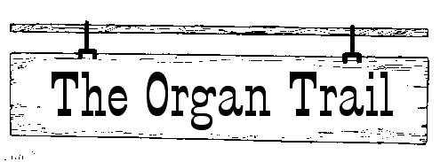
Grab yer hat and saddle the broncs!
Tis time to head down the Organ Trail on a little adventure!

Your job for this journey is to gather all the information you can about your organ. At the end of this cybertrail, you will need to whip up a wanted poster to share your finds with the other cowboys and cowgirls in your camp.

Gather Your Facts!
At the end of this journey, you will need to know (and answer on the back of the wanted poster) the following:
- Which organ system contains your organ?
- What are the organ's main functions?
- How does your organ works with other systems to keep the body healthy?
- Which diseases or disorders affects your organ?
- Can a person live without your organ?
Trail Sites
Visit the Health page of the Kid Zone at http://kidshealth.org/kid/htbw/htbw_main_page.html for sites that will help with your project!
The Roundup
Share the information you have discovered by completing a Wanted poster. Go to http://sciencespot.net/Media/otwntdposter.pdf for a copy if you misplaced the one attached.
The poster should include a picture of your organ and the information
outlined in the "Gather Your Information" section.

