Assess Teach Learn

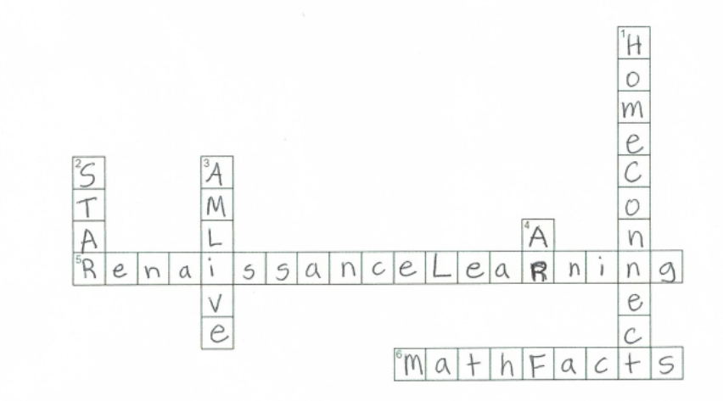

Assess
Teach
Learn

Assess

- STAR Early Literacy
  - Who takes? When?

- STAR Reading
  - Who takes? When?

- STAR Math
  - Who takes? When?

- What do we do with the data?

- Who do we share it with?

- How do we use it to improve student learning?

Teach

- Core Progress (Learning Progression)
  - What is it?

  - How do we use to help plan instruction?

- Core Progress
  - Common Core State Standards
    - Skills
      - Vocabulary
      - ELL Support
      - Conceptual knowledge
      - Skill probes
      - Teacher Activities
      - Performance Tasks
      - Khan Academy Videos
      - Worked examples

- Record Books
  - Where are my students in the learning progression?

  - How can I differentiate instruction?

  - How can I scaffold instruction to assess prior knowledge or for intervention?

  - What’s the purpose of each of the instructional tools? How will I use these?

Learn

- Accelerated Reader
  - When do students practice reading? How much should they practice and at what level?

  - How will students transfer skills and apply strategies while they are reading?

  - How will teachers manage practice? Which reports will they review?

- AM Live
  - When do students practice math? What math objectives and how many?

  - How will students practice? Online or paper?

  - How will teachers manage practice? Which reports will they review?

- Math Facts in a Flash
  - When do students practice their math facts? What levels and what time goals?

  - What are our benchmark levels and by when?

  - Where will students practice? iPads, Responders, Computer lab

  - How will teachers manage practice? Which reports will they review?

Back cover:
How will we motivate, recognize, and praise students for their efforts?

