Cleveland County School District is currently looking for a Jr & Sr Girls Basketball
Coach. Must be licensed in Health and P.E. Having a license in Middle School Social Studies is a plus. Please fill out the application and return it to the office at the High School.
Cleveland County School District is currently looking for a 7-12 Art Teacher. If interested, please contact Davy King at 870-325-6241 or Johnnie Johnson at 870-325-6344.
Cleveland County School District is currently looking for two Maintenance Department Employees. Please fill out the application and return it to the Central Admin Office.

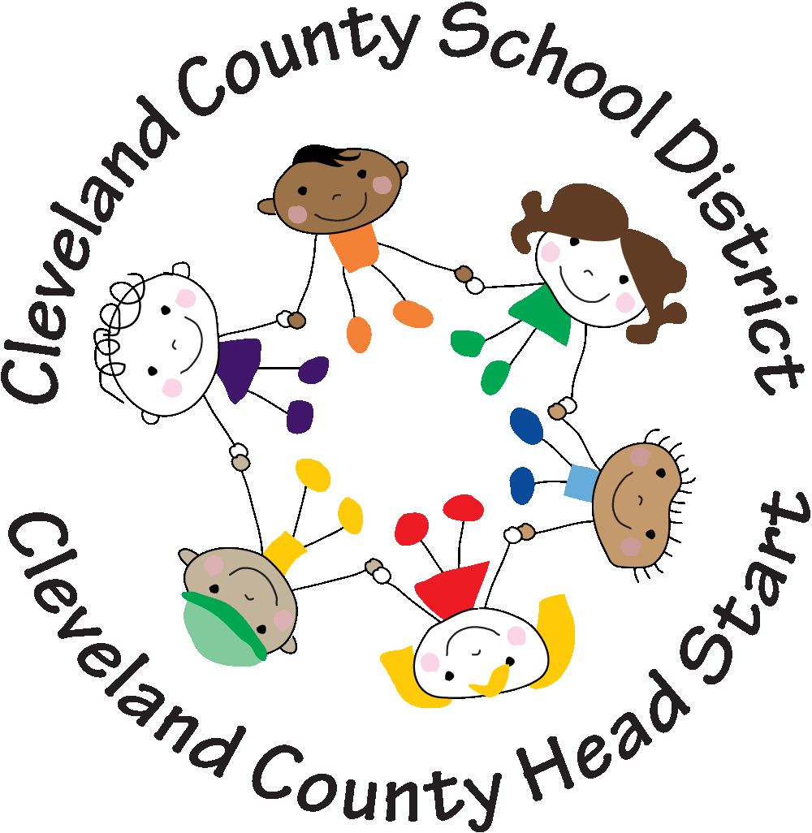

CENTER DIRECTOR
The Cleveland County School District is accepting applications for Center Director for our Woodlawn Center Head Start/Early Head Start Program. Applicant must be twenty-one years of age or older, have a Bachelor’s Degree or higher degree in Early Childhood Education or a related field. Applicant must meet the requirements set forth by the AR Minimum Licensing Requirements and Head Start standards for a Center Director. Applicants must possess an authentic love and appreciation of children with eagerness to learn about child development and quality interactions. The applicant will be required to meet all minimum licensing standards, including but not limited to a background and child maltreatment check. All Applications are being accepted at the Rison Head Start Central Office, 700 Main St Rison, AR until position is filled. Applications are available to download at http://ccsdheadstart.org. For questions please email laura.burns@ccs1.org No phone calls please.

