http://www.mapquest.com/maps/map.adp?latlongtype=internal&addtohistory=&latitude=E9sCxnKCRzNqqQjkqtnB%2fQ%3d%3d&longitude=x8M0m%2fimxjH190juaixn1Q%3d%3d&name=Arcadia%20High%20School&country=US&address=180%20Campus%20Dr&city=Arcadia&state=CA&zipcode=91007&phone=626%2d821%2d8370&spurl=0&&q=Arcadia%20%20High%20School&qc=Schools%20%28K%2d12%29
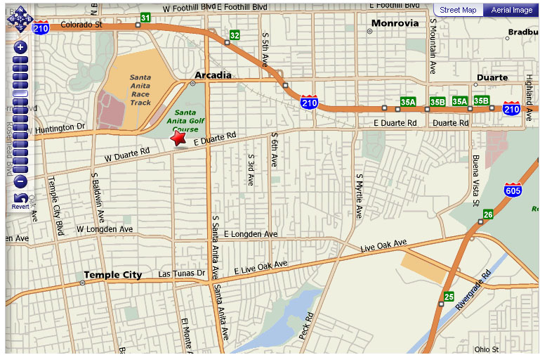
P.S.
Arcadia High School is located on the red star

