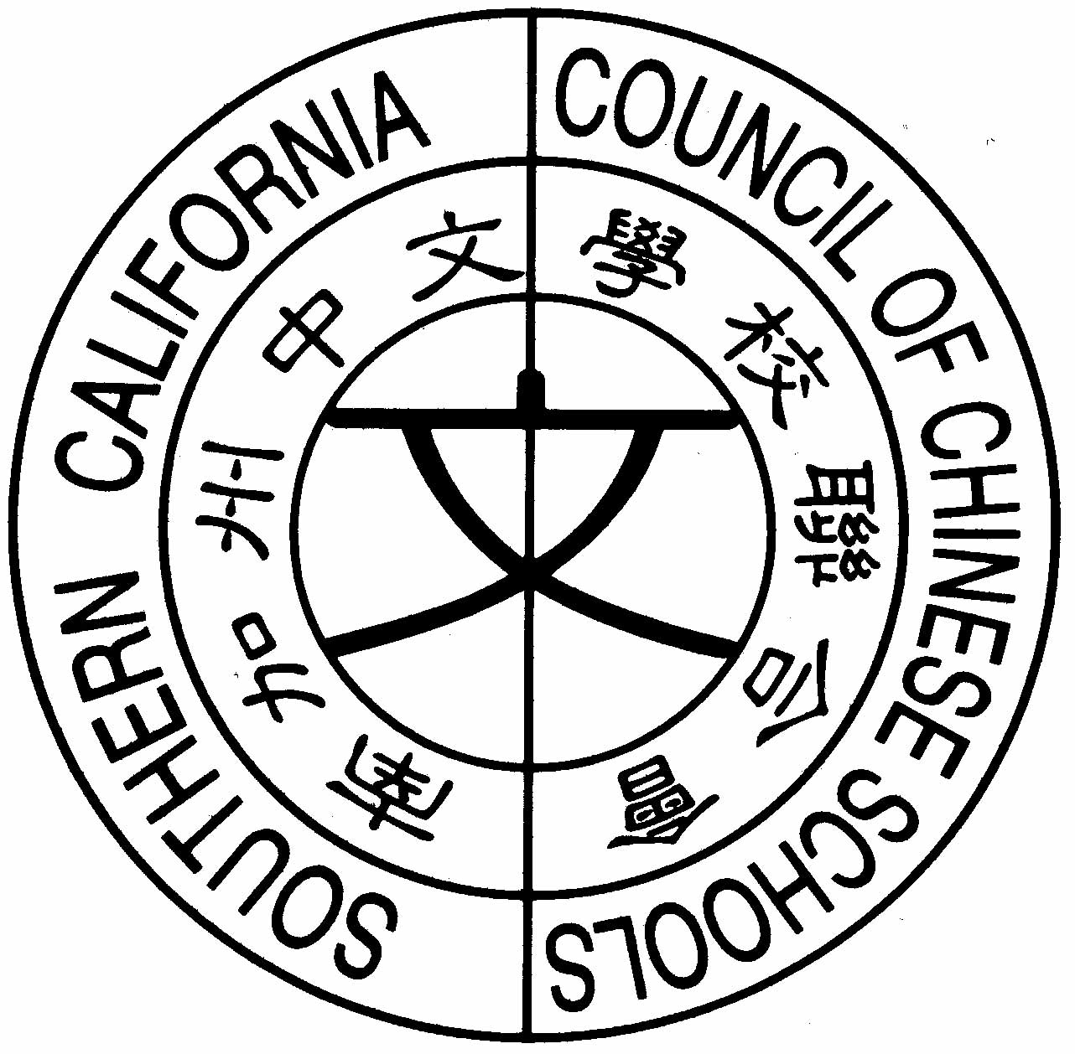
南加州中文學校聯合會
Southern California Council of Chinese Schools
21821 Ladeene Avenue, Torrance, CA 90503
(310) 540-6430, Fax (310) 543-1040 www.scccs.com

October 30, 2007

To: Member Schools
From: Southern California Council of Chinese Schools (SCCCS)
RE: 2006-2007 Insurance Matters

Dear Member Schools:

After careful review, the Board of Southern California Council of Chinese Schools has made some changes in regards to the insurance coverage for the participating member schools, for the 2006-2007 period and thereafter. We would like to take this opportunity to present the changes:

- The existing insurance policy covering participating member schools will be terminated on November 30, 2006. Due to rapid changes in the Los Angeles Chinese language centers, and other types of learning centers, it is necessary for each school to obtain its own insurance policy
starting on November 30, 2006.

- When a school has its own policy, it can enjoy its own coverage limit. Furthermore, the premium calculation is based only on that school’s operation and it does not share other schools’ “prior policy history”.

- Each school has its own choice to purchase any policy to meet its insurance needs.

- We have been informed by our current insurance broker, Global General Insurance Services, renewal proposals are ready. Some of you may have been contacted by Global already and some will be contacted shortly.

If questions are in relationship to “insurance”, please do not hesitate to call Global General Insurance Services or your own insurance agent.

Thank you very much for your cooperation for this matter.

Sincerely yours,

Chester Sung

