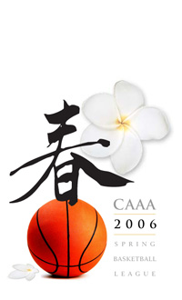
第五屆中華青少年籃球聯盟賽
CAAA Youth Basketball League
DISCLAIMER AND LIABILITY RELEASE ( 意外傷害自理保證書)

I accept any and all responsibility for, and assume the risk of, any and all injury or damage to myself and my team if you are a captain or team leader I, we or they while are participating in the 2007 Youth Basketball League during any practices or any events that take place as part of the tournament. I hereby expressly release, discharge and hold harmless from any liability whatsoever any of the Chinese American Athletic Association (CAAA), CAAA committee and their members and the City of Cerritos or any associate sponsors. This also includes any other sponsors and individuals and helpers whether salaried or voluntary.
I certify that I have read, understood the contents of the liability release and disclaimer and that it is my intention, by signing this form that it is binding not only upon me but also upon my heirs, executors, administrators, successors and assigns.

Team Leaders and Team Captains are responsible for each of their participants. Therefore this Release MUST also be signed.
Team Name_________________ ______________________________ Age___________
Jersey  Number | Player Name as Photo ID Please | Age/Birthday | Signature

Signed by your Team Leader X ____________________________________________ and

Team Captain __________________________________________________________
E-Mail _______________________________________________________________
Contact Tel No. ___________________________________________
Date ______ / ______ / ______

