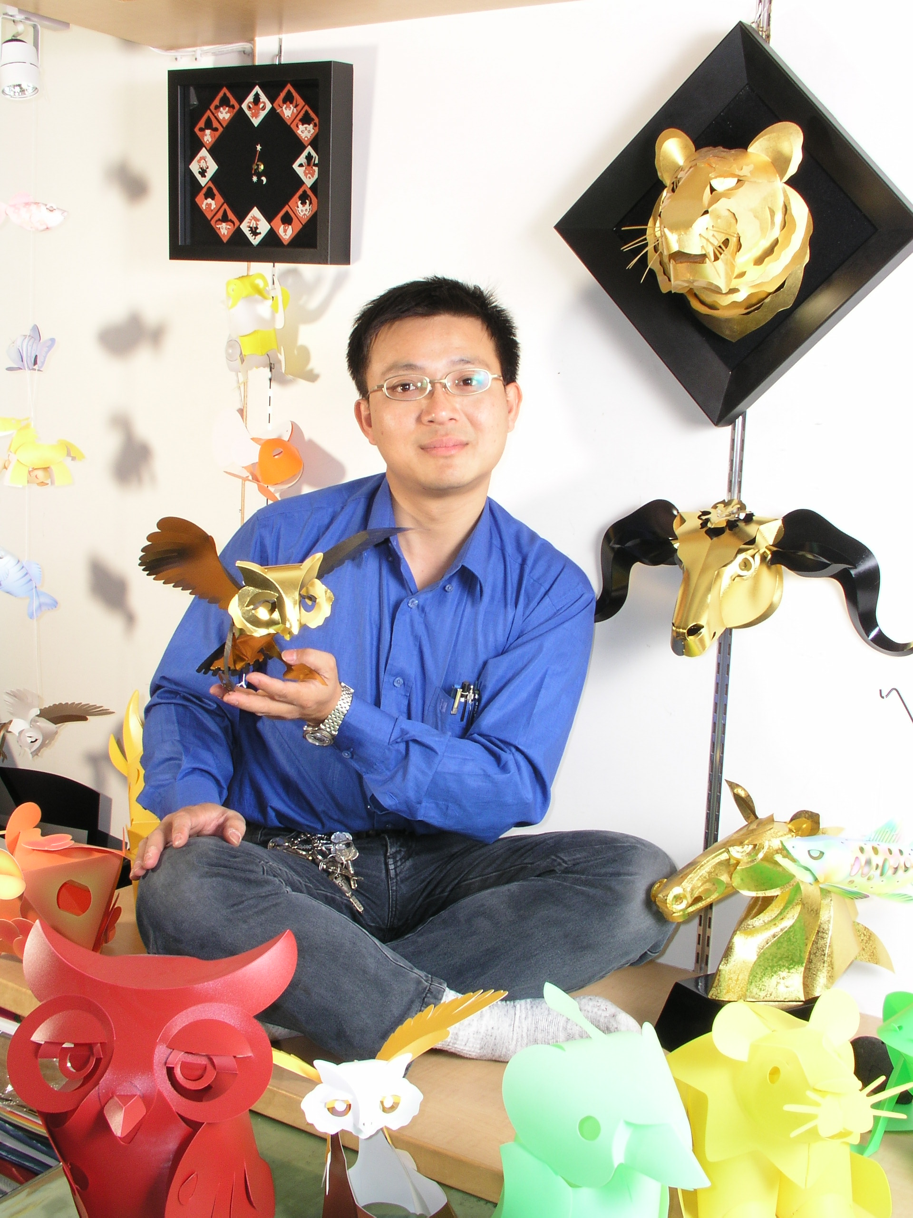
洪新富
1967年生 台北市人
中華民國第四十一屆十大傑出青年
從事紙藝創作、展覽、著作、推廣教育等工作已達
二十餘年。
現任：扶風文化事業負責人、洪新富創意文化負責人、香港聲藝文化協會顧問、台加文化協會榮譽顧問。
著有：紙雕卡片（基礎篇）、紙藝傳情、紙藝話情、紙藝寄情、紙玩七情、紙雕動物園、動感摺紙STORY、紙的可能、台灣民俗紙藝、洪新富的紙藝世界、紙的詠歎調、史前樂園等書。
紙藝  如果你肯用心去看世界，每天都會有許多精彩的故事上演，在與紙共舞的日子，洪新富用紙記錄了你的、我的、還有……他的故事。紙張可以是感性的、理性的、還可以是生活的，就像洪新富從小立志當科學家、藝術家、文學家、哲學家、而現在呢？就只是個「生活家」。  當生命在轉型的時刻，有許多許多的故事，它可能只是一個不經意的回眸，卻引起綺想與衝激，從暗戀、探索到追求，發現了生命悸動的美感，在單純的分享概念裡架構了一個從不設防的真實世界，也因此搜羅了許多現代傳說與神話；在實踐的過程中，因為參與、投入，所以成就了許多可能。  關於洪新富，就像他的紙藝一樣，沒有什麼太特別，只是比別人多一份心罷了。 |  | The Potentials of Paper  Whoever views the papercrafts done by Mr.Hung will invariably praise him for its unbelievable visual effect. Each ordinary piece of paper, after crafted by Mr. Hung, seems to come alive and tell a vivid story.  Mr. Hung had his first encounter with papercrafts at the age of four. At age eleven, he decided to pursue it, and by fifteen, he appreciated papercrafts at a much deeper level. By seventeen, it was his passion, and he decided to make it his life-long professon. Through his family's opposition, acquiescence and then the eventual approval, he has recorded your stories and mine, and yes, his own stories with paper.  Like his work, Mr. Hung appears to be not "showy". In fact, he looks very plain and ordinary. The difference is that he has a "heart". When you view his work, you will discover that in each piece, he has put his "heart" into it. And through this, one comes to understand the experience and interesting stories that Mr. Hung is trying to tell you.  When viewing Mr. Hung's work, one will find that he has projected his life experiences through his mind onto his papercrafts. And thereby it provides a demonstration and record of his inner awareness. You can also feel that he is ceaselessly trying different innovative ways of crafting, and therefore each piece is unique. His devotion to the papercrafts is an expression of his love of life.  Papercrafting is "universal" and without borders. It belongs to you and me. Mr.Hung's works faithfully record his mood and feeling. To be able to create such resonance among the audience is his greatest achievement, he says.  Mr. Hung can not answer whether it was fortunate or unfortunate for him to choose this career. However, one thing is certain, he is happy. He says he is very lucky too. Life is just like a sheet of paper. By touching, folding, cutting, or manoeuvring, one can create one's dream figure or shape, expression of one's innermost desires.

洪新富創意文化
台北市忠孝西路一段５０號２０樓－１３
Tel：886-2-23899296、Fax：886-2-23704953
franys@ms26.hinet.net
www.3dpaper.com.tw

