Higher Order Thinking Skills
Dr. Lin Yu Lan
Different types of thinking:

1. Critical thinking - This is convergent thinking. It assesses the worth and validity of something existent. It involves precise, persistent, objective analysis. When teachers try to get several learners to think convergently, they try to help them develop common understanding.
2. Creative thinking - This is divergent thinking. It generates something new or different. It involves having a different idea that works as well or better than previous ideas.
3. Convergent thinking - This type of thinking is cognitive processing of information around a common point, an attempt to bring thoughts from different directions into a union or common conclusion.
4. Divergent thinking - This type of thinking starts from a common point and moves outward into a variety of perspectives. When fostering divergent thinking, teachers use the content as a vehicle to prompt diverse or unique thinking among students rather than a common View.
5. Inductive thinking - This is the process of reasoning from parts to the whole, from examples to generalizations.
6. Deductive thinking - This type of reasoning moves from the whole to its parts, from generalizations to underlying concepts to examples.
7. Closed questions - These are questions asked by teachers that have predictable responses. Closed questions almost always require factual recall rather than higher levels of thinking.
8. Open questions - These are questions that do not have predictable answers. Open questions almost always require higher order thinking.

Bloom's Taxonomy
Evaluation appraise, choose, compare, conclude, decide, defend, evaluate, give your opinion, judge, justify, prioritize, rank, rate, select, support, value
change, combine, compose, construct, create, design, find an unusual way,
Synthesis formulate, generate, invent, originate, plan, predict, pretend, produce, rearrange, reconstruct, reorganize, revise, suggest, suppose, visualize, write
Analysis analyze, categorize, classify, compare, contrast, debate, deduct, determine the factors, diagnose, diagram, differentiate, dissect, distinguish, examine, infer, specify
Application apply, compute, conclude, construct, demonstrate detennine, draw, find out, give an example, illustrate, make, operate, show, solve, state a rule or principle, use
Comprehension convert, describe, explain, interpret, paraphrase, put in order, restate, retell in your own words, rewrite, summarize, trace, translate
Knowledge define, fill in the blank, identify, label, list, locate, match, memorize, name, recall, spell, state, tell, underline

Ability to Think
- Problem solving
- Informed decision making
- Systems thinking
- Critical, creative, and analytical thinking
- Imagining places, times, and situations different from one's own - Developing and testing a hypothesis
- Transferring learning to new situations

Skill in Communication
- Constructing and defending an argument
- Working effectively in groups
- Com]11Unicating plans and processes for reaching goals - Receiving and acting on instructions, plans, and models - Communicating with a variety of tools and skills

Production of Quality Work
- Acquiring and using information
- Creating quality products and performances - Revising products and performances
- Developing and pursuing positive goals

(Wisconsin State Foreign Language Framework)

ill. How do I foster higher-order thinkin2: in my classroom?

1. Set up a classroom environment that is conducive to high-level thinking.
A. Multi-level materials
B. flexible grouping
C. Accept and celebrate diversity D. Print-rich environment
E. High expectations
F. Teacher as co-learner
G. Nurture risk-taking
2. Engage students in activities which foster high-level thinking.
A. Collaborative group activities in which students can communicate with others in a variety of ways.
B. Problem-solving activities that require more than routine calculations.
C. Open-ended activities with more than one "right" answer.
D. Activities which accommodate multiple intelligences.
E. Activities in which both genders participate freely.
3. Construct questions that caU for high-level thinking.
A. Ask yourself, "Do I always know the answer to my questions?"
B. Use variety of assessment-methods that match teaching-strategies. For example, use a project for assessment instead of an end-of-unit test.

QUESTIONS THAT PROBE REASONS AND EVIDENCE

What would be an example?
By what reasoning did you come to that
How do you know? conclusion?

Why do you think that is true? How could we find out whether that is true?
Do you have any evidence for that?
Are these reasons adequate?
What difference does that make?
Why did you say that?
What are your reasons for saying that?
What led you to that belief?
Could you explain your reasons to us?
How does that apply to this case?
Is there reason to doubt that evidence?
What would change your mind?
What would you say to someone who said____?
What other information do we need?
Can someone else give evidence to support that response?
But is that good evidence to believe that?
Who is in a position to know if that is so?

QUESTIONS ABOUT VIEWPOINTS OR PERSPECTIVES
You seem to be approaching this issue from _________perspective.
Why have you chosen this rather than that perspective?
How would other groups/types of people respond? Why? What would influence them?
How could you answer the objection that__________ would make?
What might someone who believed_______ think?
Can/did anyone see this another way?
What would someone who disagrees say?
What is an alternative?
How are Ken's and Roxanne's ideas alike? different?

QUESTIONS THAT PROBE IMPLICATIONS AND CONSEQUENCES
What are you implying by that?
But if that happened, what else would happen as a result? Why?
What effect would that have?
Would that necessarily happen or only probably happen?
What is an alternative?
If this and this are the case, then what else must also be true?
If we say that this is unethical; how about that?
When you say_________ you are implying?
Higher Order Thinking Skills Question Templates

Recall
Note:  Any question becomes a recall question if the answer has already been explicitly provided to the student in class or in the text.  When did ______take place?  List the__________. | Define the term___________.  What is a__________?  Who did___________?  Name_____________
Analysis
How does work?  Sort these ___________.  Use the table to determine___________  Use the graph to determine__________  Graph____________  What caused____________?  What is another possible cause of______?  Outline the_____________  Based on the written description, draw a diagram.  Draw your own map of_________ without tracing or copying.  Use the map to determine__________  In what sequence did_________happen?  Break___________down into its component parts.  Give an example of____________  What literary form is being used?  What technique is being used?  What information is needed?  Is the information relevant?  Into what groups can you organize these?  Draw a picture that illustrates what's described in the story_____________ | What does___________ symbolize?  Find examples of [a literary device] in your  readings.  Analyze the________ in_______.  Classify these according to___________.  Separate the _______ from the_________.  Translate____________  Analyze how____________  Explain how__________ works.  What was the author's point of view?  How did the author convey_________?  What words does the author use to paint an image of _________ in your mind?  How were_________ used to______?  What kind of a_________ is this?  Which one doesn't belong in this group?  What is the function of_______?  What is the purpose of__________?  What is the relationship between________ and________?  What is the pattern?  Use manipulatives to illustrate a concept.  Bu ild a model of _________.  Measure_________.

Comparison
How is ___________ like____________?  How are _________ and _________different?  Compare the _______ before and after______.  Compare the character___________ at the beginning of the story and at the end. | Distinguish between _________ and________.  Compare ________ with __________.  On what dimensions might you compare______ and ___________?  Which one is the biggest/oldest/tallest?

Inference
Hypothesize what will happen if________.  Predict what will happen if __________.  Apply the rule to __________.  Solve the problem ______________.  Predict how the story _________will end.  What is the main idea of the story _________?  What is the overall theme of __________?  What is the moral of the story?  Develop of plan to ___________.  Propose and describe an invention that fills  some need.  Write a research paper on__________. | Based on your readings, what can you  conclude about _________?  What was the author's point of view?  Solve a logic puzzle.  What if _________?  What rule applies here?  What generalization can you make from this  information?  Create a ___________.  Design a ___________.  Propose a solution to the problem of ________.

Evaluation
Was________ worth the costs? Explain your answer.  Was the argument convincing? What makes you think so?  Did ________ behave appropriately? Why?  What would you have done in this situation?  Why?  Write a critique of ____________.  Was this experiment well designed? Defend your answer.  Judge which is the best solution to the problem of __________? Why do you think so?  How well are the conclusions supported by the data/facts/evidence? Explain. | Did _________ choose a wise course of action? Give reasons.  Apply a scoring rubric to this piece of work.  Explain why you are assigning each score.  What would you have done in this situation?  Why?  Review a book, performance, or exhibit.  Justify your evaluation.  Which _________ is the best? Why do you think so?  Whose arguments/evidence was more convincing? Why?  If you were the judge, what would your decision be? Why?  Give and justify your opinion on _________.

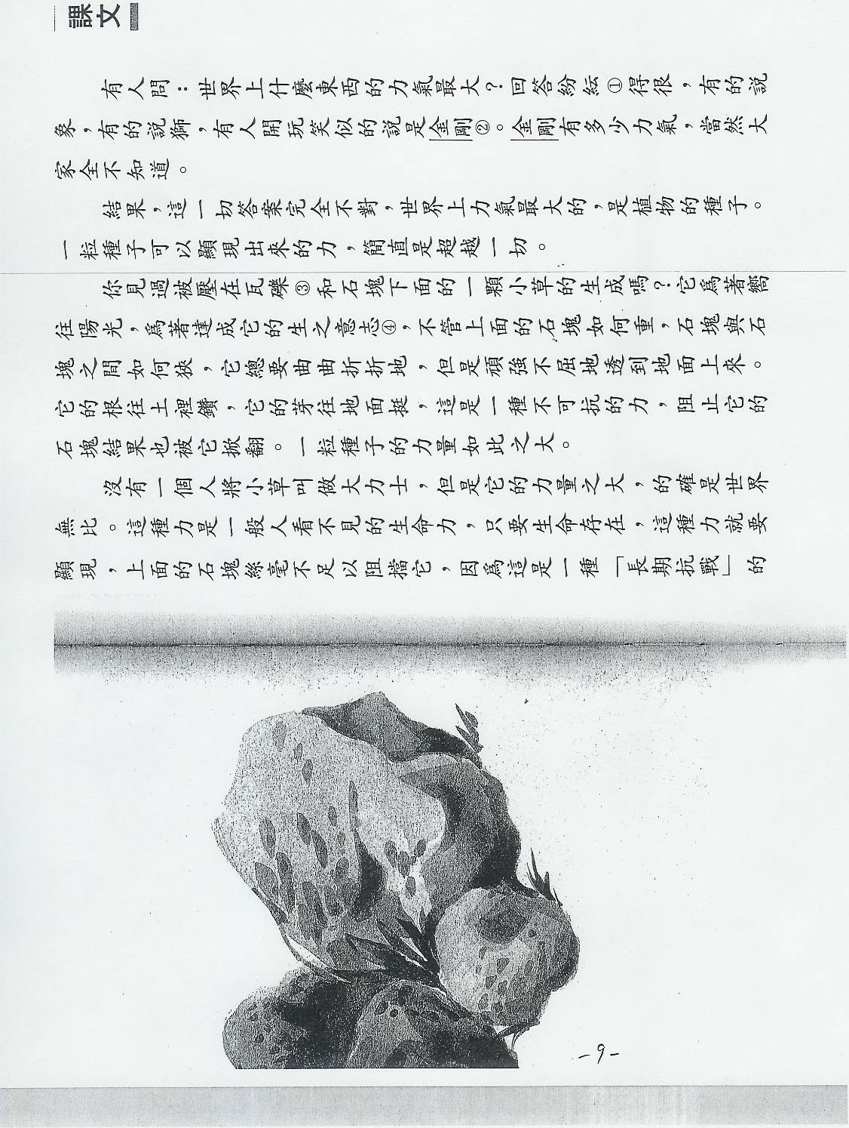
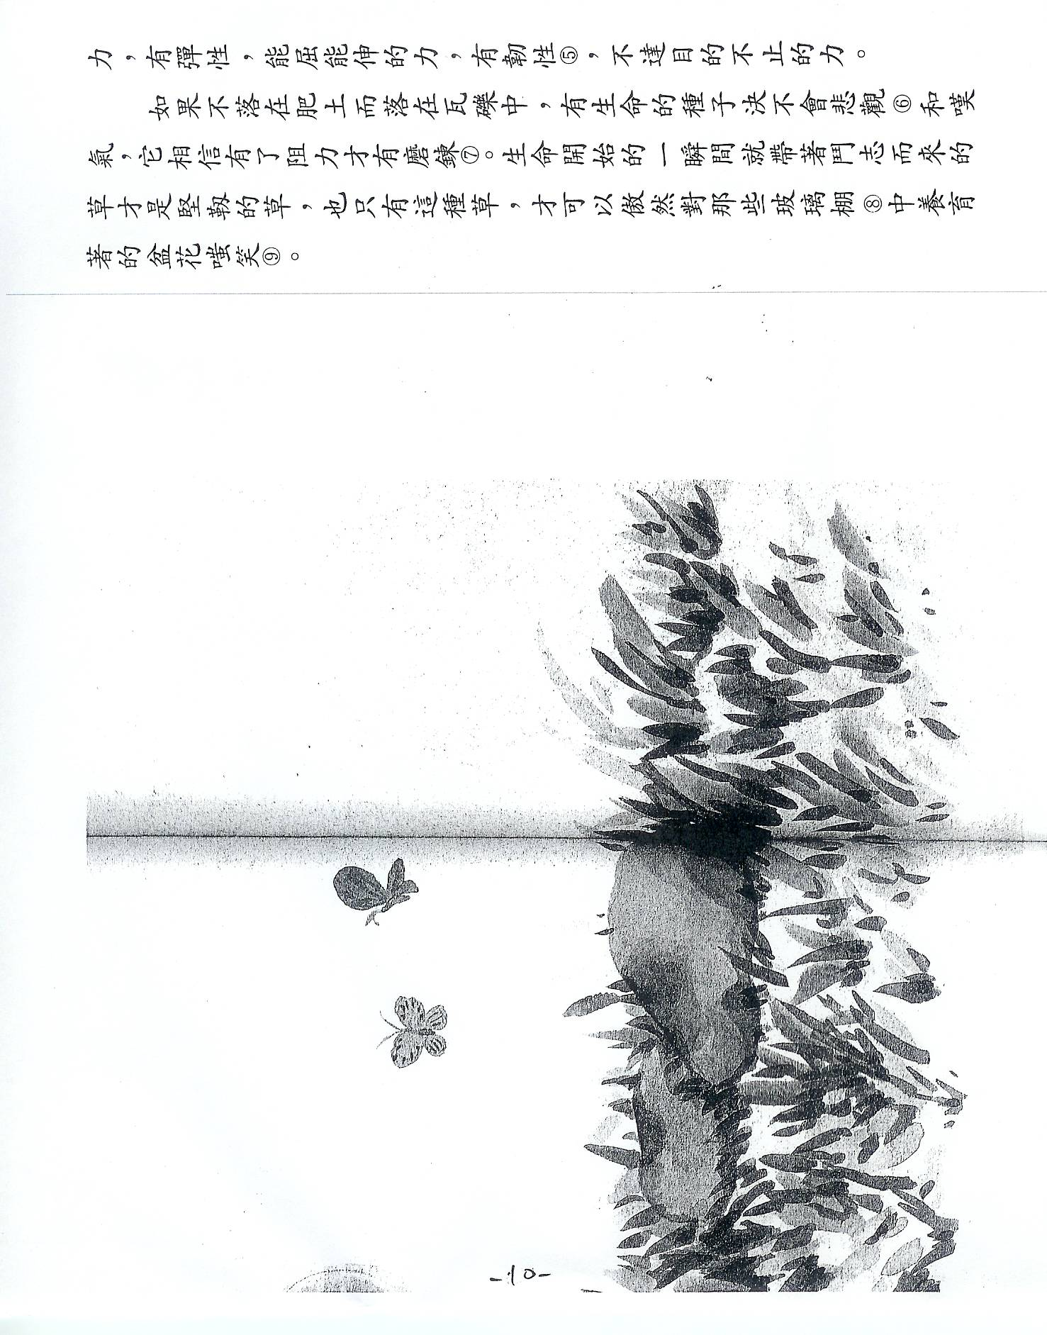

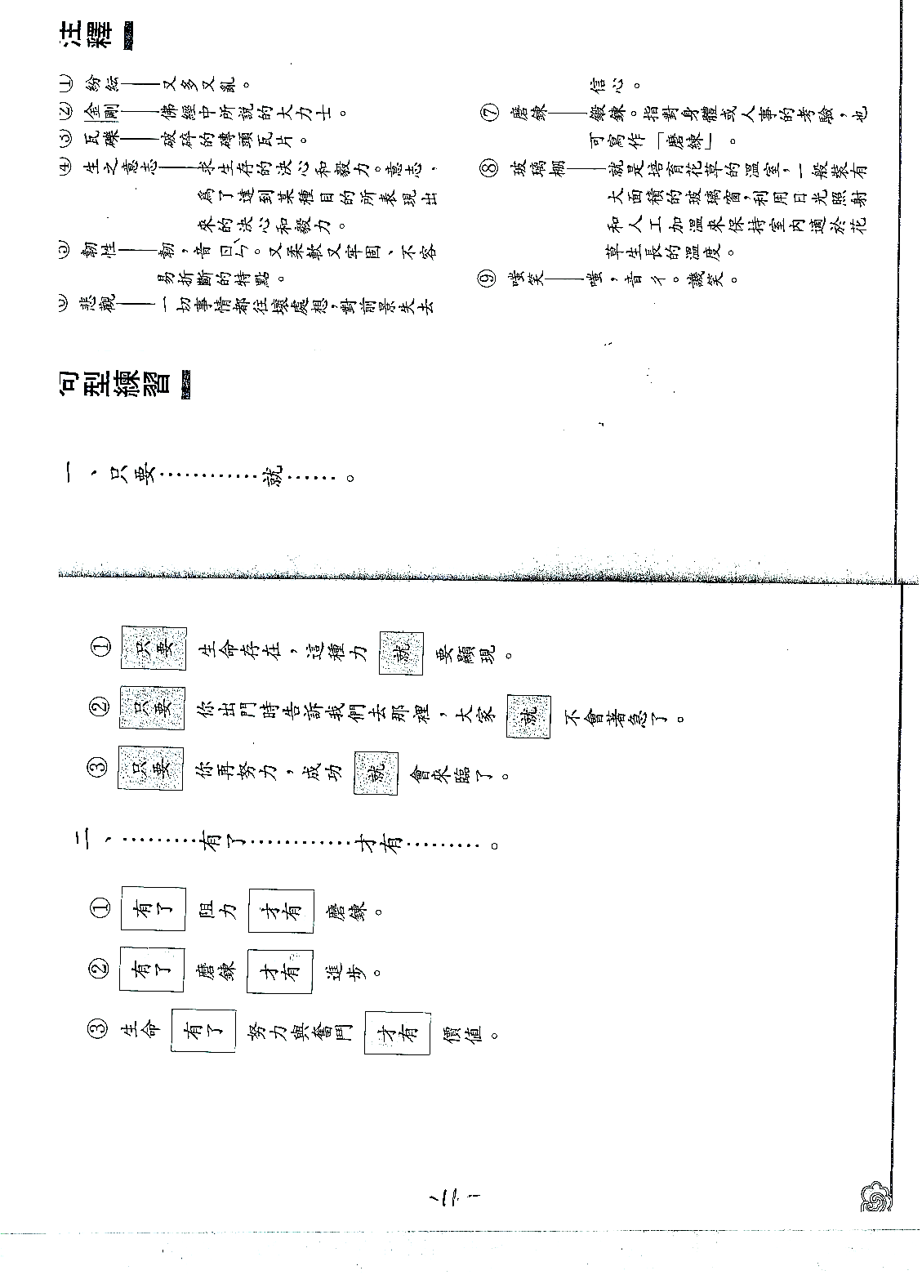
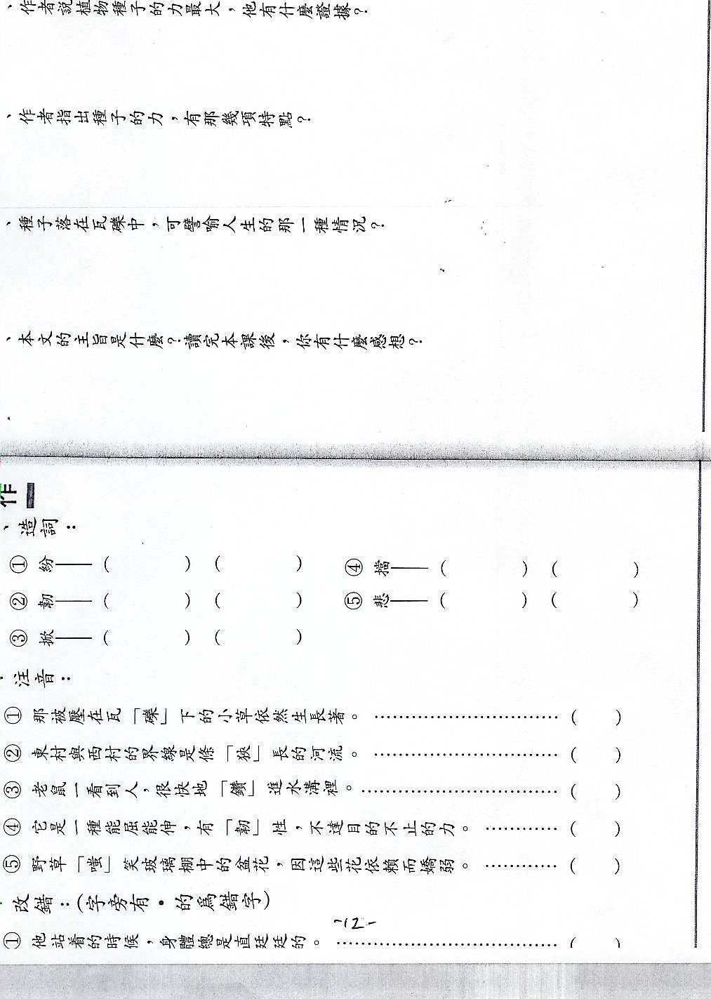
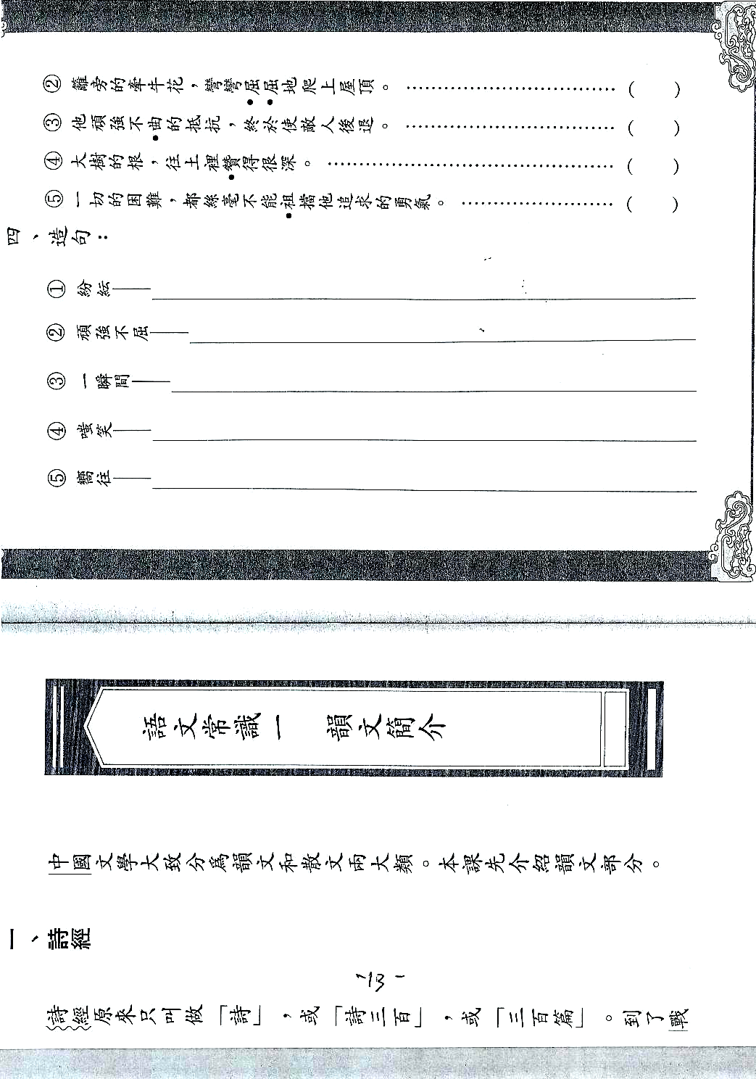
Performance Task
Elements
Preparation:
Decide: stage (level); standards; and content standards

1. Title: (short and clear)
2. Task objectives: (What do we want students to demonstrate?)
3. Student role: (What role will your students play?)
4. Audience: (For whom your students perform?)
5. Setting: (Situation that prompts the performance)
6. Activity: (skit, interview, advertisement, brochure, etc)
7. Rubrics: (analytical or holistic)
8. Background description:
Performance-based Activities

Title:__________________________

Targeted Standards:____________________________

Grade:_______________

Enduring knowledge: _______________________________________________________

Task objectives: __________________________________________________________

Student's role: ____________________________________________________________

Audience: _______________________________________________________________

Setting/Situation: __________________________________________________________
________________________________________________________________________
________________________________________________________________________
________________________________________________________________________
Activity: _________________________________________________________________
________________________________________________________________________
________________________________________________________________________
________________________________________________________________________
________________________________________________________________________
________________________________________________________________________
Rubrics:_________________________________________________________________
Background description: ____________________________________________________
________________________________________________________________________
________________________________________________________________________
Analytical Rubrics for Speaking
Boston Public Schools
World Languages Program

I. Comprehensibility
4. Responses require no interpretation on the part of the listener.
3. Responses require minimal interpretation on the part of the listener.
2. Responses require interpretation on the part of the listener.
1. Responses not comprehensible.

II. Ideas and Content
4. Are clear, focused and accurate.
3. Contain enough believable details.
2. Show basic development but not enough information.
1. Lacks central topic.

III. Pronunciation and Word Choice
4. Enhance and convey message effectively.
3. Mostly correct and appropriate thus do not interfere with communication.
2. Occasionally interfere with communication.
1. Impede communication.

IV. Syntax and Accuracy
4. Demonstrate excellent command of language Use.
3. Demonstrate good control of language structure.
2. Show developing use of language structure.
1. Show merging use of language structure most of the time.

V. Presentation and Fluency
4. Demonstrate effective use of style without pausing or stumbling.
3. Demonstrate effective use of language in completing thoughts.
2. Snow frequent pauses with incomplete thoughts.
1. Show long pauses with incomplete thoughts.

Analytical Rubrics Writing

I. Comprehensibility
4. Writing effectively conveys message and requires no interpretation.
3. Writing clearly conveys message and requires minimal interpretation. .
2. Writing requires interpretation on the part of the reader.
1. Writing is barely comprehensible.

II. Ideas and Content
4. They are clear, accurate and focused with supporting details.
3. There are believable details to support the main ideas.
2. Presents basic development but not enough details.
1. Lacks central topic.

III. Word Choice and Discourse
4. Demonstrate creative use of words and cohesive devices.
3. Demonstrate adequate use of words and some use of cohesive devices,
2. Show repetitive words and no cohesive devices.
1. Show erroneous or poor choice of words and incomplete sentences.

IV. Syntax and Accuracy
4. Demonstrate excellent command of language use.
3. Demonstrate good control of language structure.
2. Show developing use of language structure.
1. Show merging use oflanguage structure most of the time.

V. Presentation and Mechanics
4. Demonstrate effective use of style with fewer or no errors in spelling.
3. Demonstrate effective use of language in completing thoughts in writing.
2. Show frequent errors in spelling and writing mechanics in presenting thoughts.
1. Show much inaccuracy in spelling and writing mechanics in presenting thoughts.

Rubrics for Holistic Scoring

3. Exceeds Expectations
- Message very effectively communicated
- Rich variety of vocabulary
- Highly accurate, showing no significant patterns of error
- Content supports interest level
- Self-correction increases comprehensibility

2. Meets Expectations
- Message generally comprehensible
- Vocabulary is appropriate, with some groping
- Accuracy appropriate to stage, although some patterns of error may interfere with comprehension
- Content is predictable, but adequate
- Occasional self-correction may be successful

1. Does Not meet Expectations
- Message communicated with difficulty and is unclear
- Vocabulary is often inappropriate, leading to miscommunication
- Significant patterns of error
- Content repetitious
- Self-correction is rare and usually unsuccessful

0. Unratable Sample
- No consistent use of target language, only isolated words in target language
- Off task

(Text from Articulation and Achievement: Connecting Standards, Performance, and Assessment in Foreign Language, a College Board publication)

