AP中文考試樣本
Parts of the exam are accompanied by a master recording. In the sample questions that follow, the material enclosed in brackets is heard by the student and does not appear on-screen.

Section I: Multiple Choice (Listening)

Sample Questions

Directions: You will hear several short conversations or parts of conversations followed by four choices, designated (A), (B), (C), and (D). Choose the one that continues or completes the conversation in a logical and culturally appropriate manner. You will have 5 seconds to answer each question.

Note: In this part of the exam, the student may not move back and forth among questions.

- [(Woman) 我帶你去參觀一下我新買的房子，好不好？

(Man) (A) 你想帶誰去找房子？
(B) 對不起，我對買新產品不感興趣。
(C) 好，我們一起去參加觀光團吧！
(D) 什麼時候買的？怎麼沒告訴我？]

- [(Woman) 對不起，沒什麼好菜招待你們。

(Man) (A) 請問你今天想點些什麼菜？
(B) 不好意思，招待不周到。
(C) 您太客氣了，我們都吃得很飽。
(D) 別著急，我一吃完飯就來你家找你。]

- [(Woman) 今天我去學校接你的時候，那個跟你說話的同學是誰啊？

(Man) 那是我的新朋友馬可明。吃了晚飯以後我可以去他家玩嗎？
(Woman) (A) 你現在跟他到學校來接我。
(B) 吃了晚飯以後早一點回家。
(C) 等你做完功課再說吧！
(D) 馬可明是新來的老師嗎？]

- . [(Man) 你是從哪兒來的？

(Woman) 我是從美國紐約來的。你呢？

(Man) (A) 老實說，我哪兒都不喜歡去。
(B) 真可惜，你從來沒去過紐約。
(C) 你可不要跟我去那個地方。
(D) 我是本地人，在這兒生的。]

5. [(Woman) 這種新飲料，好喝嗎？

(Man) 喝起來像糖水一樣，沒廣告上說的那麼好。

(Woman) (A) 真的有那麼甜嗎？
(B) 真的有那麼好嗎？
(C) 真的有那麼多嗎？
(D) 真的有那麼香嗎？]

Directions: You will listen to several selections in Chinese. For each selection, you will be told whether it will be played once or twice. You may take notes as you listen. Your notes will not be graded. After listening to each selection, you will see questions in English. For each question, choose the response that is best according to the selection. You will have 12 seconds to answer each question.

Note: In this part of the exam, the student may move back and forth only among the questions associated with the current listening selection.
Voice message
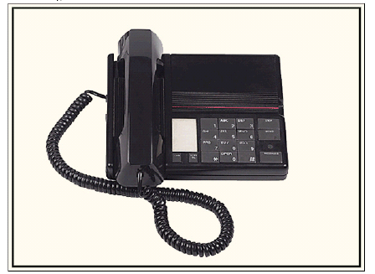

[(Narrator) Now you will listen twice to a voice message.

(Woman) 喂，張建，我是王華。我現在在急診室。我媽今天下午在家裏摔了一跤，走不了路。我剛把她帶到醫院來檢查。還好骨頭沒摔斷，但是醫生要她留在醫院裏觀察一夜，所以我得在這兒陪她。今天晚上不能跟你去看電影了。請明天早上打電話到我家，我跟你一起走路去上學。

(Narrator) Now listen again.

(Woman) 喂，張建，我是王華。我現在在急診室。我媽今天下午在家裏摔了一跤，走不了路。我剛把她帶到醫院來檢查。還好骨頭沒摔斷，但是醫生要她留在醫院裏觀察一夜，所以我得在這兒陪她。今天晚上不能跟你去看電影了。請明天早上打電話到我家，我跟你一起走路去上學。

(Narrator) Now answer the questions for this selection.]

6. What is the purpose of the message?
(A) To arrange a medical appointment
(B) To ask for directions to the hospital
(C) To cancel a previous engagement
(D) To recommend a movie

7. What is the speaker’s relationship to Zhang Jian?
(A) His mother
(B) His doctor
(C) His teacher
(D) His schoolmate

8. Where is the speaker calling from?
(A) Home
(B) School
(C) A hospital
(D) A movie theater

9. What does the speaker ask Zhang Jian to do?
(A) Call her in the morning
(B) Visit her in the hospital
(C) Take her mother home
(D) Meet her at the movie theater

School conversation
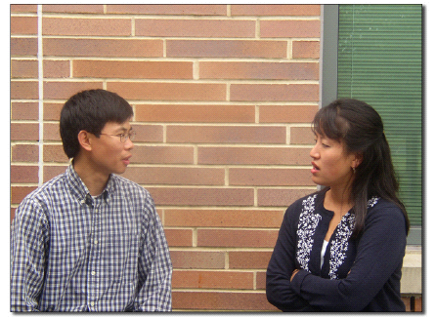
[(Narrator) Now you will listen once to a conversation between two students.

(Woman) 聽說你考上南京大學了，祝賀你啊！

(Man) 哪兒能跟你比啊，考上北大了，真羨慕你。

(Woman) 你打算學什麼專業啊？

(Man) 學醫，你呢？

(Woman) 做醫生太辛苦，我要學法律，以後當律師。

(Narrator) Now answer the questions for this selection.]

10. What does the woman ask the man about?
(A) What colleges he is applying to
(B) What he will major in
(C) His opinion of certain schools
(D) His preferred location for attending college

11. The woman expresses a desire to
(A) study medicine
(B) get a part-time job
(C) become a lawyer
(D) attend Nanjing University

12. What is the woman’s reaction to the man’s plans?
(A) She thinks that the school he will attend is better than hers.
(B) She suggests that he study law.
(C) She says that she is envious of his good luck.
(D) She says that she would not make the same career choice.

Section I: Multiple Choice (Reading)

Note: In this part of the exam, the student may move back and forth among all the questions.

Sample Questions

Directions: You will read several selections in Chinese. Each selection is accompanied by a
number of questions in English. For each question, choose the response that is best according to
the selection.

Read this e-mail.

送件人: 李玉姍

日期: 2005 年10 月26 日

收件人: 王晶晶

主題: 我的新房子

晶晶堂姐：

我們搬新家了，雖然離學校遠一點，但房子比從前大多了。最棒的是現在我有自己的房間，不像以前要跟妹妹合住一個房間。爸爸、媽媽跟妹妹都睡在樓上，我的臥房在樓下的書房對面。我的房間是這樣擺設的：進門的右邊靠牆角有一套小沙發，對著門是床，床頭的牆上掛著張全家福的照片，床的左邊有張書桌，書桌上放著電腦跟小書架。房間左邊靠牆放著一個衣櫃，櫃子上擺著花瓶、鏡子和你送給我的玩具熊。

放暑假時你跟叔叔來住，我們可以在後院的游泳池玩。

玉姍

送件人: 李玉姗

日期: 2005 年10 月26 日

收件人: 王晶晶

主题: 我的新房子

晶晶堂姐：

我们搬新家了，虽然离学校远一点，但房子比从前大多了。最棒的是现在我有自己的房间，不像以前要跟妹妹合住一个房间。爸爸、妈妈跟妹妹都睡在楼上，我的卧房在楼下的书房对面。我的房间是这样摆设的：进门的右边靠墙角有一套小沙发，对着门是床，床头的墙上挂着张全家福的照片，床的左边有张书桌，书桌上放着电脑跟小书架。房间左边靠墙放着一个衣柜，柜子上摆着花瓶、镜子和你送给我的玩具熊。

放暑假时你跟叔叔来住，我们可以在后院的游泳池玩。

玉姗

13. What does Yushan like best about her new house?
(A) It has a big backyard.
(B) It has a swimming pool.
(C) She doesn’t have to share a room with her sister.
(D) She can walk to school.

14. Where in her room did Yushan put her family photo?
(A) On the wall facing the door
(B) On top of the wardrobe
(C) Next to the couch
(D) On the desk

15. To whom is the e-mail addressed?
(A) A friend
(B) A cousin
(C) An uncle
(D) A classmate

16. Where is Yushan’s teddy bear?
(A) On the bed
(B) On the couch
(C) Next to the mirror
(D) On top of the computer

Read this public sign.

報章期刊閱畢後請放回原處

报章期刊阅毕后请放回原处

17. Where would the sign most likely appear?
(A) In a department store
(B) In a park
(C) At a newsstand
(D) In a library
18. What is the purpose of the sign?
(A) To give directions to a particular location
(B) To advertise a new product
(C) To request cooperation from the users of a service
(D) To post the penalty for violating a regulation

Answers to Multiple-Choice Questions

1—D 2—C 3—C 4—D 5—A 6—C 7—D 8—C 9—A 10—B
11—C 12—D 13—C 14—A 15—B 16—C 17—D 18—C
Section II: Free Response (Writing)
Note: In this part of the exam, the student may not move back and forth among questions.

Sample Questions

Directions: You will be asked to write in Chinese in a variety of ways. In each case, you will be asked to write for a specific purpose and to a specific person. You should write in as complete and as culturally appropriate a manner as possible, taking into account the purpose and the person described.

Story Narration

The four pictures present a story. Imagine you are writing the story to a friend. Narrate a complete story as suggested by the pictures. Give your story a beginning, a middle, and an end.
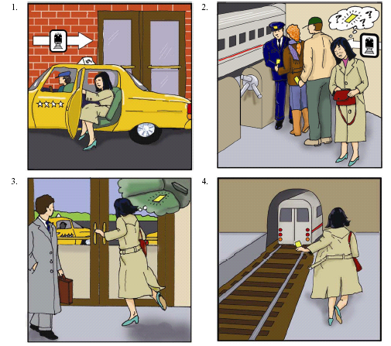
Personal Letter

Imagine you received a letter from a pen pal at a Chinese sister school. The letter asks about your school subjects. Write a reply in letter format. First, write about your school subjects in general. Then choose ONE school subject and describe either what you like or what you dislike about this school subject. Justify your opinion with specific examples.

E-Mail Response

Read this e-mail from a friend and then type a response.

送件人: 王明華

主題: 申請美國大學

因為申請到美國上大學的資料在一個月內都得寄出，所以這幾個星期忙得不得了。沒想到
申請美國大學的手續這麼複雜，跟中國的情況完全不一樣。在中國只要通過入學考試就行
了。你在美國讀書，一定比我更了解申請美國大學的要求，有什麼好主意可以分享？跟其
他的申請資料來比較，申請入學的作文有多重要？請儘快告訴我一些信息。

送件人: 王明华

主题: 申请美国大学

因为申请到美国上大学的资料在一个月内都得寄出，所以这几个星期忙得不得了。没想到申请美国大学的手续这么复杂，跟中国的情况完全不一样。在中国只要通过入学考试就行了。你在美国读书，一定比我更了解申请美国大学的要求，有什么好主意可以分享？跟其他的申请资料来比较，申请入学的作文有多重要？请尽快告诉我一些信息。

Relay Telephone Message

Imagine you are sharing an apartment with some Chinese friends. You arrive home one day and listen to a message on the answering machine. The message is for one of those friends. You will listen twice to the message. Then relay the message, including the important details, by typing an e-mail to your friend.
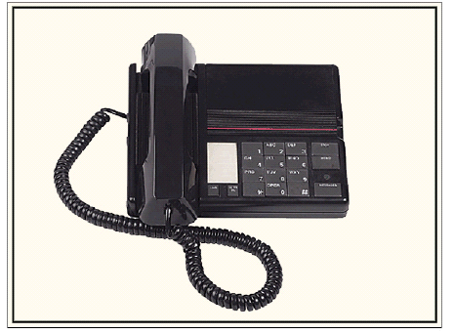

[(Woman) 喂，麗麗不在家嗎？我是小文，是麗麗的同學。麗麗：這個星期六我過生日，想請你晚上七點來參加我的生日晚會。我現在住在學院路光明園十二號，你可以坐十八路公共汽車到光明園站下車，下車後往南走五十多米就到了。請你一定要來哦。謝謝！

(Narrator) Now listen again.

(Woman) 喂，麗麗不在家嗎？我是小文，是麗麗的同學。麗麗：這個星期六我過生日，想請你晚上七點來參加我的生日晚會。我現在住在學院路光明園十二號，你可以坐十八路公共汽車到光明園站下車，下車後往南走五十多米就到了。請你一定要來哦。謝謝！

(Narrator) Now type an e-mail to your friend.]

Section II: Free Response (Speaking)

Note: In this part of the exam, the student may not move back and forth among questions.

Sample Questions

Directions: You will participate in a simulated conversation. Each time it is your turn to speak, you will have 20 seconds to record. You should respond as fully and as appropriately as possible.

Conversation

You will have a conversation with Huang Lihua, an interviewer, about your application for a scholarship to study in China.
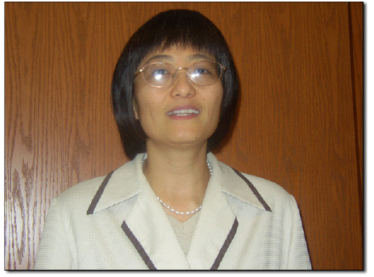
[(Woman) 請你談談你是怎麽開始對中國感興趣的。

(20 seconds)

(Woman) 如果能去中國留學，你想選修什麼樣的課程？你為什麼要選修這些課程呢？

(20 seconds)

(Woman) 你想到中國哪個城市去留學？為什麼你要選這個城市呢？

(20 seconds)

(Woman) 假如你能去中國留學，學校會安排你參加一些課外的文化活動。你對中國文化的哪個方面最感興趣？

(20 seconds)

(Woman) 去中國留學跟你將來的就業計劃有什麼關係？

(20 seconds)

(Woman) 關於這個去中國留學的項目，你有什麼問題嗎？

(20 seconds)]

Directions: You will be asked to speak in Chinese on different topics. In each case, imagine you are making an oral presentation to your Chinese class. First, you will read and hear the topic for your presentation. You will have 4 minutes to prepare your presentation. Then you will have 2 minutes to record your presentation. Your presentation should be as complete as possible.

Cultural Presentation

Choose ONE Chinese food that is associated with a particular holiday (moon cake, zongzi, etc.).
In your presentation, describe this food and explain its significance.

Event Plan

You have the opportunity to plan a tour of your community for a Chinese student. In your presentation, describe the advantages and disadvantages of different options. Also explain what you would do and why.

