《漢語拼音3日通》是你進入中文世界的第一把鑰匙。
你在尋找一本可以讓你或你的學生學得又快又好的拼音書嗎？「漢語拼音3日通」是一本用系統教學法精心設計的拼音教科書；也是一本你要找的好書。
《漢語拼音3日通》的作者陳正香老師是一位國文系、中文研究所訓練出來的資深中文老師，在台灣及美國任教達二十年。這本書有坊間許多同類教材所沒有的特色：
- 學中玩，玩中學─結合學習課程與拼玩練習於一本書，讓學生學中可玩，玩中可學。
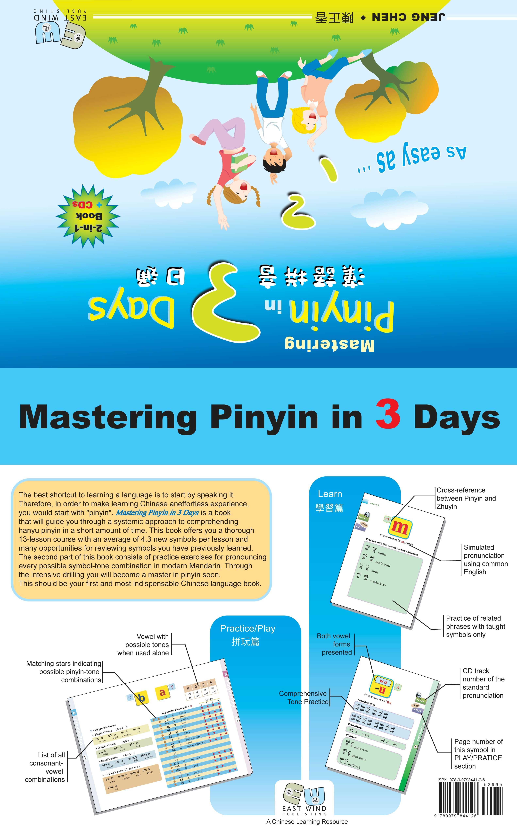
- 循序漸進，有條不紊─將拼音依共同發音部位與方法，循序漸進地分成13個課程。每課平均學習4.3個符號。由於特性相同，系統分明，學起來事半功倍。
- 輕鬆學，效果大─全部課程用「已學學新學」為原則，在大量學過的基礎上，加入少量的新學，使學生的學習變得輕鬆容易，充滿成就感。在不知不覺中，學得一套完整而紮實的拼音技巧。
- 給老師或自學者專欄─在每個單元前面，特別給老師或自學者提供單元重點說明，讓老師清楚地把握教學重點﹔讓自學者在清晰概念中自我學習。
- 拼玩篇練習所有中國語音─透過兩顆星相對，做子音與母音拼音遊戲，加上聲調，便可拼讀所有中國的語音。同時，在每個子音與母音裡，又羅列所有可能的拼音，及包含該音的語詞與句子練習，讓學生掌握每個音的實際拼音情況，並獲得實際拼音能力。
- 印刷精美，大人小孩都愛─全書中英文並列，色彩鮮麗，圖文生動有趣，並附有兩片CD導讀。不論有沒有中文經驗，自學或由老師教，從小孩到大人都適用。
To inquire: Ling Teng (310) 837-7866
（總經銷） senseio@sbcglobal.net
160 pages, hardcover $29.95
《Mastering Pinyin in 3 Days》is your key to entering the world of the Chinese language.
Are you seeking a book that can help you or your students learn pinyin effectively? “Mastering Pinyin in 3 Days”, a textbook that utilizes systematic teaching methods, may be just the textbook that you are looking for.
《Mastering Pinyin in 3 Days》 is written by Ms. Jeng Chen, who has earned a Master’s Degree in Chinese Literature and has solid training in Chinese linguistics. Ms. Chen is also a front-line Chinese language teacher with nearly 20 years of teaching experience in both Taipei and Los Angeles. This book is a product of her first-hand experiences and contains several distinguishing features that are not seen in other similar textbooks:
- Learning with fun – Learning and innovative practice exercises are combined in one book. Students will learn pinyin while having fun practicing with the book’s unique consonant-vowel matching system.
- Step by step; organized progression – The book is divided into 13 lessons structured according to pronunciation attributes. The systemic approach helps students learn pinyin in clear steps.
- Effortless, yet effective – There are on average 4.3 new phonetic symbols in each lesson. The new ones are introduced in the text along with previously learned symbols. This rote learning process effectively helps students memorize the material.
- Special columns for teachers and self-learners – In each lesson, essentials and teaching tips are highlighted in a special column. This section provides a comprehensive instructional guide for teachers and gives self-learners a clear understanding of the pinyin system.
- Exercising all the actual Chinese sounds – Through a unique matching system, readers can practice all the consonant-vowel combinations of actual Chinese words, including tones. Words, phrases, and sentences using the target symbol are also offered so the students can practice speaking in actual context.
- Readable and audible – The texts are explained in plain English and Chinese with numerous vivid illustrations. The book is also accompanied with two audio CDs containing the actual pronunciation of the entire course material in natural speech. It’s a book that suits Chinese pinyin teachers and learners of all ages.

