**HOMEWORK:**

**1. Make up 10 sentences using modals of obligation**

**2. Complete the second sentence with two or three words so it means the same as the first.**

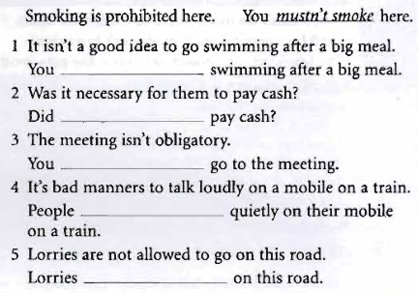

**3.**



**http://www.yapfiles.ru/files/1605922/2efe6e7c0a46cd81219ef0bcfceca27c.mp3?token=MDE2MDU5MjItMTQ4MzQzMjgyNA**



