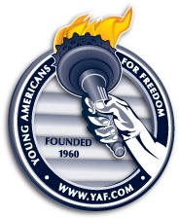
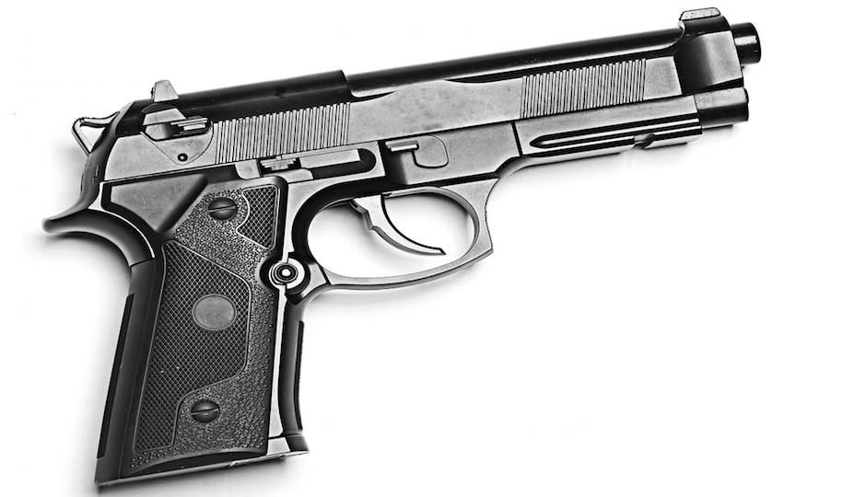

Hosted by:
Young Americans for Freedom at University of Utah

Email: yaf.utah@gmail.com
PRICE:
$30 before April 20th
$35 at the door

WHO:
NRA certified trainer, Clark Aposhian

WHEN:
5pm to 8pm
Friday, April 21st

WHERE:
TBD
CONCEALED CARRY

PERMIT CLASS

