OAC CHAMPIONS 2016-2017

Academic All-OAC Academic All – All-American
James Ritchie American Anthony Arroyo 5th Place
Graham Montague Graham Montague
David Shapiro Andrew Sierawski
Tyler MacLellan James Ritchie
Charlie Nash
Nicholas Berry

All-OAC Team National Qualifiers
Anthony Arroyo Chris Doyle
Tyler MacLellan Josh Decatur
Zek Lehman Anthony Arroyo
Ben Hooff Gabe Mahaney
Richie Burke

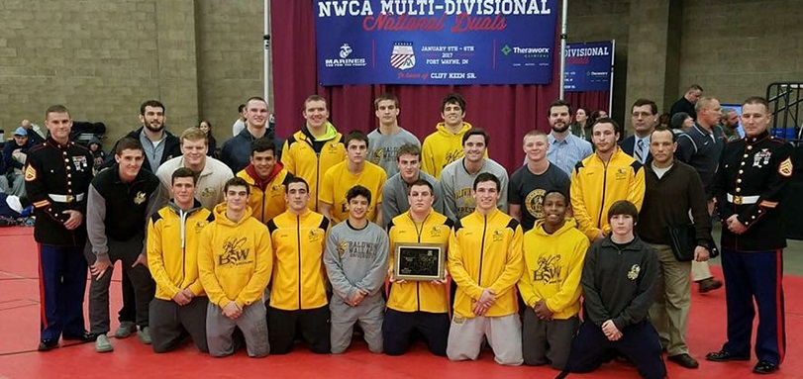

2017 Coaching Staff
Jamie Gibbs………………………………...Head Coach
Mason True…………………………………Assistant Coach
Matt Curly…………………………………...Assistant Coach
Andrew Taylor……………………………...Assistant Coach
Bill McGrain………………………………….Assistant Coach
Joey Schmidt............................................Assistant Coach
Garrett Chase...........................................Assistant Coach
Jaleel Richardson.....................................Assistant Coach
Jesse Gunter.………………………………Student Assistant

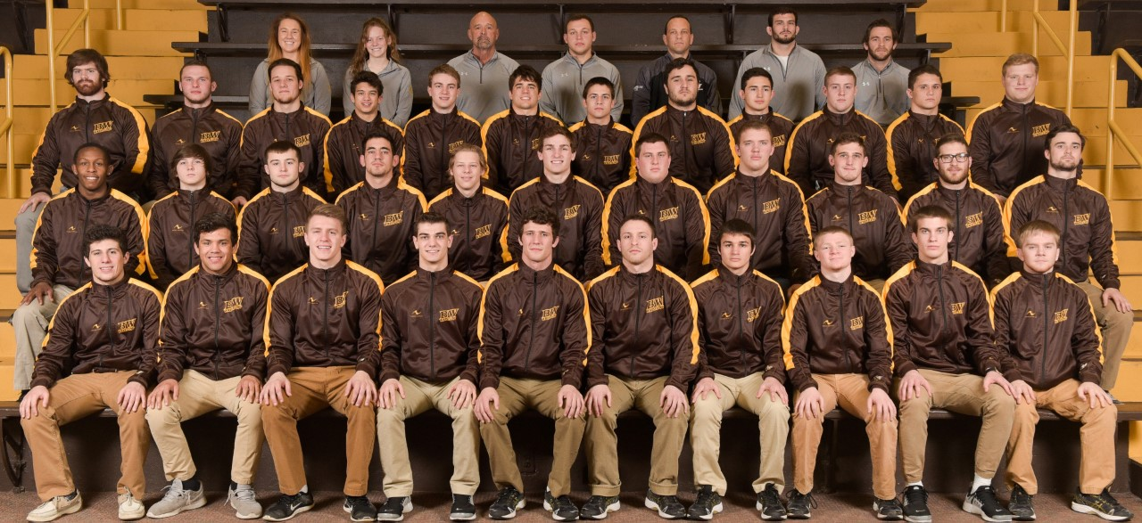

DATE

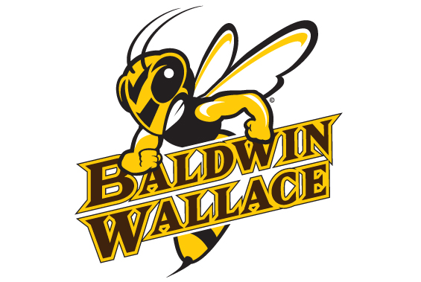
2017
WRESTLING
Recognition Dinner

2016-2017 Team Roster
Weight
Name Year Class Hometown (HS)
Anthony Arroyo SO 165 Maumee / Maumee
Seamus Bermingham SR 149 Orchard Park, N.Y. / Orchard Park
Nicholas Berry FR 125 Dayton / Dayton Carroll
Richie Burke SO 149 Ithaca, N.Y. / Ithaca
Josh Decatur SR 141 Akron / Cuyahoga Valley Christian Academy
Sam Delarge SO 157 Clifton Park, N.Y. / Albany Academy
Chris Doyle SO 125 Akron / Green
Dante Ginnetti FR 133 Poland / Seminary
Brandon Goldsmith FR 174 Westerville / Westerville North
Adam Green FR 165 Austintown / Austintown Fitch
Christopher Head SO 184 Massillon / Jackson
Liam Heslin FR 157 Greenwood Lake, N.Y. / Chester Academy
Benjamin Hooff SO 157 Worthington / Thomas Worthington
Tyler Keating SR 285 Fairview Park / Fairview
Aaron Kelly FR 141 Rocky River / Rocky River
Louie Lachapelle FR 125 Maumee / Maumee
Zeckary Lehman SO 184 Akron / Revere
Tyler Maclellan JR 197 Medina / Cuyahoga Valley Christian Academy
Gabe Mahaney JR 285 Green / Green
Patt McGinnis SR 141 Egg Harbor City, N.J. / Cedar Creek
Graham Montague SR 174 Independence / Independence
Charlie Nash FR 133 Norwalk / Norwalk
Blake Perry SR 174 Jefferson / Jefferson Area
Justin Ransom SO 174 Madison / Madison
Grant Rathburn JR 174 New Albany / Bishop Hartley
James Ritchie JR 197 Carlisle / Carlisle
Nick Sbrocco SO 157 Perry / Perry
David Shapiro SR 157 Beachwood / Beachwood
Collin Shirley FR 285 Rocky River / Rocky River
Andrew Sierawski JR 285 Delaware / Hayes
Eddie Sternad FR 285 Brecksville / Brecksville-Broadview Heights
Zack Taylor SR 141 Brunswick / Brunswick
Christian Wellman FR 125 Applecreek / Waynedale

Baldwin Wallace 2016-2017 Wrestling Schedule

Record: (OAC)**
November 10 at Adrian (Mich.) W, 56-0
November 19 vs. #13 Messiah (Pa.) @ Mount Union Duals; Alliance, Ohio L, 20-15
vs. Alma (Mich.) @ Mount Union Duals; Alliance, Ohio W, 32-6
vs. Greensboro (N.C.) @ Mount Union Duals; Alliance, OH W, 38-7
vs. #11 Stevens Institute of Technology (N.J.)
@ Mount Union Duals; Alliance, OH L, 20-16
November 29 LOURDES W, 36-9
December 3 at New Standards Corporation Invitational 7th of 16 Teams
December 10 vs. #16 York (Pa.) @ Waynesburg Duals; Waynesburg, Pennsylvania W 35-15
vs. The Apprentice School (Va.) @ Waynesburg Duals;
Waynesburg, Pennsylvania W, 46-3
vs. Waynesburg (Pa.) @ Waynesburg Duals; Waynesburg, Pennsylvania W, 30-18
December 17 vs. Olivet (Mich.) @ Gator "Boots" Duals; Nashville, Tennessee W, 34-12
vs. Millikin (Ill.) @ Gator "Boots" Duals; Nashville, Tennessee W, 36-12
vs. Loras (Iowa) @ Gator "Boots" Duals; Nashville, Tennessee W, 33-9
January 5 vs. #13 New York University @ Allen County War Memorial Coliseum;
Fort Wayne, Indiana W, 25-19
NWCA National Duals
vs. #1 Wartburg (Iowa) @ Allen County War Memorial Coliseum;
Fort Wayne, Indiana L, 35-3
NWCA National Duals
January 6 vs. College of New Jersey @ Allen County War Memorial Coliseum;
Fort Wayne, Indiana W, 28-10
NWCA National Duals
vs. #12 Coe (Iowa) @ Allen County War Memorial Coliseum;
Fort Wayne, Indiana W, 25-10
NWCA National Duals
vs. #18 Wisconsin-Whitewater @ Allen County War Memorial Coliseum;
Fort Wayne, Indiana W, 27-13
NWCA National Duals
January 13 at John Carroll * W, 27-11
January 20 vs. Mercyhurst North (Pa.) @ Thiel College; Greenville, Pennsylvania W, 55-0
Mel Berry Duals
@ Thiel (Pa.) W, 48-0
January 24 at Otterbein * W, 37-6
January 28 at Pete Willson-Wheaton (Ill.) Invitational 5th of 34 Teams
January 31 MUSKINGUM * W, 39-6
February 3 OHIO NORTHERN * W, 33-6
February 4 31ST JOHN SUMMA INVITATIONAL 2nd of 13 teams
February 7 HEIDELBERG * W, 26-12
February 14 at Mount Union * W, 32-7
February 26 vs. NCAA Mideast Regional (York) @ York College; York, Pennsylvania 2nd of 19 Teams
March 10 vs. NCAA Division III Championships (Wisconsin-Lacrosse)
@ LaCrosse Center; LaCrosse, Wisconsin 19th of 58 Teams
March 11 vs. NCAA Division III Championships (Wisconsin-Lacrosse)
@ LaCrosse Center; LaCrosse, Wisconsin 25th of 58 Teams

Baldwin Wallace University
2017 Wrestling Recognition Dinner
Welcome and Opening Remarks……………………………….Jamie Gibbs
Dinner
Player Recognition and Honors
Senior Recognition
Closing
End of Year Video

