Widener University
School of Engineering
Department of Mechanical Engineering

ME-303 Mechanical Measurements Laboratory I

Team B: | Email:
Haley Arici | haleygirl96@gmail.com
Tyler Walker | walker.tyler94@gmail.com
Bryan Auxier | auxier102@gmail.com
Andrew Wileczek | andrewwileczek@gmail.com
Cassidy Gardner | cassidysname@gmail.com
Robert Thigpen | Rthigpen162@gmail.com
Experiments:
1. Simple measurements
8. Frequency measurement and sampling rate
9. Buckling of columns

Program Outcomes:
- design and conduct experiments, as well as to analyze and interpret data.
- design a process to meet desired needs within realistic constraints.

Project Objectives:
- The objectives of this experiment will be to use the VCT to show there is linear relationship between the natural frequency of the tested material and its critical load.
- Team B will also introduce changes in material, length and cross-sectional area to observe the frequency/critical load linear relationship is unbiased.
- The final objective is to apply a low magnitude static axial load (less than the critical load) to a material measure its frequency at that applied load to have the ability to predict its specific critical load.

Widener University

School of Engineering
Department of Mechanical Engineering

ME-303
Project Proposal

Vibrating Correlation Technique (VTC) for finding the Critical Load of Columns

Submitted by: Team B
Bryan Auxier
Andrew Wileczek
Tyler Walker
Robert Thigpen
Cassidy Gardner
Haley Arici

Date: 11/10/2017

Abstract:
When analyzing a long column that is subjected to a compressive load, the stability is more important than the compressive yield strength. The stability of a long column is its buckling load also known as critical load. In the mechanical measurements lab for course code ME-303 experiment number nine analyzed the buckling load of columns by physically buckling each specimen. However, there is a modern and superior way to conclude the critical load in a nondestructive manor. The Vibration Correlation Technique (VCT) allows for a linear relationship between natural frequency and critical load to be obtained. In this project Team B will demonstrate this relationship in the lab and document the results. The main goal is to apply an increasing low magnitude static axial load (less than the critical load) to a material to measure its frequency at that applied load to have the ability to predict its specific critical load without degrading the specimen tested.

Introduction and objectives:
The advantage of the VCT is that it is nondestructive. The ability to find a specific buckling load for each new component allows for a greater confidence in the stability of the new part. Experimentally finding the buckling load of a component or member using the conventional method requires taking the material to its actual buckling load. This is common practice because most materials do not leave the elastic region at the buckling load. One might wonder what can be done for materials that fail at their respective critical load. The typical answer to this question is to test as many components as possible to gather data for an average standard deviation to produce a best guess. With this method, when a new component is received from a supplier the buckling load is a statistical range for possible buckling loads from previous components.

The objectives of this experiment will be to use the VCT to show there is linear relationship between the natural frequency of the tested material and its critical load. Team B will also introduce changes in material, length and cross-sectional area to observe the frequency/critical load linear relationship is unbiased. The final objective is to apply a low magnitude static axial load (less than the critical load) to a material measure its frequency at that applied load to have the ability to predict its specific critical load.

Experimental setup:
This project is heavily based on several of the experiments that were performed over the course of the Fall 2017 semester, the most influential being experiments eight and nine however elements of others were used too such as experiment one.

Laboratory eight studied the natural frequency of a cantilever beam and how the sampling of the test affected the ability to detect the vibrations and properly determine the natural frequency. In this test a piezoelectric sensor was connected to a cantilever beam, the beam was struck causing it to vibrate at its natural frequency. The vibrations in the beam were detected by the sensor and the information was sent to a computer that was recording data using LabVIEW (Laboratory Virtual Instrument Engineering Workbench) at various sampling rates. After performing the lab, the experimental data was graphed in excel to determine the natural frequency and compared to values that were obtained using formulas. Laboratory nine examined Column buckling and critical loading. In this test several different size steel columns with different end conditions were tested using a Loading and Buckling of Struts (SM1005). In this machine, the buckling load of each specimen was found experimentally and compared to values determined using Euler’s Critical loading theorem.

This experiment represents the culmination of these laboratories because it uses many of the same apparatuses and theories that were tested in them. One primary difference though is the materials that will be tested, in this project the buckling loads of Brass, Aluminum, Plywood, and Fiberglass will be found using VCT. To perform this experiment, the SM1005 will be used in combination with a piezoelectric sensor and LabVIEW, to determine the natural frequency of a partially loaded column and by performing a series of data analysis and calculations the buckling load will be determined without buckling the columns in question.

Methods and resources:
When a component can no longer support an increased load due to instability caused by bending this is the members buckling load. Depending on the material the buckling load can be experimentally found by simply applying an increasing load while measuring maximum deflection. When there is an increase in the load but no increase in the deflection the buckling load of the component has been reached. In most metals this method works well because at the buckling load the material does not leave the elastic region and no failure has occurred. This method is also assuming the member can be tested as an individual specimen. In the aerospace industry composite materials are often used for their strength versus weight ratio. The issue with finding the buckling load of a composite such as carbon fiber is the laminated layers inherently associated with manufacturing the composite. When subjecting a composite to its buckling load it will be compromised due to delamination between the layers. This substantially weakens the specimen tested potentially destroying it. A test of 100 carbon fiber specimens can be performed to find the standard deviation and or average of the buckling load. There are two main reasons why this method is substandard. First, composite parts are expensive to manufacture, a single carbon fiber shell can cost as much as $100,000. Second, the average standard deviation is not specific to some individual specimens buckling load, it is just the best guess. At such a high cost for one sample the 100-specimen test using the conventional method for finding the buckling load would be a 10-million-dollar experiment to conclude a statistic for the new components buckling load. For most companies this is not a practical solution because it's too expensive for the concluded statistical results. What is needed is a way to find the buckling load without damaging or destroying the specimen. The Vibration Correlation Technique [7] is a new technique in nondestructive testing. Multiple increasing low magnitude static axial loads are placed on the tested specimen and the frequency of the material is measured. The buckling load will be obtained when the measured frequency reaches zero. The measured data will be plotted with (1-p)² on the y-axis and (1-f ⁴) [7] on the x-axis where p=P/P_{cr} and f=f_{m}/f_{ω} where P is the static load applied, P_{cr} is the desired critical load, f_{m} is the measured frequency at load P and f_{ω} is the natural frequency or measured frequency and P = 0. When the relationship of the plotted data between (1-p)² and (1-f ⁴) show a linear line, the team will be able to solve for P_{cr}. The project budget per team is $50.00 however the team plans to spend no money to complete this project. A list of all the required references to complete this project is listed in the reference section of this document [1] [2] [3] [4] [5] [6] [7] [8].

A column is typically a support use to hold a force applied from a structure. In past experiments the team looked at compressive loads and how they affect materials. It is more common for a beam or column to fail from bending or buckling then compression when subjected to a force. Buckling is when the material has reached its maximum bend just before complete failure. Euler’s maximum axial buckling load or critical load equation was used as the theoretical control for this experiment. The Euler formula was given by the equation

$$P_{cr}= \frac{π^{2}EI}{{\left(KL\right)}^{2}}$$

where (E) is the modulus of elasticity, (I) is the moment of inertia, (L) is the length of the specimen and (K) is the effective length factor. The (K) in this equation is a multiplier to the length of the specimen to reduce its size due to an end mounting condition. In part I a 600mm steal specimen was placed on the testing stand with both end mounting conditions as pinned and a load of ~90N was applied until the defection was ~6mm. Measurements were taken every 25mm from end to end and the data was plotted with the theoretical shape of deflection in Figure 3

I = $\frac{{bt}^{3}}{12}$

A = $bt$

f = $\frac{1}{period}$

A simply supported beam that undergoes a vibration can be measured for the frequency of that vibration. The natural frequency of a vibration in a continuous beam of a fixed length is given by the equation

$$ω_{n}=\frac{{\left(3.142\right)}^{2}}{L^{2}}*\sqrt{\frac{E*I}{ρ*A}}$$

where L = Length of the beam, E = modulus of elasticity of the beam material, I = moment of inertia, ρ = the density of the beam material and A = the cross-sectional area of the beam. The moment of inertia was calculated using the equation

The beam was fixed to a testing stand and a piezo-electric sensor

Results:

Table 1: Cross-Sectional Measurements
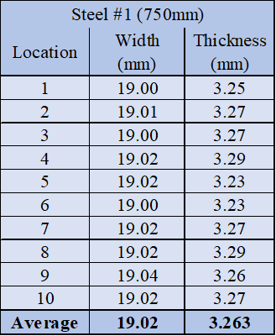

Table 2: Specimen Material Properties and Structural Geometry
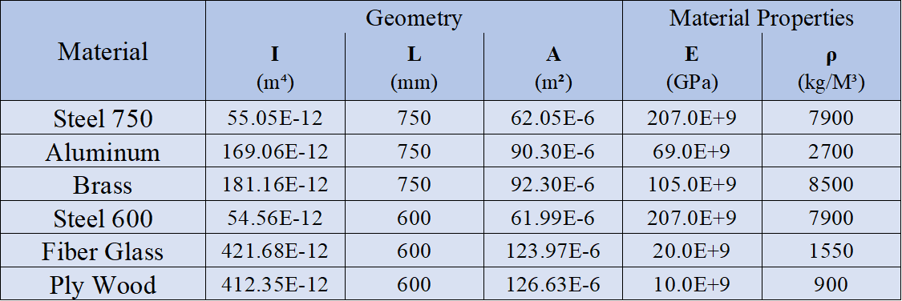

Table 3: Measured Buckling Load Compared to Calculated Theoretical
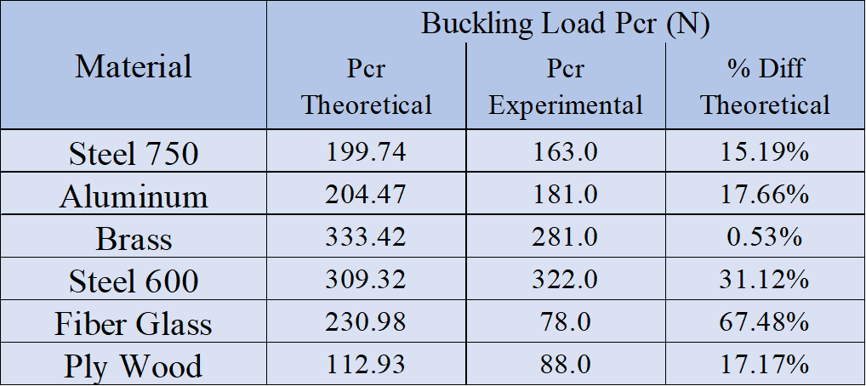

Figure 1: Fiber Glass Cross-section Graph

Talk about slope percent difference

Figure 2: Dimensionless Steel Length 0.75m f_{n} and P_{cr} Linear Relationship

Figure 3: Dimensionless Steel Length 0.6m f_{n} and P_{cr} Linear Relationship

Figure 4: Dimensionless Fiber Glass f_{n} and P_{cr} Linear Relationship

Table 4: Graphically Predicted Experimental Buckling Loads

Table 5: Measured Natural Frequency Compared to Calculated Theoretical

Figure 5: Steel Length 0.75m Graphically Verified P_{cr} Using Slope

Figure 6: Brass Graphically Verified P_{cr} Using Slope

Figure 7: Aluminum Graphically Verified P_{cr} Using Slope

Figure 8: Steel Length 0.6m Graphically Verified P_{cr} Using Slope

Figure 9: Fiber Glass Graphically Verified P_{cr} Using Slope

Figure 10: Ply Wood Graphically Verified P_{cr} Using Slope

The whole reason for this is that you don’t know the buckling load in the first place

Now………..

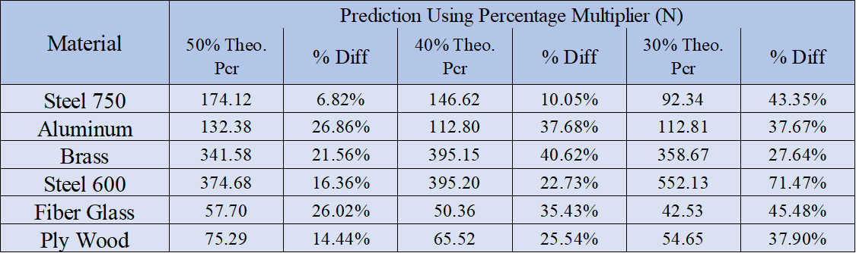

If you can calculate the theoretical buckling load, then use a fraction of it
Or apply small static loads and use the slope
What is the normal fudge factor for designs
Another way is to destroy one specimen to get an idea of the buckling load to get your fraction multiplier

Figure 11: Loaded with 50% Theoretical P_{cr} Graphically to Predict P_{cr} Using Slope

Figure 12: Loaded with 40% Theoretical P_{cr} Graphically to Predict P_{cr} Using Slope

Figure 13: Loaded with 30% Theoretical P_{cr} Graphically to Predict P_{cr} Using Slope

Appendix stuff-----------------------

Appendix A:

Figure 4: Dimensionless Aluminum f_{n} and P_{cr} Linear Relationship

Figure 4: Dimensionless Brass f_{n} and P_{cr} Linear Relationship

Figure 4: Dimensionless Ply Wood f_{n} and P_{cr} Linear Relationship

Table 11: All Recorded Experimental Specimen Cross-Sectional Measurements

References:

Experiment #8:
[1] Widener University School of Engineering. "Experiment #8 Frequency Measurement and Sampling Rate." Campus Cruiser. Department of Mechanical Engineering, 28 Aug. 2017. Web. 08 Nov. 2017.

Piezo-electric Sensor:
[2] Gautschi, G, Piezoelectric Sensorics: Force, Strain, Pressure, Acceleration and Acoustic Emission Sensors, Materials and Amplifiers. Springer, 2002.

Theory of Experiment #8:
[3] Anthony J. Wheeler A.J. Ganji A.R., Introduction to Engineering Experimentation, 3rd Edition, Prentice Hall, 2009.

Experiment #9:
[4] Widener University School of Engineering. "Experiment #9 Buckling of Columns." Campus Cruiser. Department of Mechanical Engineering, 28 Aug. 2017. Web. 08 Nov. 2017.

Objectives and Rules for Technical Documents:
[5] Widener University School of Engineering. "Objectives and rules." Campus Cruiser. Department of Mechanical Engineering, 28 Aug. 2017. Web. 08 Nov. 2017.

Course Text Book:
[6] Mott, Robert L., et al. “Principles of Design and Stress Analysis.” Machine Elements in Mechanical Design, Pearson, 2018, pp. 27–29.

Linear (VCT):
[7] M. A. Souza, W. C. Fok, and A. C. Walker, “Review of experimental techniques for thin-walled structures liable to buckling, part I—neutral and unstable buckling,” Experimental Techniques, vol. 7, no. 9, pp. 21–25, 1983.

Modified Nonlinear (VCT):
[8] M. A. Arbelo, S. F. M. de Almeida, M. V. Donadon et al., “Vibration correlation technique for the estimation of real boundary conditions and buckling load of unstiffened plates and cylindrical shells,” in-Walled Structures, vol. 79, pp. 119–128, 2014

