ME-351: Kinematics
Summer 2018

Project Report

Independent Automobile Front Suspension and the transfer of energy scaled model Analysis

Team III:
Bryan Auxier
Andrew Wileczek
Matthew Corrigan
Edward Andrescavage
Date: August 3, 2018

Table of Contents

Introduction…………………………………………………………………….…...3

Kinematic Analysis…………………………………………………………………4

Functional Model…………………………………………………………………...7

Conclusion………………………………………………………………………....10

Appendix………………………………………………………………………......11

References…………………………………………………………………..……..12

Introduction
Automobile suspensions are a common but essential aspect of automobile design. To travel through a wide variety of terrains, an automobile tire must maintain constant contact with the ground to provide proper friction for traction. Without an articulated suspension that maintains this contact, bumps or changes in elevation can easily shift the wheels off-center and cause them to lose full, flat contact with the ground. This situation applies additional moment and shear stress to the axle and decreases the friction between the tire and ground, which can result in the loss of control of a vehicle. Therefore, to achieve a smooth and safe ride, a front suspension system that allows the tires to “give,” or to trace through a prescribed motion in response to changes in elevation is an absolute necessity in all modern automobiles.

Fundamentally, the front suspension of an automobile can be modeled kinematically as a four-bar linkage. The design constraints of this device include controlling the desired path of the multiple links (primarily the coupler, which is attached to the wheel) and maximizing passenger comfort (which is directly related to how much the linkage can move).

For this project, Team III designed and built a scale model of a front-end suspension that mimics the motion of a real automobile suspension system. The basis for the design was a planar four-bar linkage with the usage of a spring as an additional link. In addition, to demonstrate the motion that the suspension design imposes on the frame of the vehicle, the team created a rotating belt with a grooved track to drive the wheel. The rotating belt operates akin to a treadmill for the wheels, allowing stationary wheels to travel along the belt and simulate driving over uneven terrain. The belt is powered by a motor linked to a linear Geneva mechanism, which both drives the belt forward intermittently and creates a hump in the track to simulate bumps. As the wheels follow the humps in the track, the suspension linkage system undergoes its prescribed motion, keeping the wheels aligned and the contact area constant.

Furthermore, the rotating belt is mechanically linked via a gear train to a paper scroll and a marking device to record the output path of the suspension linkage. As the wheel travels over different elevations, the setup draws the path of motion of the linkage system as the suspension responds to the changes in terrain.

Kinematic Analysis

To mimic the motion of a real-world auto suspension, a basic four-bar linkage was utilized due to its versatility and ability to control the motion of multiple points. In a suspension, the motion is largely oscillatory, moving up and down due to bumps and elevation changes in the road surface. In response, Team III determined that either a special-case Grashof linkage or non-Grashof triple-rocker linkage would be suitable to produce the required oscillatory movement in the coupler link. Furthermore, to achieve constant contact area between the tire and ground, the wheel is required to be restricted from lateral motion and only translate vertically. In terms of a four-bar linkage, this means that the coupler link, representing the chassis of the car, must only move in straight, vertical motion. An analogous model of this type of linkage is a walking-beam conveyor, such as the one shown in Figure 1. below.

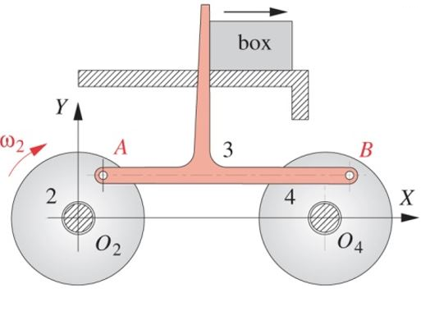

Figure 1: Walking beam conveyor as a four-bar linkage

For this type of mechanism, the crank (link 2) is the input link, which drives the motion of the coupler (link 3) and the output link, or rocker (link 4). The crank and the rocker are equal in length, and the coupler is the same length as the ground link. This configuration is a special-case Grashof or Class III linkage, where the Grashof condition results in the following:

S + L = P + Q (1)

where S is the shortest link, L is the longest link, and P and Q are the remaining links. For this case, the linkage is a double-crank, where links 2 and 4 can rotate fully. However, for the project design, full rotation of the linkage is undesirable and was avoided through the addition of limit stops (namely the track and an additional spring). Consequently, since the input and output links are the same length and rotate at the same angular velocity, the coupler and any point P connected to it (such as the wheel and tire) move in a restricted translational motion. A schematic diagram of the four-bar linkage can be seen in Figure 2.

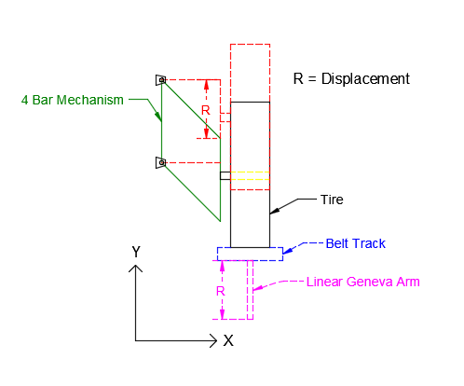

Figure 2: Schematic Diagram of Four-Bar Linkage

The four-bar linkage is driven by the motion of the linear Geneva mechanism. In the final design, a loose belt was used so that as the crank arm drives the track forward, it provides tension in the belt and forms the hump for the tire to travel over. Each bump drives the motion of the four-bar linkage by pushing up on the coupler link via the tire. As the arm approaches its maximum height (at a rotation of 90°), the four-bar linkage is driven towards its maximum vertical displacement. Once the four-bar linkage travels through its max displacement, its motion is limited by an additional spring link. Upon reaching this point, the linear Geneva continues to drive the coupler up-ward, but the system is damping some energy. This was to show the Impact on a passenger. The addition of a translating joint was required to prevent the four-bar linkage from creating a bending moment. The linkage with the lockout pin installed imitates the effect on passengers in the cabin with the absence of a suspension system. This was visually confirmed by the magnitude of the line recorded on the paper scroll.

As previously mentioned, the pen draws on an unraveling paper scroll that is driven through the motion of the linear Geneva mechanism. The rotation of the belt as actuated by the linear Geneva is used to drive a gear train, which transmits the motion to a vertical shaft that unravels and collects paper from a paper scroll on the opposite side of the device. A schematic diagram of the gear train is illustrated in Appendix A.

In effect, the output of the gear train rotates a shaft that unravels the paper roll. This allows the paper to unroll intermitted in time with the rotation of the linear Geneva and provides a moving surface upon which the pen (attached to the ground of the four-bar linkage) can trace the path of the suspension motion through each Geneva crank rotation. As a result, this creates a visual representation of the suspension’s movement.

The purpose of this recording device was to illustrate how the impact experienced by passengers could be lessened using a suspension. To demonstrate this, a “lockout” pin was utilized that would prohibit the motion of the four-bar linkage. Inserting this pin into the four-bar linkage mechanism restricted the degree of freedom of the linkage to 0, reducing the suspension to a structure. This setup could simulate the motion of a vehicle chassis without a suspension system, as it would transfer the energy of riding over the bump directly into the kinetic energy of the chassis, resulting in undamped motion of the chassis.

Degree of Freedom Analysis:

A major goal of the project was to design the mechanism such that it could perform all its functions with only one degree of freedom (DOF) calculation can be found in Appendix A. In other words, only one input would be necessary to drive the motion of the system, such as through a single motor, so that the design could be kept simple. In general, the degree of freedom (or mobility) of any kinematic system can be determined by the Grübler-Kutzbach equation, which can be expressed as:

M=3(L-1)-2J1-J2 (2)

where M is the mobility or degree of freedom, L is the number of links, J₁ is the number of 1 DOF (full) joints, and J₂ is the number of 2 DOF (half) joints. Applying Equation (2) to the a four-bar linkage (4 links, 4 revolute joints with 1 DOF) results in the following:

M=3( (4) -1 )-2(4)-(0)

M=1

Similarly, the linear Geneva mechanism was modeled as a four-bar linkage and analyzed under similar conditions. By nature, a linear Geneva mechanism is essentially an Inversion #1 slider-crank mechanism with intermittent dwells, since it transfers rotational motion (the rotating crank) into translational motion (the sliding track) in short bursts. A slider-crank itself is simply a modified four-bar linkage, which means that linear Geneva mechanism must also have only 1 DOF, driven by its input crank. This is demonstrated in the final design as the linear Geneva crank was driven through a single motor, which in turn was used to drive the motion of the four-bar linkage through the tire on the coupler link.

Functional Model
Images of the functional scale model of the real-world mechanisms can be seen below in Figures 3 through 11.

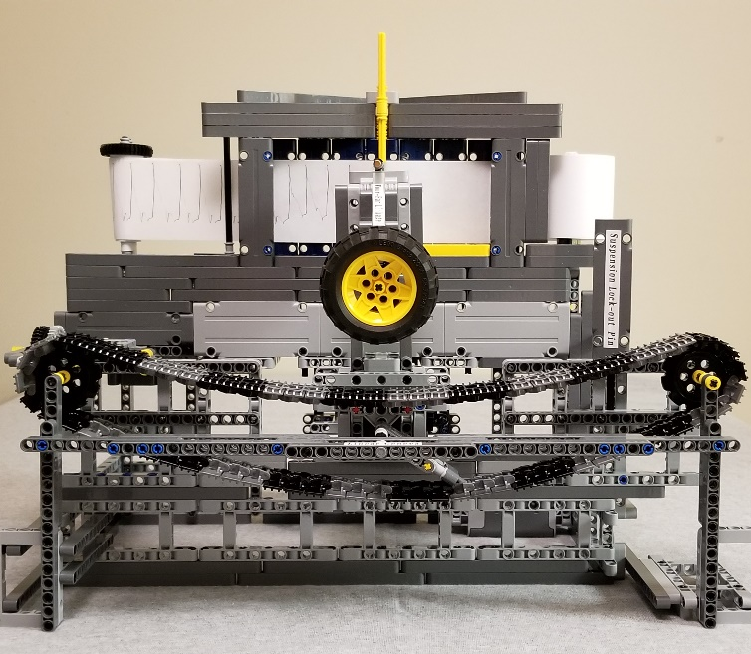

Figure 3: Kinematic model (Frontal view)

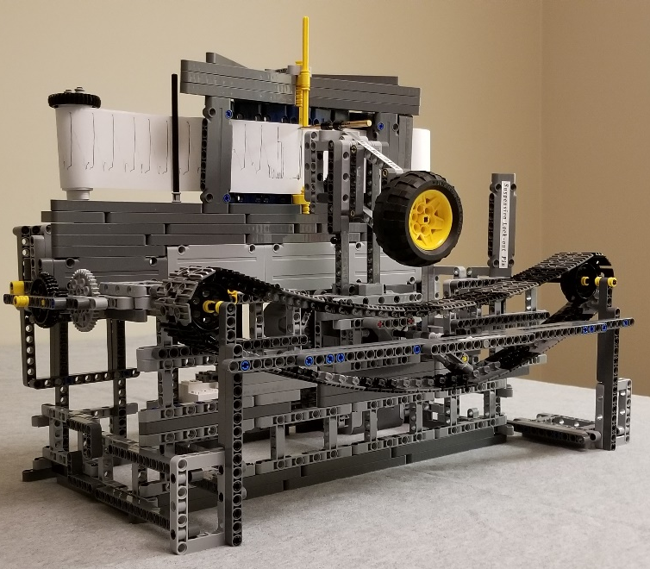
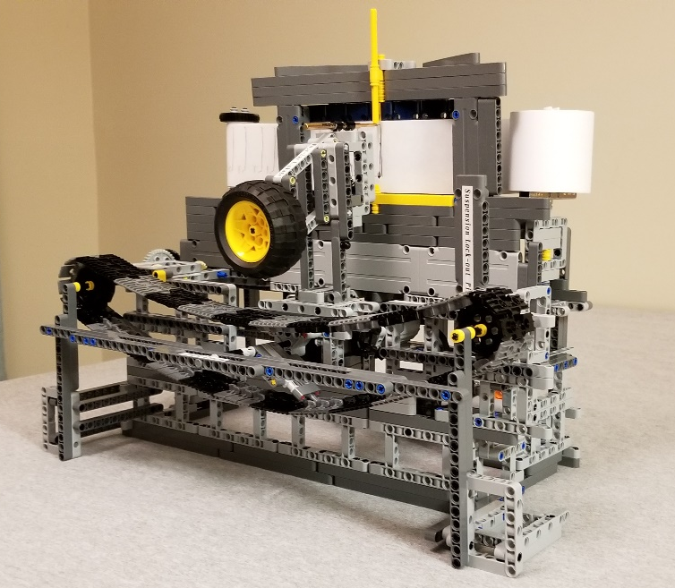

Figure 4: Kinematic model (Left view) Figure 5: Kinematic model (Right view)

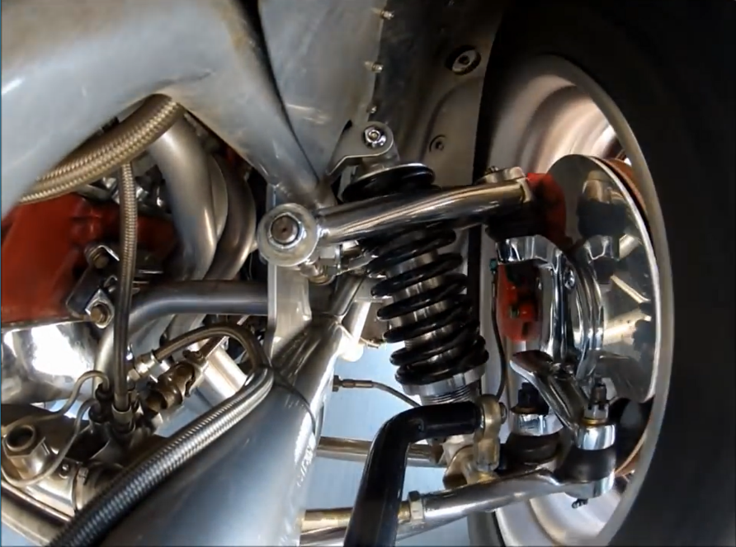

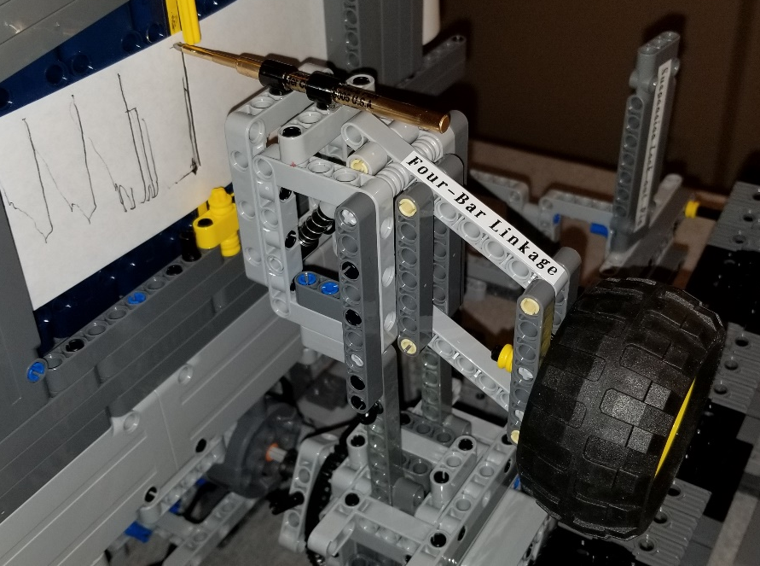

Figure 6: Four-Bar Linkage Mechanism Figure 7: Independent front suspension

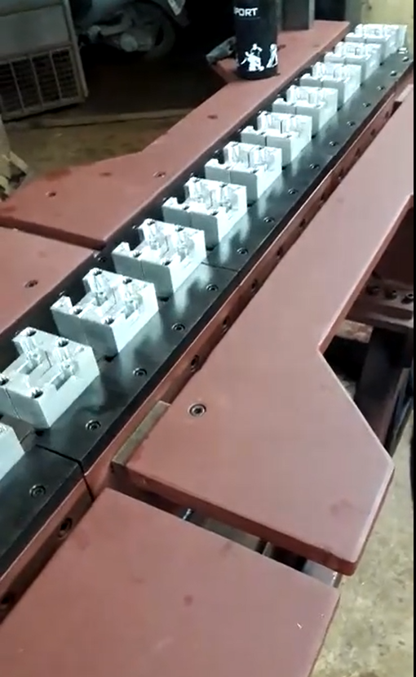
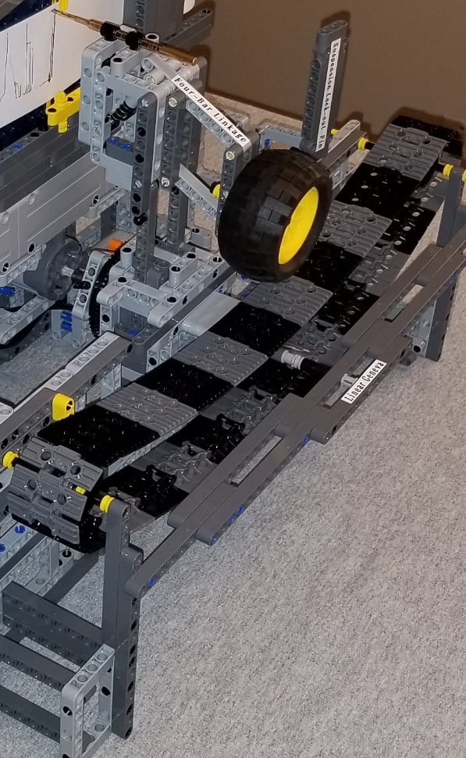

Figure 8: Linear Geneva Mechanism Figure 9: Conveyor belt with prescribed
dwell periods

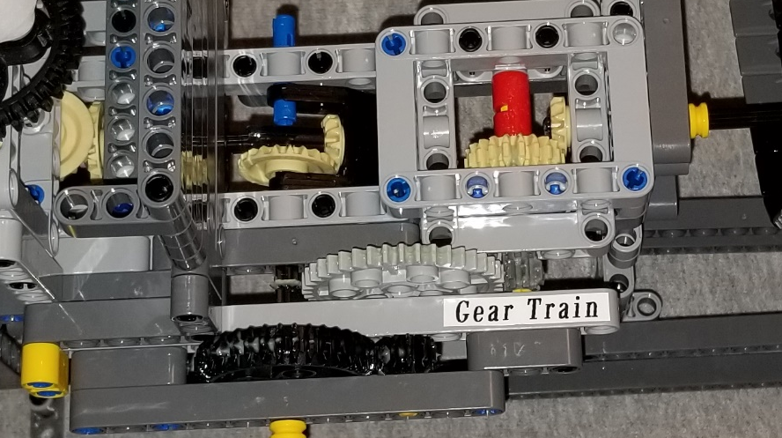

Figure 10: Modeled Gear Train

Conclusion
The primary goal of this project was to design and build a mechanism which imitates the behavior of a real device. After investigating many options, Team III decided to replicate the front suspension of an automobile. This was accomplished by creating a test stand that combines several devices to demonstrate the mobility of a front suspension over changing terrain.

The essential components of the completed mechanism are a four-bar linkage, designed to simulate the motion of a suspension, and a linear Geneva mechanism, which both drives a belt with intermittent motion for the tire to travel along and creates humps in the track that actuates the four-bar linkage. In addition, a sliding joint was connected in tandem with the four-bar allow it to function as a slider-crank after maximum displacement and giving it a greater range of motion. In addition, a gear train was linked with the linear Geneva belt to transfer the rotational motion to unravel a paper scroll, used to record the movement of the four-bar linkage through an attached pen.

As illustrated in the accompanying photographs and video provided with this report, Team III successfully created a working model that not only demonstrates the kinematic motion of a front suspension, but also visually depicts the displacement that would be experienced by the vehicle occupants with and without the suspension. Furthermore, the project was designed with just one degree of freedom, meaning every function of the mechanism can be driven with just one motor. As shown above, the mobility of this mechanism was confirmed by using the Grübler-Kutzbach formula and the Grashof condition was confirmed by using Grashof’s Law.

This functional demonstration model illustrates the core reasons that establish the suspension as an essential component for all cars and trucks on the road. In the real world, the suspension of an automobile is a critical component that serves many functions, from maintaining the contact of the tires with the ground, to providing a smooth and comfortable ride to the passengers in the cabin. This mechanism softens the impacts experienced by vehicles in every life and ensures that automobile drive safely and comfortably.

Appendix A

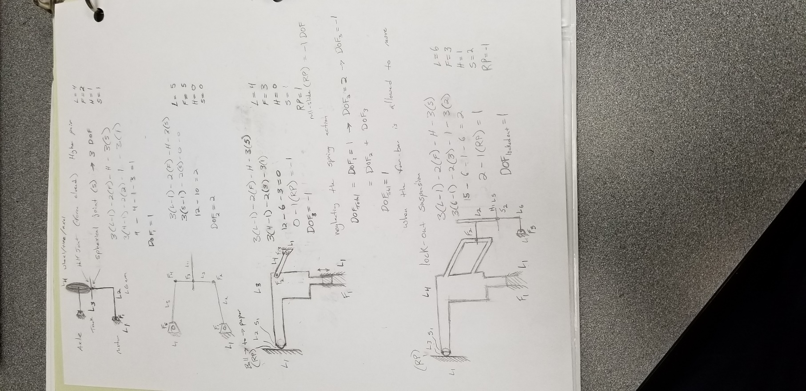

Figure 12: Degree of Freedom calculations

References

Norton, Robert L. Design of Machinery: An Introduction to Synthesis and Analysis of Mechanisms and Machines. 5th ed., McGraw-Hill, 2014.
Tci, director. YouTube. YouTube, YouTube, 18 Sept. 2012, www.youtube.com/watch?v=CF6YMHf1Cdk.
Nelmon, director. YouTube. YouTube, YouTube, 10 Aug. 2017, www.youtube.com/watch?v=rlQRGeKXwcE.

