Jenna Eggert
Dr. Pearl Rosenberg
EDU 191
19 February 2018
Analysis of Gallery Drawing
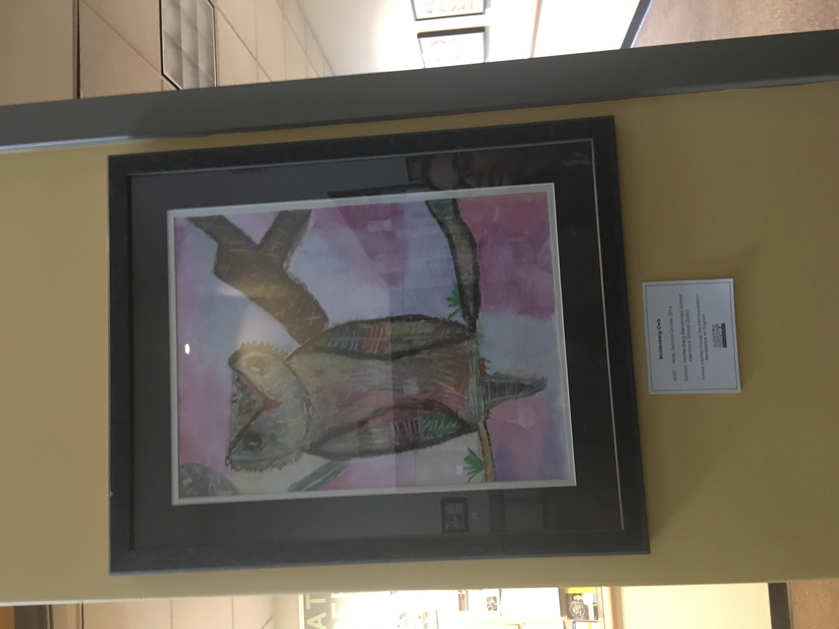
I chose to write my analysis on a drawing of an owl by second grader Noel from Muhlenberg Elementary School. One thing that strongly caught my eye was the artist’s emphasis on color, such as the pink in the background, green of the grass, red of the owl’s nose, and the many colors of the oil’s feathers and body. Additionally, I observed that Noel used a very unique technique to give the tree branches and the owl texture; she made scratch marks with what appears to be her fingers. The scratches may also mean that Noel was trying to add a sense of realism into her drawing. Noel also used very definitive lines in her drawing. The outlining of the owl’s wings and the tree branches is very pronounced. I like the variety of thickness between the branch the owl is sitting on and the tree in the background. Additionally, I observed that she did not erase the pencil line that she made through the middle of the drawing. I think she made have used this line as a baseline for where the owl should sit and where the sky should begin. I personally really enjoy this drawing because it is colorful but also has hints of realism, such as how everything is spaced on the page. The color may not be realistic, but the way the owl is perched on the tree is accurate.
There is a lot that I can interpret about Noel through her art. Knowing that Noel is a second grader, she would fall into what Piaget called the Concrete Operational stage. She most likely has the ability to think logically about concrete or hands-on problems, understands conservation, and organizes things into categories and in series. I can tell that Noel can think concretely because there are aspects of realism in her drawing. The owl may be colorful but it also has many accurate features. She has long surpassed the scribbling or tadpole phase of making art. As Noel is progressing through the stages of Piagetian development, she is also progressing through certain stages of development in her art making. It is obvious through Noel’s drawing that she is able to somewhat realistically represent an owl. She may know what color an owl is but liked the idea of drawing in color. She understands the idea that objects do not randomly float in space, as seen by the precise way the owl is perched on a branch. Noel obviously has a more complex understanding of the world than a kindergartener or first grader. She has a relatively strong visual awareness of the things around her, but probably is not self critical yet or aware of any inaccuracies in her art. Her owl has aspects of realism, but it is still colorful, unlike the gray or brown owls you find in real life. The use of color in her drawing may mean that she was in a good mood when she drew her picture, or she just wanted to put a fun spin on owls. She may have also just been drawn to the colors and instinctively chosen them. Through Noel’s drawing, I can tell that she is very expressive and original. As she grows older, she may lose these qualities if not instructed and motivated in the correct way. Therefore, I really enjoy looking at Noel’s art and find it to be effective because it has a certain charm, novelty, simplicity, and playfulness but also expresses a lot about Noel and her progression in development.

