Janeel Solanki

CSC 356 – 010

Spring 2018

Due: 4/11/2018

Submitted: 4/11/2018

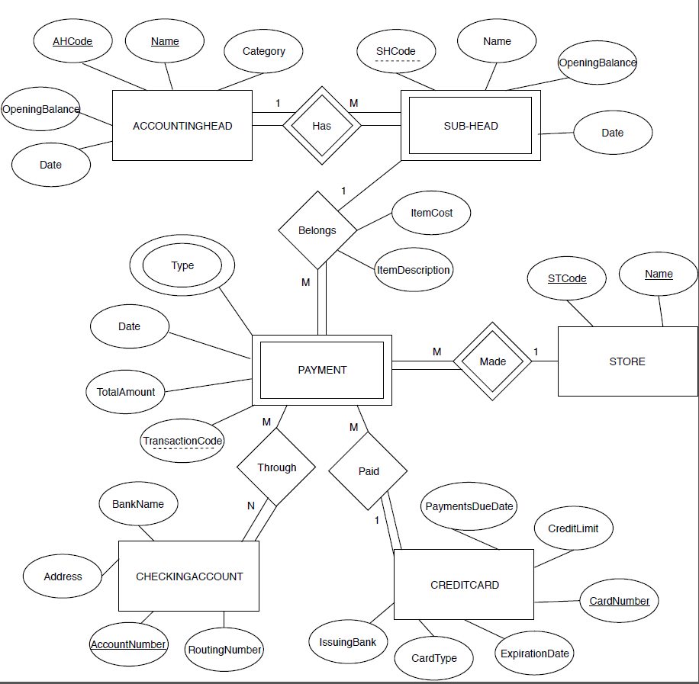Project Phase I

Assumptions:

* All account numbers are unique for the individual.
* Every payment has a unique transaction code on the receipt.
* Every credit card number is unique.

Relational Schema

AccountingHead (AHCode, Name, Category, OpeningBalance, Date).

Store (STCode, Name).

CheckingAccount (AccountNumber, BankName, Address, RoutingNumber).

CreditCard (CardNumber, PaymentDueDate, Credit Limit, Expiration Date, Card Type, IssuingBank).

FK

Sub-Head (SHCode, Name, Opening Balance, AHCode).

FK FK FK

Payment (TransactionCode, Total Amount, Date, STCode, SHCode,AHCode, CardNumber).

FK FK

Through (TransactionCode, STCode, AccountNumber).

FK

TypeofPayment (TransactionCode, STCode, Type).

|  |  |  |
| --- | --- | --- |
| **Date** | **Hours** | **Activity** |
| 3/31/2018 | 5 | Design the ER Model based on the given case. |
| 4/1/2018 | 4 | Add constraints to the ER Model & create the relational schema based on the ER model. |
| 4/2/2018 | 2 | Edit the ER Model and constraints based on feedback. |
| 4/3/2018 | 3 | Fix the Relational Schema using the updated ER Model. |
| 4/4/2018 | 1 | Review the final ER diagram and Relation Schema |

Log Table