# Manual Written By:

Janeel Solanki, Nicholas Paolella and Matt Sauchelli

Advanced Networking Project

CSC 411

Dr.Frye

Spring 2018

IT Majors

Switch Labs Project

# Table of Contents

**Manual Written By:** **1**

**Table of Contents** **2**

**Gantt Chart** **3**

**Project Lab 1** **4**

Create vlan byport 4

Add IP address to vlan 4

Add ports to vlan 5

Enable telnet 5

Configure Client IP address, subnet mask, and default gateway 5

Save all configurations 6

Display forwarding table 6

Forwarding table explanation 6

**Project Lab 2** **7**

Create vlan and assign IP address 7

Add ports to the vlan 7

Enable RIP 7

Add appropriate routes to vlans 7

Show vlan information 8

Switch 5 8

Switch 7 12

Show routing table 16

Switch 5 16

Switch 7 16

Ping from Switch 5’s Client to all the vlans 17

Ping from Switch 7’s Client to all the vlans 18

Save all the configurations 19

Network Diagram 20

**Project Lab 3** **21**

Assign values to MIB variables 21

Download files from course website 21

SNMPWALK of the mgmt.system subtree 22

SNMPGET of the sysName and sysLocation variables 22

**Imunes** **24**

# Gantt Chart

[Gantt Chart Link](https://docs.google.com/spreadsheets/d/1csCLF7YMAvEWCuUhCHSWtXR5LiHDPwnPR7H9eWb6UfM/edit?usp=sharing)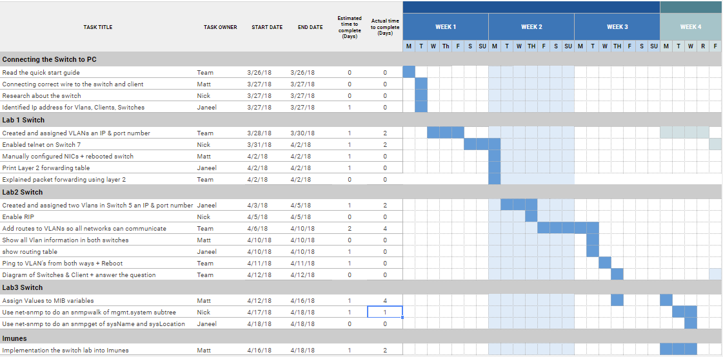

# Project Lab 1

### Create vlan byport

1a)

Command: config vlan 70 create byport 1

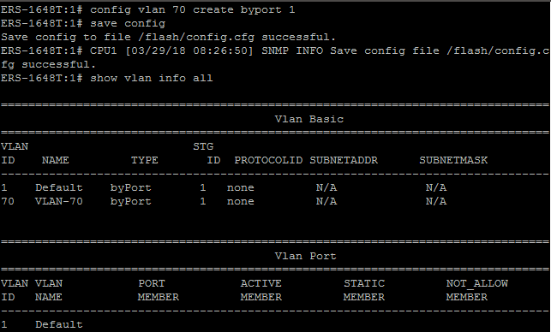

### Add IP address to vlan

1b)

Command: config vlan 70 ip create 192.168.200.1/255.255.255.0

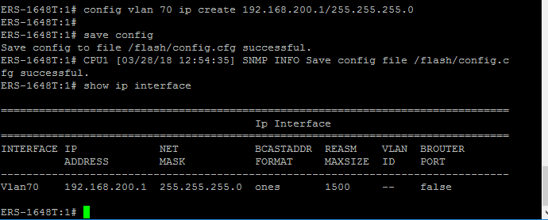

### Add ports to vlan

1c)

command: config vlan 70 ports add 1/1-1/52

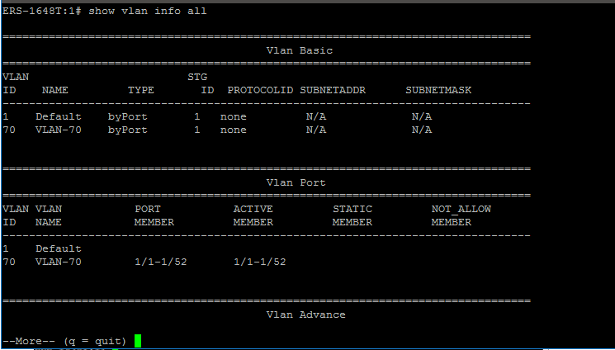

### Enable telnet

1d)

Command: config bootconfig flags telnetd true

Control Panel -> Programs - > Windows Features -> Telnet Client -> Enabled - > OK

### Configure Client IP address, subnet mask, and default gateway

2)

IP address first client: 192.168.200.10

IP address second client: 192.168.200.11

Subnet mask: 255.255.255.0

Default gateway: 192.168.200.1

Command: Ping <IP addr>

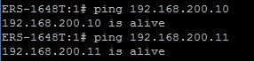

### Save all configurations

3)

Commands: save config; save bootconfig; save boot; boot → y;

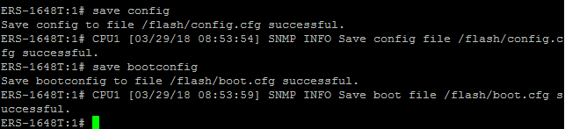

### Display forwarding table

4)

Command: show vlan info fdb-entry 70

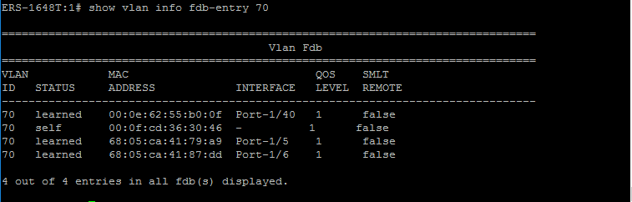

### Forwarding table explanation

5)

The packet sent from client one to client two would use the switch’s forwarding table to identify the corresponding MAC address for client two’s IP address because as shown in the previous questions’ answer, the forwarding table of the switch contains both client’s MAC addresses. Which enables client one to identify the correct MAC address of client two and thus does not have to send a broadcast message.

# Project Lab 2

### Create vlan and assign IP address

1a)

Commands:

-config vlan 60 create byport 1

-config vlan 80 create byport 1

-config vlan 75 create byport 1

-config vlan 80 ip create 192.168.110.1/255.255.255.0

-config vlan 75 ip create 192.168.111.1/255.255.255.0 (Switch 5)

-config vlan 75 ip create 192.168.111.2/255.255.255.0 (Switch 7)

### Add ports to the vlan

1b)

Commands:

-config vlan 80 ports add 1/25-1/48

-config vlan 75 ports add 1/40 (Both Switches)

### Enable RIP

2)

Commands:

-config ip rip enable

-config vlan 75 ip rip enable (Both Switches)

-config vlan 70 ip rip enable

-config vlan 80 ip rip enable

-show ip rip info

-show ip rip interface

### Add appropriate routes to vlans

3)

Commands:

-config ip static-route create 192.168.200.0/255.255.255.0 next-hop 192.168.111.2 cost 1 (Switch 5)

-config ip static-route enable 192.168.200.0/255.255.255.0 next-hop 192.168.111.2 (Switch 5)

-config ip static-route create 192.168.110.0/255.255.255.0 next-hop 192.168.111.1 cost 1 (Switch 7)

-config ip static-route enable 192.168.110.0/255.255.255.0 next-hop 192.168.111.1 (Switch 7)

-save config

-show ip static-route info

### Show vlan information

4) Command:

-show vlan info all

#### Switch 5

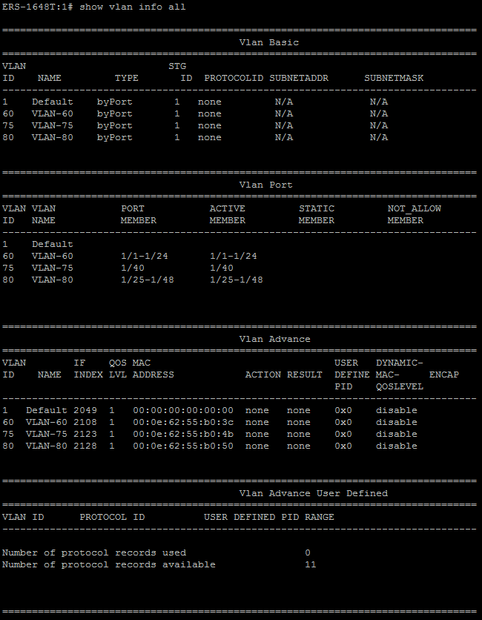

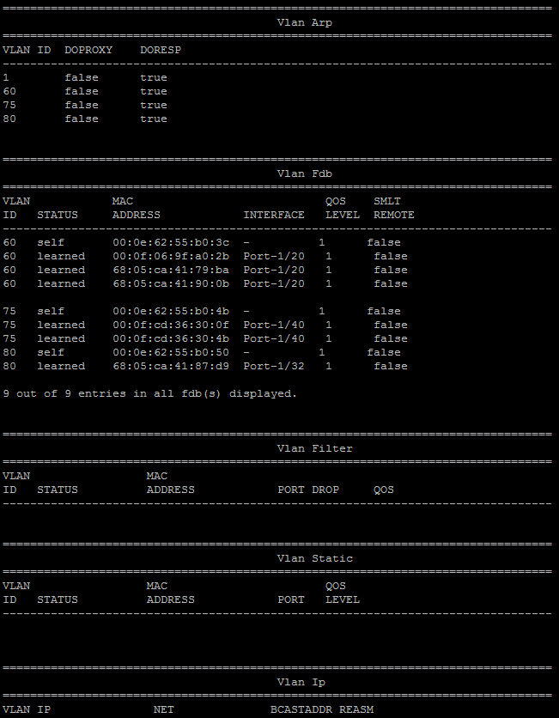

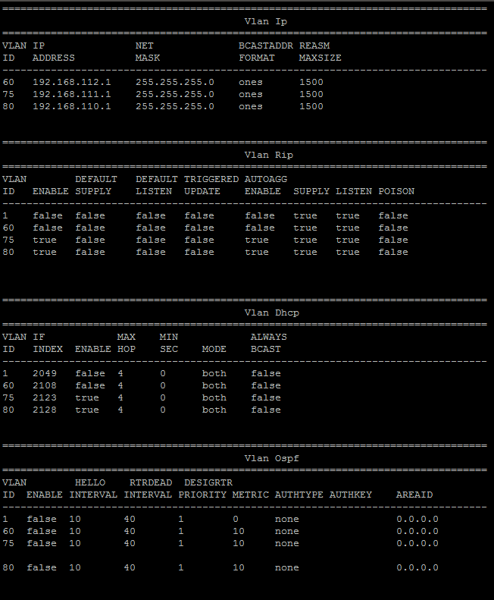

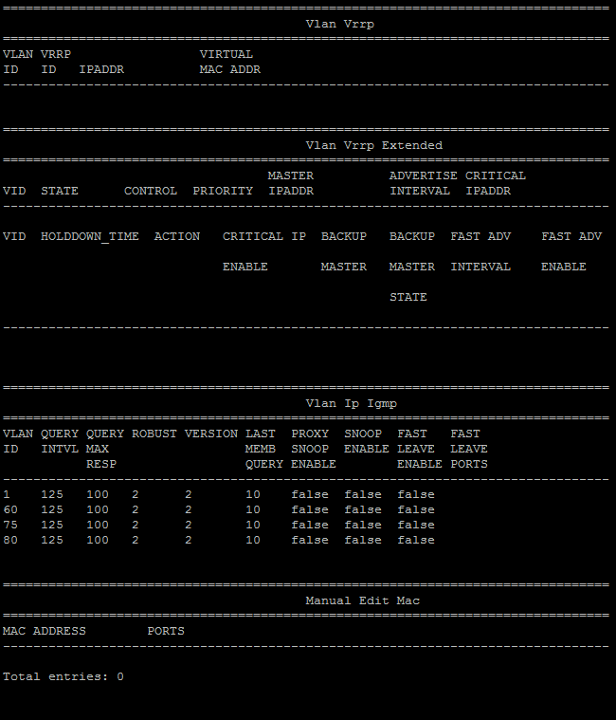

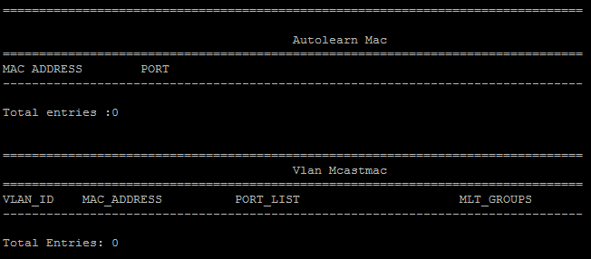

#### Switch 7

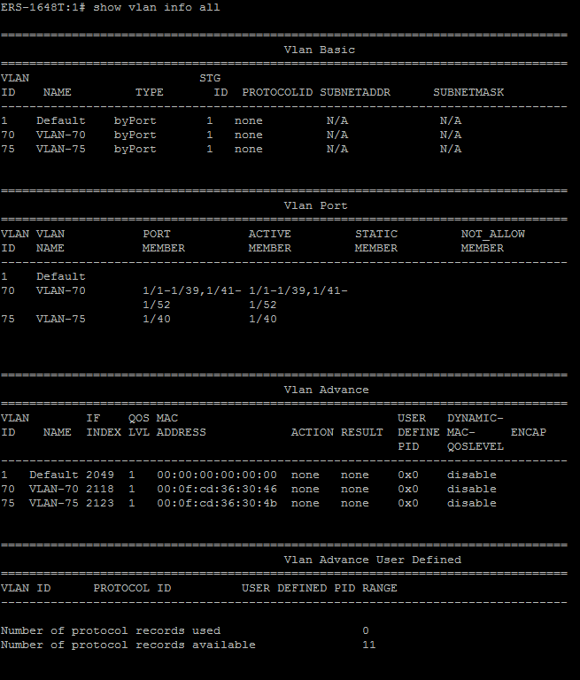

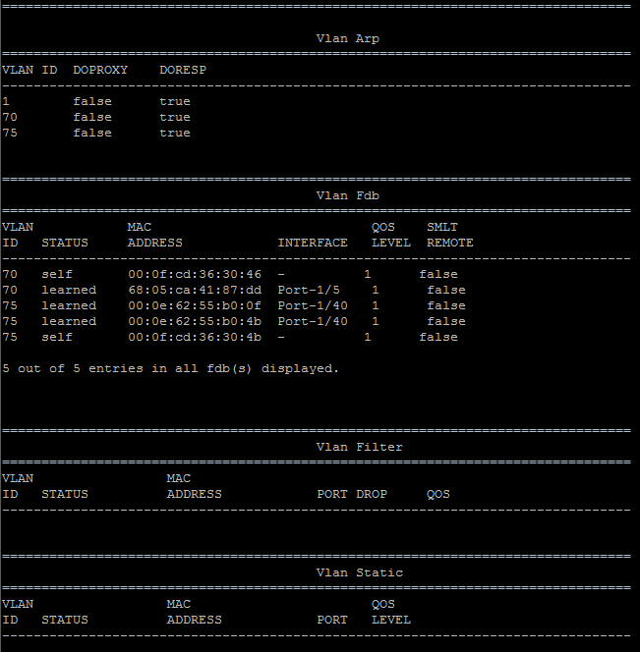

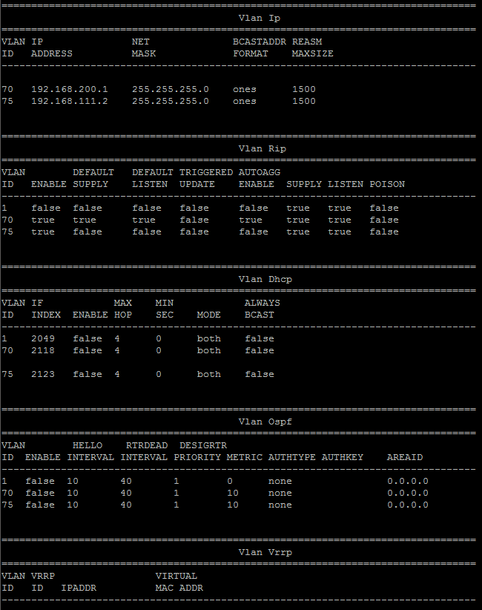

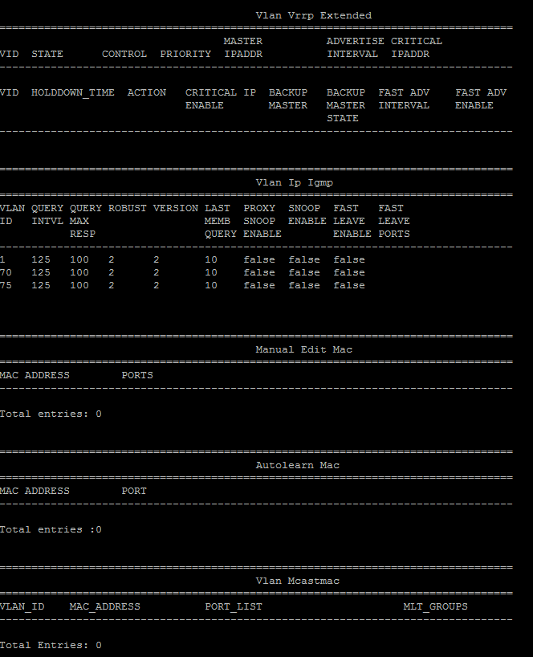

### Show routing table

5)Command:

-show ip route info

#### Switch 5

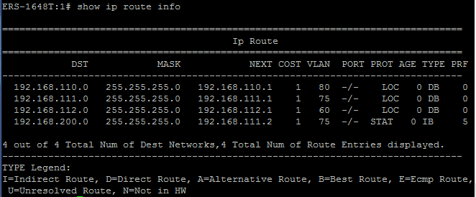

#### Switch 7

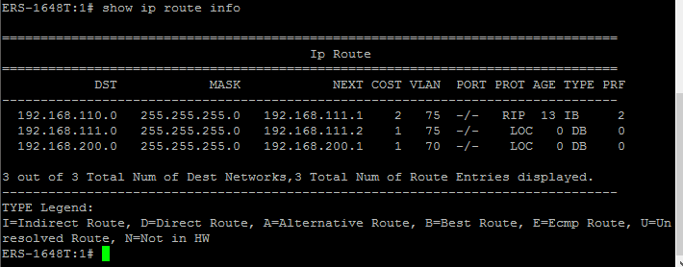

### Ping from Switch 5’s Client to all the vlans

6)

Switch 5

Client: 192.168.110.10 -> 192.168.110.1

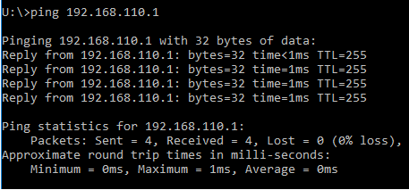

Client: 192.168.110.10 -> 192.168.111.1

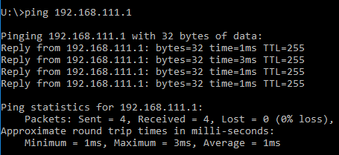

Client: 192.168.110.10 -> 192.168.111.2

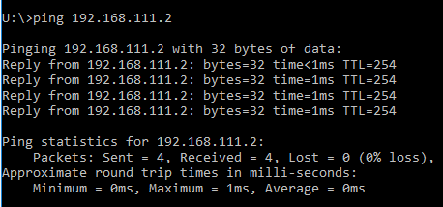

Client: 192.168.110.10 -> 192.168.200.1

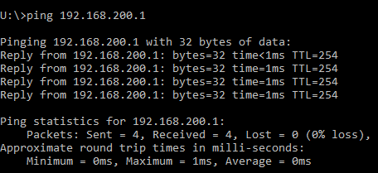

### Ping from Switch 7’s Client to all the vlans

7)

Switch 7

Client: 192.168.200.10 -> 192.168.110.1

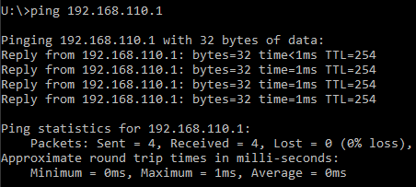

Client: 192.168.200.10 -> 192.168.111.1

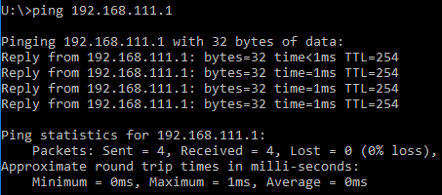

Client: 192.168.200.10 -> 192.168.200.1

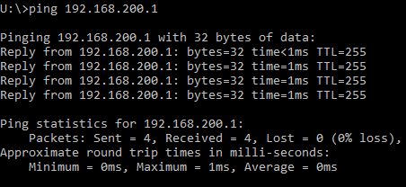

Client: 192.168.200.10 -> 192.168.111.2

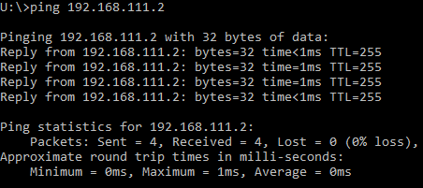

### Save all the configurations

8) Command:

-save config; save bootconfig; save boot; boot → y;

Q1: Why is it necessary to use a crossover patch cable instead of a straight-through patch cable to connect the two switches? Be specific.

-Crossover patch cables uses two different wiring standards for each end of the cable. One uses T568A and the other uses T568B. Crossover cable is generally used for two devices of the same type, for example, the scenario of our project which consists of us connecting both switches to each other. Where as a straight through cable is primarily used to connect two different devices.

### Network Diagram

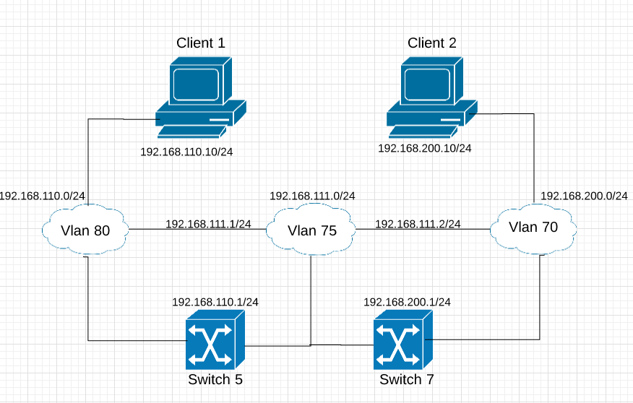

# Project Lab 3

### Assign values to MIB variables

1)

Commands:

-A) Config sys set name CSC411Nortel

-B) Config sys set contact [csc411@kutztown.edu](mailto:csc411@kutztown.edu)

-C) Config sys set location Networking

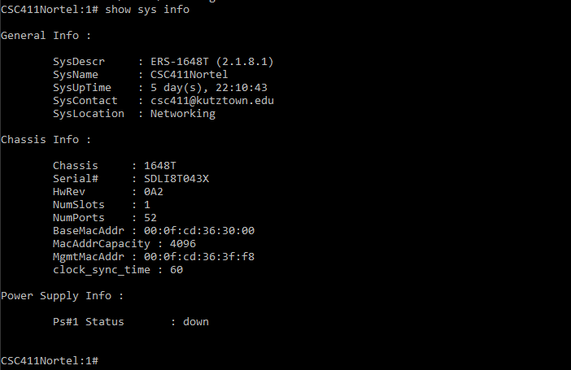

### Download files from course website

2)

File: snmpget.exe and snmpwalk.exe

### 

### SNMPWALK of the mgmt.system subtree

3)

"U:\My Documents\CSC411\snmpwalk.exe" -c public -v1 192.168.200.1 1.3.6.1.2.1.1.0

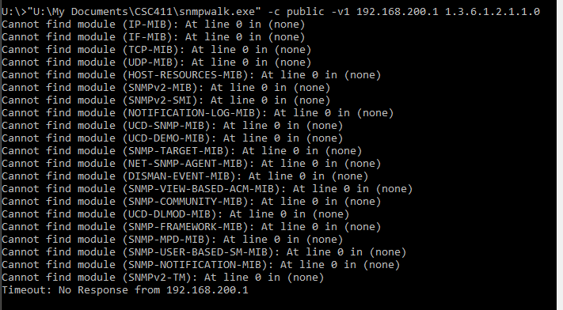

### SNMPGET of the sysName and sysLocation variables

4)

U:\>"U:\My Documents\CSC411\snmpget.exe" -c public -v1 192.168.200.1 1.3.6.1.2.1.5.0

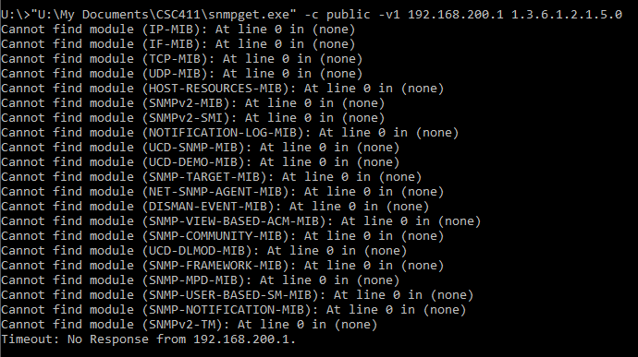

U:\>"U:\My Documents\CSC411\snmpget.exe" -c public -v1 192.168.200.1 1.3.6.1.2.1.6.0

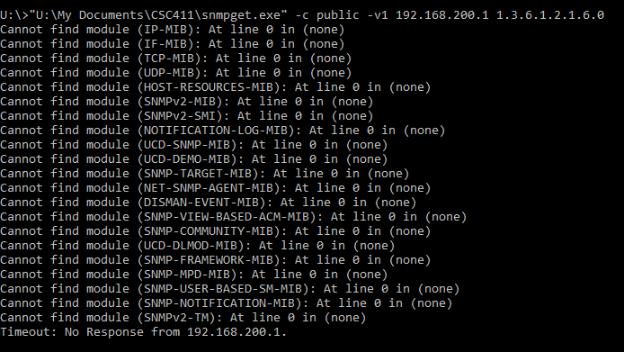

# 

# Imunes

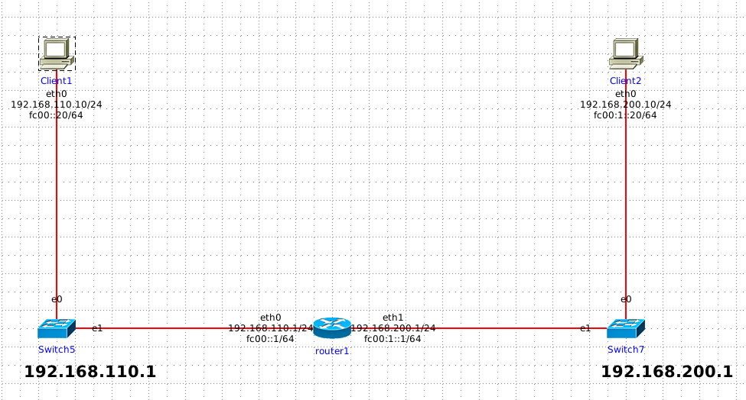

Network Topology

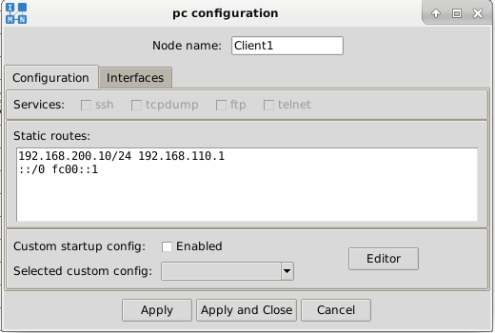

Client1 Static Routes

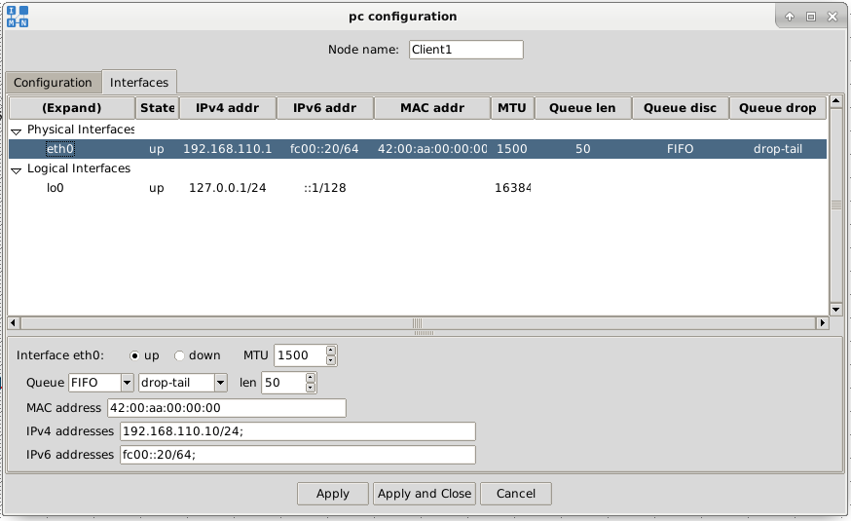

Client1 IP Interfaces

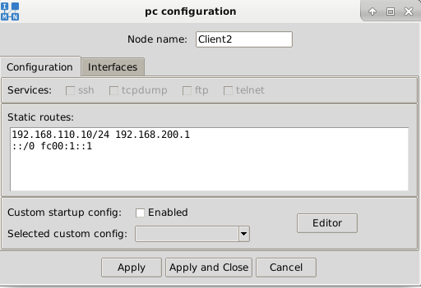

Client2 Static Routes

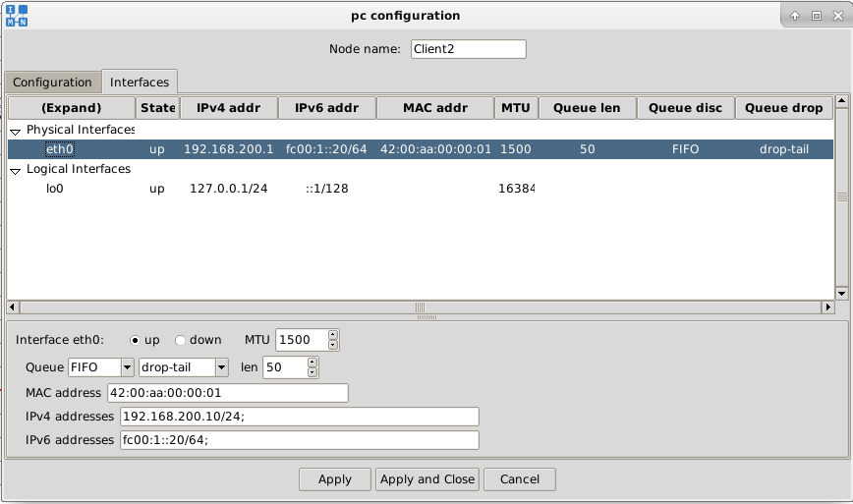Client2 IP Interfaces

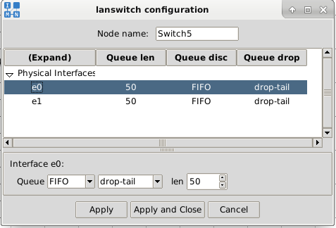

Switch5 IP Interfaces

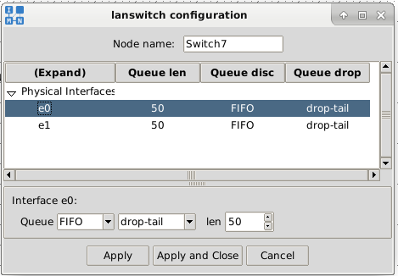

Switch7 IP Interfaces

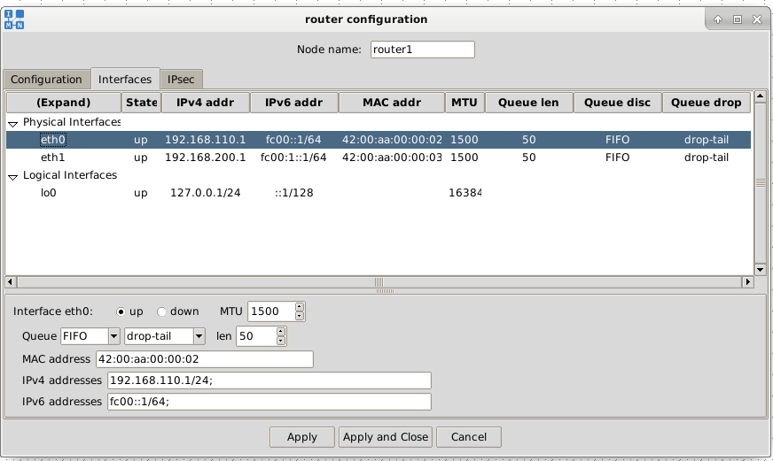

Router IP Interfaces