The 13th Amendment, The Enabling Clause, and The Civil Rights Cases (1883): Congress versus Courts

1865-1885

Sid Walker, Georgia Southwestern State University

Abstract
The 13th Amendment abolishes slavery and involuntary servitude but the terms “slavery” and “involuntary servitude” are not adequately defined in the United States’ Constitution. This is the reason why the second section of the 13th Amendment is very important. It gives Congress the responsibility to define and counteract the badges and incidents of slavery through its Enabling Clause. Altogether, Congress has the authority to create “appropriate legislation” for matters pertaining to violations. Instead of drafting the 13th amendment around a more liberal perspective that encourages effective strengthening, in its beginning stages, it has only managed to solve the issue from a conservative perspective that acted quicker to dismiss the institution of slavery. However, this is not all of Congress’s fault. Because the United States has a trilateral checks-and-balances system, the courts play a major role in interpreting the law. Judicial Review may easily strike down laws that are not consistent with the Constitution; yet, during the Civil Rights Cases (1883), Courts chose to merely view the 13th Amendment as a political issue versus a lasting legal one causing it to be more reactive than proactive.

Introduction
The 13th Amendment has two sections that reads:
“Section one: Neither slavery nor involuntary servitude, except as a punishment from crime whereof the party shall have been duly convicted, shall exist within the United States, or any place subject to their jurisdiction.
Section two: Congress shall have power to enforce this article by appropriate legislation. (US Const. amend. XIII)”
The first section is an act through Congress to abolish legal slavery and involuntary servitude. The meaning behind the amendment exceeds the standards of the Emancipation Proclamation, that only promised to free slaves in certain states, by vowing to release all the forced workers throughout the nation. It was passed on December 18, 1865 as the first major response to Reconstruction – the era after the American Civil War. Notably, in reference to punishment for a crime, slavery was and still is permitted through sources like work camps and prison labor.
Meanwhile in section two, known as the Enabling Clause, Congress is given the power to enforce provisions through appropriate legislation. In other words, they draft legislation that constitutes definitive slavery, by their expressed powers, to outlaw 13th Amendment violations deemed by the Supreme Court (Greene and McAward).
However, the 13th Amendment’s importance has taken a major shift since its framing. The powers delegated to the Judicial Branch worked efficiently against those of the Legislative and Executive branches. Though Congress was granted permission to create appropriate legislation surrounding the issues of slavery, the Civil Rights Cases (1883) disregarded their proactive measures by holding them only to reactive initiatives. The ruling from this case distinctively separated slavery from discrimination and resulted in limiting the effectiveness of congressional enforcement powers.

Literary Review

The History of the 13th Amendment
Slavery and involuntary servitude was not directly confronted in the U.S Constitution before the 13th Amendment. Forced free laborers were looked at as property. Discrepancies with property was only looked at as a states’ rights issue. The Three-Fifth Compromise appeared in the earlier drafting of Constitutional Convention but predominately focused on representation. It’s worth mentioning that the 5th Amendment covers free labor under its clause that ‘No Person shall be deprived of life, liberty, or property, without due process’ but its dealings with slavery is a subjective argument.
Nevertheless, the 13th Amendment was the first amendment signed Postbellum. It intentionally reserved room for legislation by giving strict authority and responsibility to Congress. The reason being is often debated. When discussing the historical background, some legal scholars believe that the framers were mostly radicals who aimed at incorporating their personal viewpoints into the Constitution as a means to create a holistic change. Others believe moderates ultimately supported the amendment as a negotiation attempt to formulate policy (Kaczorowski 1987).

Authors

Executive Branch
President Abraham Lincoln (1861-65) was in office during the signing of the amendment. He represented the Union during the Civil War – a fight over the legality of southern slavery. During the disputes, northern states fought to abolish slavery while southern states fought to keep it.
As a representative of the north, Lincoln endorsed national sovereignty. He believed that the United States should work together, as an independent nation, instead of coexisting separately amongst states. The Confederate states, led by Jefferson Davis, opposed Lincoln’s perspective and was in favor of states’ sovereignty. They refused to abide by any act that would endanger slavery and/or threaten succession from the north (Vorenburg 2001).
Lincoln debated that all men were created equal by referencing the importance of ‘liberty’ formulated in the Declaration of Independence. He contended that liberty, in its purest form, implied that everyone should be treated equal and fairly. Meanwhile, Davis advocated the importance of ownership and believed that liberty was interpreted as an entitlement to all private property. He argued that the invasion of private property was an infringement on the natural rights of citizens (Brettle 2007).
In light of negotiation, Lincoln issued the Emancipation Proclamation in 1863. This proclamation attempted to free slaves in certain Confederate states. It focused primary on occupied confederate territories and seemingly disregarded those in border states. He figured this was the most prudent way to end the Civil War. Moreover, it did not work because the Confederates rebelled and threatened secession from the northern Union.
After four years, the Union won the war. Lincoln was reelected and promoted to represent the entire United States of America. Throughout his speeches he emphasized his will to create federal unity amongst Confederate and Union states. After emancipating southerners from restraint, he stated, “It is my wish for you to relieve the people from all burdens, grievances, and oppressions… The object of the war being to restore and maintain the blessings of peace and good government… I desire to help and not hinder any advance in that direction (Brettle 2007).”
Shortly after making this statement, President Lincoln signed off on the 13th Amendment. His signature acted as a Joint Resolution with Congress. It was then sent off to State Legislators for immediate action. In spite of his Emancipation Proclamation, he understood the importance of signing the 13th Amendment and how it would equate to a more effective solution.

Congress
Article V describes the process of amending the Constitution. Congress has a bicameral legislative body that is split between the House of Representatives and the Senate. Both bodies play identical roles in the ratification process. The first step involves making a proposal by gaining two-thirds of the votes from both chambers. Either two-thirds of both houses must agree or two-thirds of the state legislatures must call a conventional proposal. Next is the ratification process. The proposed amendment must then get approval from the States’ Legislators. Three-fourths of the state legislatures or three-fourths of the states’ ratifying constitutional conventions must agree on the amendment. Once this process is completed the new amendment is added to the Constitution (Constitution 2016).
The 13th Amendment’s proposal came from an increasing uproar about legal slavery. Representation was split between the Union, Confederacy, and the border-states. Unlike the Confederacy, the border-states were the middle states [Delaware, Maryland, Kentucky, Missouri, and West Virginia] that had slaves but did not threaten secession from the Union. The Union represented 23 northern states while the Confederacy represented 11 southern states. Majority of the Union sought to abolish slavery while the Confederacy was in favor of keeping it.
The Radical Republicans were the frontrunners of the amendment. They fought for total eradication of the slavery and succession. They also favored punishment as a repercussion to the Confederate states that lost the war. Meanwhile the Moderate Republicans, who were led by President Lincoln, were more willing to negotiate terms and conditions to benefit both the north and the south. This party was intermingled with different political ideologies and mixed with: conservative Republicans, anti-abolitionists, anti-Reconstruction Democratic Party affiliates, conservatives in the south, and liberals in the north (Tsesis 2004).
Drafting the 13th Amendment took two years. It was first debated in Congress, by the Senate, on March 31, 1864. The Senate favored the bill on a 38-6 count vote. The House of Representatives voted, the same year, on June 14th. A day later the results came in. The ballot did not receive a two-thirds favored count. 93 representatives favored the bill, 65 opposed and 23 delegates did not vote. On December 6, as an advocate of the bill, President Lincoln proposed reconsideration in his 4th Annual Message to Congress by stating:
“At the last session of Congress, a proposed amendment of the Constitution abolishing slavery throughout the United States, passed the Senate, but failed for look of the requisite two thirds vote in the House of Representatives. Although the present is the same Congress, and nearly the same member and without questing the wisdom or patriotism of those who stood in opposition, I venture to recommend the reconsideration and passage of the measure at the present session (13th Amendment)”
Shortly after, on January 6, 1865, another attempt was made. On January 31st, the House of Representatives agreed with the Senate by a 119-56 vote. Then it was submitted to the states on February 1, 1865. Within one month, 18 states agreed to ratify the bill. Georgia was the last mandatory vote of a two-third majority [27 out of 36]. The 13th Amendment was then ratified by the Secretary of State William Seward on December 18, 1865.

Relevant Acts by Congress

Northwest Ordinance 1787
The Northwest Ordinance of 1787 was enacted by the Congress of the Confederation. It attempted to organize the Northwestern territory during the Manifest Destiny. After its signing, the federal government was granted northwestern sovereignty and expansion in the existing states. This was an effort, ultimately by the northern states, to expand westward by allowing territories to join the union. Meanwhile, southern states were in favor of the ordinance because they felt the expansion would decrease the competitive tobacco industry that was controlled by the south eastern states of the Mississippi River (Finkelman 1986).
This Act was relevant to the 13th Amendment because of its provision prohibiting slavery and involuntary servitude. It was a negotiation tactic to obtain land from the Native Americans. Altogether, it served as a blueprint in the drafting of the 13th Amendment. Article six stated:
“There shall be neither slavery nor involuntary servitude in the said territory, otherwise than in the punishment of crimes whereof the party shall have been duly convicted. Provided, always. That any person escaping into the same, from whom labor or service is lawfully claimed in anyone of the original states, such fugitive may be lawfully reclaimed and conveyed to the person claiming his or her labor or service as aforesaid (Northwest Ordinance).”

Civil Rights Act of 1866

The Civil Rights Act of 1866 defined citizenship after the ratification of the 13th Amendment. It specifically aimed to equalize the rights of ex-slaves to the rights of freed citizens. It gave all citizens the right to: make and enforce contracts, sue and be sued, testify in court, and inherit, purchase, lease, sell, hold, and convey real and private property. The amendment was proposed in Congress twice. The first time it failed but the next time it passed by a two-thirds majority vote in both houses.
Senator Lyman Trumbull introduced the bill to Congress. As a Republican and chair of the Senate Judiciary Committee (1861-73), he felt obligated to enforce effective legislation that would protect and enforce civil rights (Kaczorowski 1989). Yet, it was vetoed both times by President Andrew Johnson. His opposing views surrounded the idea that the Civil Rights Act would interfere with private property by disrupting the status quo of labor laws. He proclaimed that the bill was overstepping congressional boundaries in his veto statement that stated:
“This bill frustrates this adjustment. It intervenes between capital and labor and attempts to settle questions of political economy through the agency of numerous officials, whose interest it will be to foment discord between the two races; for as the breach widens, their employment will continue; and when it is closed, their occupation will terminate (teachingamericanhistory.org).”

Peonage Act of 1867
The Peonage Act of 1867 aimed to end peonage, wage and unfree labour, in all U.S territories, predominately Mexican territories. The peonage system was the method in which employers lent transportation to laborers in exchange for labor. Laborers were forced to work for free to pay off debt. Their debt included sharecropping loans, credit, and living expenses. In most cases, this method never worked because the expected repayment cycles were too high. Nonetheless, this act particularly focused on involuntary servitude which was specifically mentioned in the 13th Amendment (Rogers 1916).

Civil Rights Act of 1875
The Civil Rights Act of 1875, or the Enforcement Act, gave ex-slaves the right to accommodate public services. It was passed by the 43rd United States Congress and was signed by President Ulysses S. Grant on March 1, 1875.
Charles Sumner introduced the bill to Senate on May 13, 1870. He was an abolitionist and a Radical Republican. Instead of advocating acceptance and embracing the Confederacy after their Civil War loss, Sumner felt that the South should be punished and forced to confirm with the conveniences of the Union. His bill was eventually passed shortly after his death.
Public opinion opposed the reformed civil rights act because it was presumed to interfere with states’ rights. Others argued that, by forcing business owners to accept service from ex-slaves, their private property rights were being violated. Therefore, federal laws were unfairly overriding states’ benefits. This argument was later debated in the Civil Rights Cases of 1883 (Jager 1969).

Civil Rights Cases (1883)

The Civil Rights Cases (1883) were five lower court cases grouped together and taken by the Supreme Court. The cases were as follows: United States v. Stanley, United States v. Ryan, United States v. Nichols, United States v. Singleton, and Robinson et ux. v. Memphis and Charleston R.R. Co. Together, they all questioned the constitutionality of the Civil Rights Act of 1875.
Business owners argued that it was their constitutional right to discriminate as they chose. A business is a matter of private property and Congress is responsible for ensuring that all businesses are treated equally and fair. By implementing the laws that surrounded the Civil Rights Act of 1875, provisions infringe upon those rights to private property. The Supreme Court agreed with the business owners and found it unconstitutional. Business owners had the right to refuse service, and Congress did not have the enforcement powers to interfere with legal matters pertaining to private sector legislation.
The Supreme Court questions if discrimination is considered an incident and/or badge. In a majority vote, the courts determined that ‘slavery’ and ‘discrimination’ were two different legal matters so therefore should not constitute as a 13th Amendment issue. Private acts are not state actions. They are only conducted by private individuals. Therefore, Congress did not have the authorization to interfere with private businesses unless it was a federal issue (Fliter 2002).
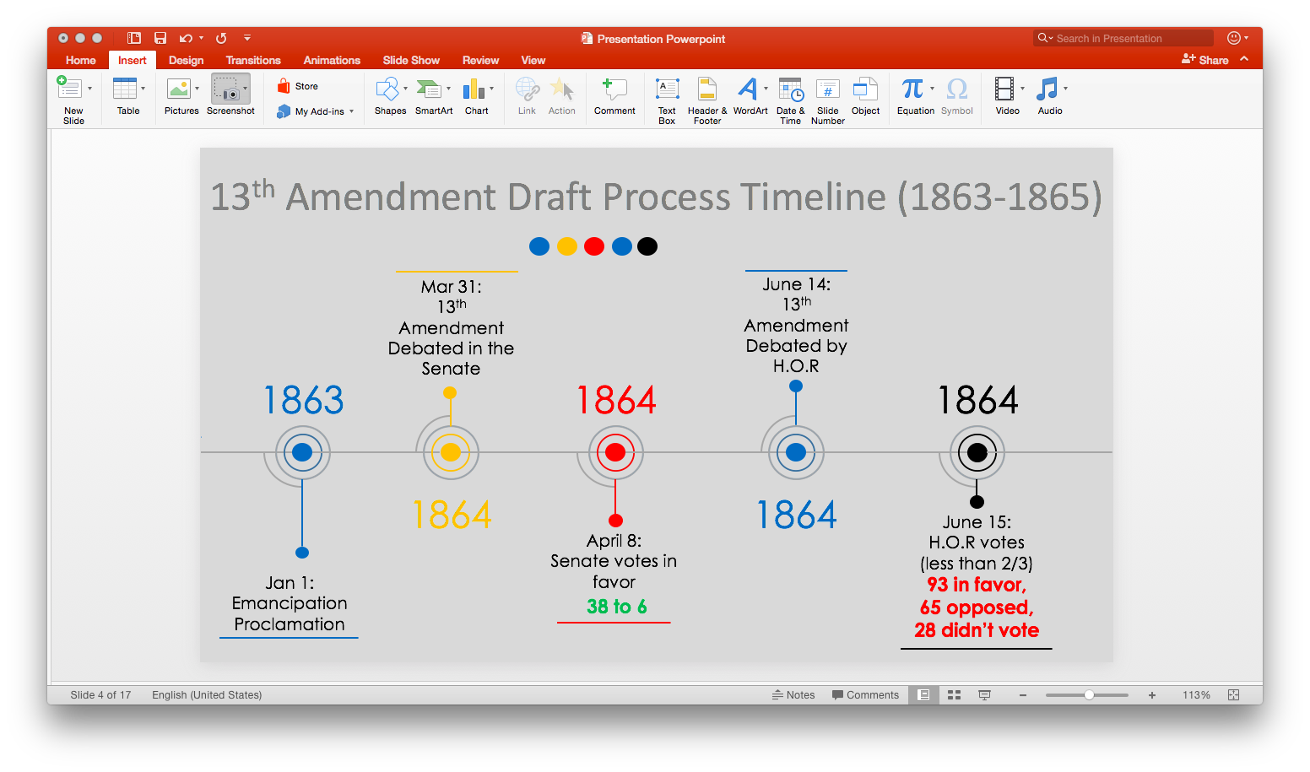
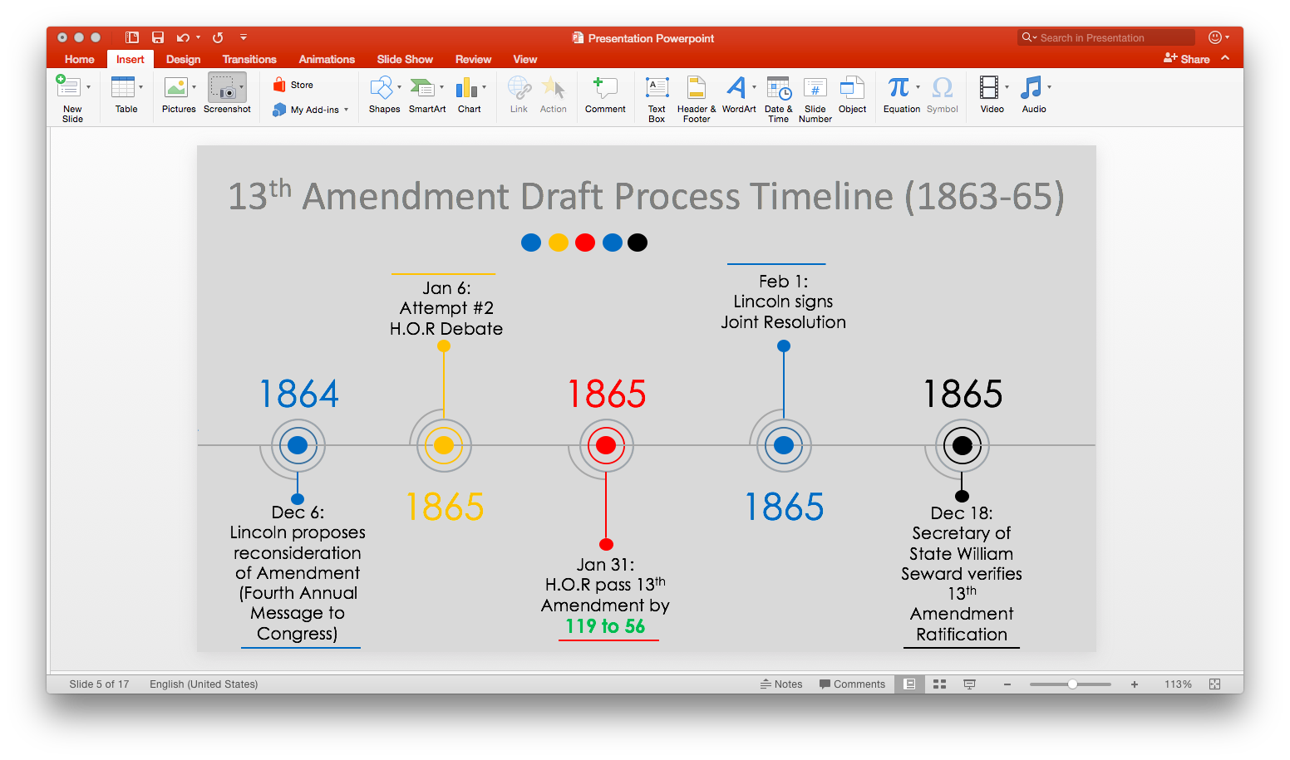

Body of Project
Institutional slavery was a critical part of America’s economic system during the 18th and 19th century. It started during the Colonial era and lasted until the 13th Amendment. Slavery was predominately located in the South because there were northern abolitionist laws set during the Revolutionary War. Reason being, despite popular belief, northern states at one point had a higher proportion of free labor (Smith 1973). The high demand for southern cotton requested tough labor and business owners used slaves to increase profits. Meanwhile, the north benefited from involuntary servitude. Northern industries were more industrial than agriculture presenting a bigger need for labor skills and trades. Therefore, business owners strategically endorsed immigration, employment, and housing credited for free labor (Menard 1973). Ultimately, these two industries were split into two sections of dominating states: The Union and The Confederacy.
The Union represented the northern states and the Confederacy represented the southern states. The middle states were the geographical split that represented the border states: Maryland, Delaware, Missouri, Kentucky, and West Virginia. These states also contained slaves but were neutral in affairs. Nonetheless the growing Abolitionist Movement, spreading throughout the north, brought upon issues pertaining to states’ rights, tariffs, and slavery. The Confederacy felt as though southern tariffs were unfair, and the threat to abolish slavery infringed individual states’ rights. Together, they eventually threatened secession and the American Civil War was initiated (McDonald 2012). The Union won and the Civil War ended on May 13, 1865.
During the Civil War, President Abraham Lincoln issued the Emancipation Proclamation in 1863. This inspired the 13th Amendment. The executive order demanded the freedom of slaves in ten Confederate States as a means of a war tactic. It chose to only focus on states who rebelled against the Union while disregarding the border and southern states that did not. Though it aimed at fairness, it did not completely outlaw slavery, grant citizenship, nor compensate slaves or slave owners. It more so counteracted the Fugitive Slave Act of 1850 that stated that all escaped slaves had to either be returned to their masters or held as contraband, in which, the proclamation stated:
“…all persons held as slaves within any State or designated part of a State, the people whereof shall be in rebellion against the United States, shall be then, thenceforward, and forever free; and the Executive Government of the United States, including the military and naval authority thereof, will recognize and maintain the freedom of such persons, and will do no act or acts to repress such persons, or any of them, in any efforts they may make for their actual freedom (Lincoln).”
Eradicating slavery was later presented in Congress by the Republicans. Within the Republican party, ideologies supporting slave abolishment were inconsistent. Moderates were in favor of preserving the union while Radicals sought permanent prohibition and secessionism without compromise. After the 1860’s elections moderates, such as President Lincoln, dominated Congress.
Before Lincoln was assassinated on April 15, 1865, he initiated a Ten-Point Plan for congress, as a strategy to compromise and ensure allegiance. The postwar reconstruction Ten-Point Plan ensued that rebelled states would only be admitted into Congress if ten percent of its voters, from the 1860 voting polls, pledged allegiance with the Union. This would allow admitted voters to draft revised state constitutions and establish new state governments. Moderates saw this plan as a swift end to southern/northern disputes; Radicals thought it was too lenient and agreed on the Wade Davis Bill (1864) while the remaining Republicans feared that it would potentially restore slavery through an agricultural aristocracy. The Wade-Davis bill was more extreme as it demanded admittance into the Union under the grounds that an Ironclad oath be made while increasing the demand to fifty percent. Lincoln vetoed this bill even though it passed in both houses but never took effect. He believed the bill would decrease the likelihood of ever establishing ‘a more perfect Union’. He favored a more comprehensive way of building gradual emancipation and compensation for former slaves through banning color discriminations and endorsing the Freedmen’s Bureau. The Freedmen’s Bureau was established through the Freedmen’s Bureau Bill of 1865 during Lincoln’s administration. It provided food, clothing, and labor advice to former slaves. Unfortunately, he was assassinated before he could approve a commissioner so it was left in the hands of Vice President Andrew Johnson’s administration. He later vetoed the bill and Congress failed to override it.
Residing President, Johnson, had a new set of reconstruction goals that were different than Lincoln’s. Lincoln chose him as Vice President primarily as an attempt to gain a running mate that would appeal to southern support. Johnson was a Union supporting Southern Democrat who focused chiefly on the rapid recovery of southern states after the war. It’s imperative to note, the frontrunner supporter of Reconstruction, Lincoln, did not leave a detailed description of his policies so therefore Johnson had to create his own Presidential Reconstruction campaign. It categorized southern chaos and confusion, after the war, as a state issue instead of a federal problem. This ultimately caused cabinet division. Johnson saw Reconstruction going in another direction and it developed a feud against Congress. Being a Democrat, he felt that Moderate Republicans ultimately sought out the Democratic demise. He immediately issued Proclamation 134 on May 29, 1865 – Granting Amnesty to Participants in the Rebellion, with Certain Expectations:
“I, Andrew Johnson, President of the United States, do proclaim and declare that I hereby grant to all persons who have, directly or indirectly, participated in the existing rebellion, except as hereinafter excepted, amnesty and pardon, with restoration of all rights of property, except as to slaves and except in cases where legal proceedings under the laws of the United States providing for the confiscation of property of persons engaged in rebellion.”
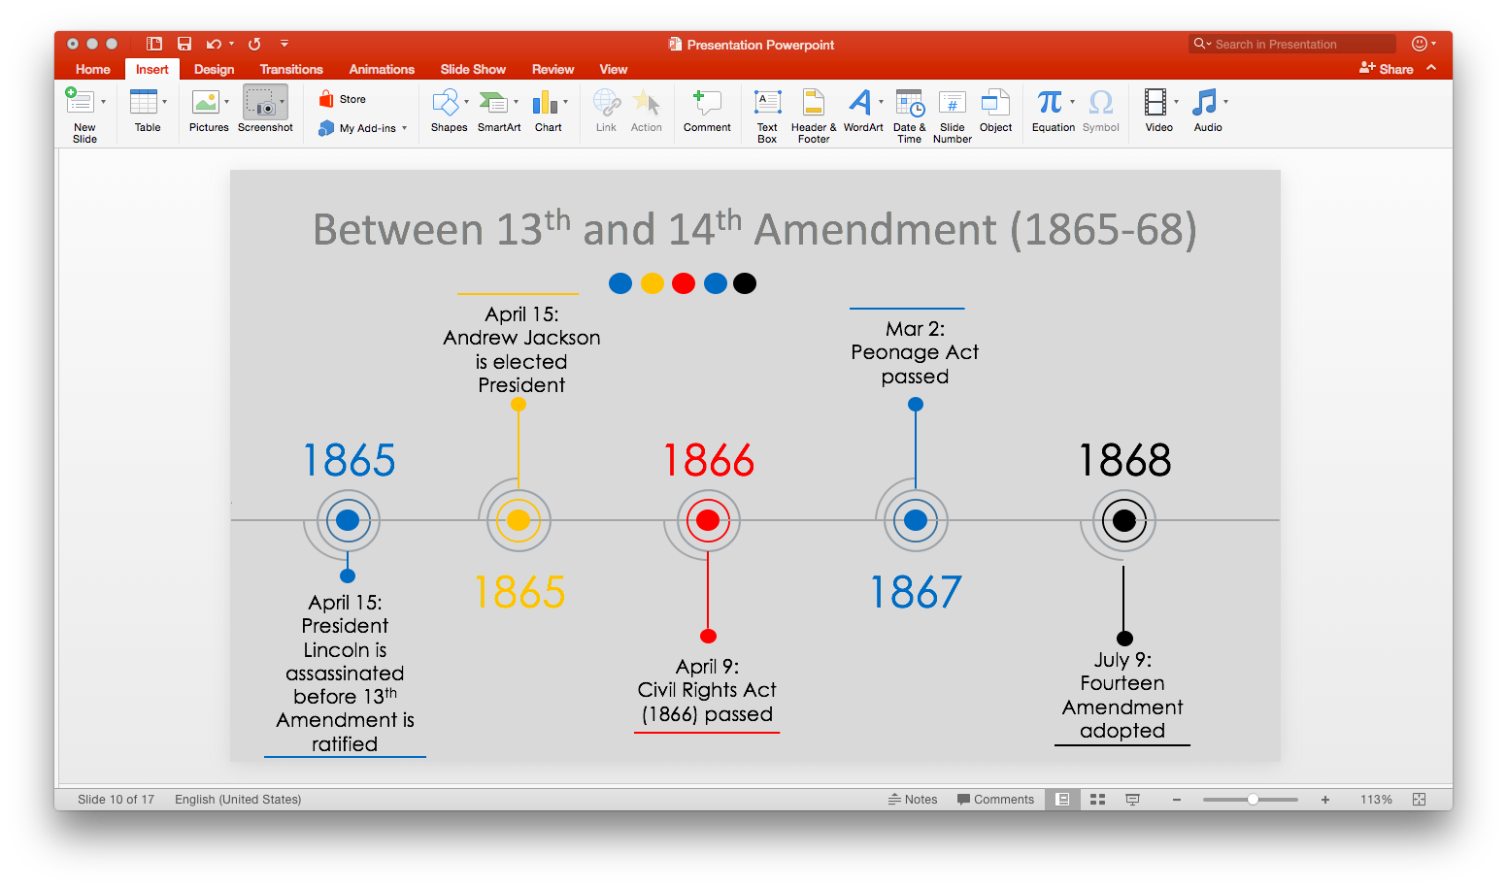
The grudge escalated because radicals aimed for a more aggressive consequence. Congress struck back by using their Article 1 Section 7 powers:
“Every Order, Resolution, or Vote to which the Concurrence of the Senate and House of Representatives may be necessary (except on a question of Adjournment) shall be presented to the President of the United States; and before the Same shall take Effect, shall be approved by him, or being disapproved by him, shall be repressed by two thirds of the Senate and House of Representatives, according to the Rules and Limitations proscribed in the Case of a Bill. (U.S Const. Art. 1 Sec. 7)”
Thaddeus Stephen, in particular, favored taking land away from slave-owners and redistributing it back to former slaves. He supported the idea that Confederates were conquered and should thereby be treated like subordinate provinces by stripping them of their constitutional rights. He suggested that Congress accept no senators nor representatives from the south, due to their potential threat of teaming up with Johnson and undoing emancipation. Johnson affirmed Stephen’s predictions by attempting to displace some of his Republican cabinet members. He saw his Secretary of War, Radical Republican Edwin Stanton, as a threat to his administration so attempted to suspend him. He knew he couldn’t fire him so he strategically waited until the Senate was out of session. Congress didn’t allow this to happen. They counteracted Johnson’s attempt with the Tenure of Office Act (1867) which intended to restrict the power of the President to remove certain office holders without approval from the Senate. This then led to his impeachment on February 24, 1868.
The Radical Republicans were the frontrunners of the bill. They advocated civil rights and restoration policies for former slaves. Senator Charles Sumner of Massachusetts was the prominent leader of the Radicals during the drafting of the bill. On February 8, 1864, he submitted a constitutional proposal that stated, “All persons are equal before the law, so that no person can hold another as a slave; and the Congress shall have power to make all laws necessary and proper to carry this declaration into effect everywhere in the United States (Stanley 2010).” Being inspired by Senator Sumner, representatives James Mitchell Ashley of Ohio and James F. Wilson of Iowa introduced the 13th Amendment proposal to Congress. According to a New York Times article, Representative Wilson stated, “Congress shall have the power, by appropriate legislation, to protect citizens of the United States in the exercise and enjoyment of their rights, privileges, and immunities, and to assume to them the equal protection of the laws (New York Times).” Though they were not as radical as Sumner, together they proposed an initiative that not only demanded eradication of slavery; but, also sought Congressional authority to govern the proposed bill which birthed its Enabling Clause.
The Enabling Clause gave Congress the enforcement powers over the 13th Amendment. Supporters believed enforcement powers would ensure fairness; meanwhile, opposers argued that Congress would merely abuse its powers and infringe states’ rights. The remedies and prevention tactics were not grounded in the language of the amendment. Supporters claimed that the diversity of Congress would safeguard fair judgement in drafting appropriate legislation. Yet, fairness may vary amongst majority. Hence, there could be a certain majority party that dominates decision making on 13th Amendment legislation. This was shown during the dominance of the Republican party’s 38th – 39th congressional reign. Congress was able to, instead, pass an additional amendment by gaining a two-thirds vote in both houses. Though the Civil Rights Act of 1866 was vetoed twice by President Andrew Johnson, Congress was able to override the presidential vetoes by ratifying the 14th Amendment granted through Article 1, Section 7, Clause 2 of the Constitution:
“Every Bill which shall have passed the House of Representatives and the Senate, shall, before it become a Law, be presented to the President of the United States: If he approve he shall sign it, but if not he shall return it, with his Objections to that House in which it shall have originated, who shall enter the Objections at large on their Journal, and proceed to reconsider it. If after such Reconsideration two-thirds of that House shall agree to pass the Bill, it shall be sent, together with the Objections, to the other House, by which it shall likewise be reconsidered, and if approved by two-thirds of that House, it shall become a Law (US. Cons. Art 1. Sec. 7. Cl. 2).”
Congress was initially proactive in their attempts to utilize their enforcement powers. Shortly after the 13th Amendment, they quickly issued appropriate legislation to enforce section one – Civil Rights Act of 1866 and Peonage Act of 1867. Together, these acts expanded congressional enforcement powers by allowing them to view and attack institutional slavery from a broad liberal standpoint. They later took it a step closer when they issued the Civil Rights Act of 1875 that aimed to protect all citizens from discrimination in places of public accommodation.
This legislation, however, was struck down in the Supreme Court. Court Justices found the Civil Rights Act of 1875 unconstitutional because Congress exceeded authorized powers. Supreme Courts ruled that this act antagonized private property due to the fact that it duly interfered with personal businesses structures. Together, they ruled in favor of the states by a 8-1 vote. Totally a one-sided verdict. Majority opinions pointed out the difference between discriminatory conduct and slavery. It was agreed that these two issues were not supposed to be combined, and in the case by which it does, Congress has exceeded its authority. A belief that this matter would presumptively stretch beyond its framers’ intentions. In light of acknowledgement, by providing a better understanding of the 13th Amendment’s congressional scope, the Courts entitled ‘badges and incidents of slavery’. The badges and incidents of slavery were directed at searching for the authoritative characterization of subjects pertaining to slavery.
The judgement was ruled by Justice Joseph P. Bradley’s majority opinion and Justice John M. Harlan’s dissent. Bradley was in favor of the 1866 civil rights act but disapproved the Civil Rights Act of 1875. He argued that there was a distinct difference between slavery and infringement upon private property rights. This therefore made the Civil Rights Act of 1875 unconstitutional in a court of law. He contended that congressional enforcement powers were only supposed to only focus on the laws which were ‘necessary and proper’ in keeping institutional slavery banned. Nonetheless, the burning question was: Whether the badges and incidents of slavery was meant to signal an enhanced broader view of slavery. His analysis suggested that it was not, by arguing differences between fundamental rights and civil freedom by stating:
“… it would be running the slavery argument into the ground to make it apply to every act of discrimination which a person may see fit to make as to guests he will entertain, or as to the people he will take into his coach or cab or car; or to admit to his concert or theatre, or ideal within other matters of intercourse or business (Civil Rights Cases, 109 U.S. 3 (1883)).”
He supported the claim that history shows contentment of citizenship by referring to past societal relationships. He concluded that expanding power to citizens over private property owners actually enslaves the owner by forcing them to restructure their business structure:
“There were thousands of free colored people in this country before the abolition of slavery, enjoying all the essential rights of life, liberty, and property the same as White citizens; yet no one, at the time, thought that it was any invasion of their personal status as freeman because they were not admitted to all the privileges enjoyed by the White citizens (Civil Rights Cases, 109 U.S. 3 (1883)).”
Meanwhile, Justice Harlan’s dissent surrounded the opposite. He affirmed both civil right acts constitutional because he believed the burden lying on the foundation of slavery was considered a badge and incident of it. Badges and incidents are equivalent to burdens and disabilities that favor slavery. Liberty infringement is indeed slavery at its broadest interpretation. Throughout his dissent, he emphasized congressional roles of enforcement powers by stating:
“Congress, therefore, under its express power to enforce that amendment, by appropriate legislation, may enact laws to protect that people against the deprivation, on account of their race, of any civil rights enjoyed by other freeman in the same state; and such legislation may be a direct and primary character, operating upon states, that officers and agents, and also upon, at least, such individuals and corporations as exercise public functions and wield power and authority under the state (Civil Rights Cases, 109 U.S. 3 (1883)).”
He directed the attention of the courts to the power of Congress. He proclaimed that this matter should be in the hands of Congress, not the judiciary, in which it shall remain. He noted the fact that Congress sought proactive solutions as an attempt to disband any future resonance of the slavery by stating:
“… it is for Congress, not the judiciary, to say which is best adapted to the end to be attained… no interpretation of the words in which those powers are granted can be a sound one which narrows down their ordinary import so as to defeat those objects… the rights which Congress, by the act of 1875, endeavored to secure and protect are legal, not social rights (Civil Rights Cases, 109 U.S. 3 (1883)).”
As it seemed, opposed justices were directing their attention to the social freedom of business owners by posing the question of their freedom versus those who were enslaved. In a sense, one group had to submit to an individual vitality rather it be business owners or ex-slaves. It was a matter of a political perspective versus one that dealt with the legalities of congressional powers. Nonetheless, Congress was given the express powers to interpret and draft legislation. In support, Justice Harlan stated:
“…by appropriate legislation, Congress has been invested with express power – everyone must bow, whatever may have been, or whatever now are, his individual views as to the wisdom or policy, either of the recent changes in the fundamental law, or of the legislation which has been enacted to give them effort (Civil Rights Cases, 109 U.S. 3 (1883)).”

Findings

Section one of the 13th Amendment seemingly wasn’t enough. Congressional enforcement powers are mandatory as it takes appropriate legislation from the Congress. To ensure that slavery is completely dissipated, they are instructed to identify and attack badges and incidents of slavery. I’ve found arguments from both sides. It was perceivably deeper than the actual act of holding slaves and indentured servants. It was also a case of federal integrity. To what extent is the federal government able to interfere with private property?
This issue surrounded inconsistencies from the Congress and the Supreme Court. According to the language of the amendment, Congress is supposed to be in charge of making proactive legislation counteracting institutional slavery. However, the Supreme Court limits their ability to do so. There were great debates questioning the expansiveness of slavery. In sum, it disgruntled appropriate resolutions. Radicals, the framers of the 13th Amendment, viewed slavery from a broad perspective. They insisted that slavery abolishment was in need of a series of reparations. The Confederates should reap consequences for threatening war and secession. As a means of accepting defeat, the Confederacy should only adhere to the wants of Union. Meanwhile, Moderate Republicans faced the issue of slavery from a narrower approach. They felt as though the disease of slavery was indeed curable through a matter of unity. In any means possible, the Moderates were willing to put differences aside for the greater good.
With so many representatives disagreeing within the Congress, it was difficult to actually pinpoint the intentions of section two. Of course, it aimed at abolishing slavery but what did slavery include aside from free labor? Was it discrimination? If it only covered free labor, why couldn’t the judgement be left to the judicial branch? Why involve legislation from the Congress? More so, under which grounds could Congress write appropriate legislation to constitute of slave abolishment?
Due to the fact that, within the ratification of the 13th and 14th Amendment, a concise plan was never drafted and carried out; congressional enforcement powers struggled to find out how to enforce this bill. The framers had their ideas in mind but it was shortly lived by the judgement in Civil Rights Cases (1883).
Judicial Review struck down congressional efforts to make lasting legislation. The court justices, in turn, viewed the case from a narrow perspective. They viewed slavery abolishment from a conservative standpoint by focusing on the current issue at hand. It was a very narrow approach. True enough, slavery and discrimination is different. But, what are the badges and incidents of slavery? It has to be some form of discriminatory conduct in which the Congress was trying to avoid. By disbanding discriminatory policies, Congress attempted to eradicate any possible means in which slavery could return. However, the courts saw it as a matter of exceeded powers – a political issue.
The Supreme conclusively proclaimed that in the matter of discrimination and private property, someone would have to ‘bite the bullet’. Either the business owners were going to be enslaved to a federal law that forces him/her to do business against their will or the former slaves were going to be enslaved by discrimination policies. The courts chose to favor business owners because business owners constituted a matter of private property and states’ rights which ultimately adheres to the 10th Amendment statutes, “The Powers not delegated to the United States by the Constitution, nor prohibited by it to the States, are reserved to the States respectively, or to the people.”
Noteworthy, however, is the fact that the Congress did try to create proactive legislation. The peonage and civil rights acts were all ways in which the Congress immediately reacted to the 13th Amendment. They attempted to draft lasting legislation to reprimand slavery. However, they did not have that support that they once had when it was initially framed. Due to the assassination of President Lincoln, the Moderate Republican who spear-headed the bill, the change in executives affected the efficiency of the amendment. President Johnson often struggled with the likes of Congress and made their proactive attempts very difficult. From the angle that Lincoln was taking, had he survived to lead the nation, he would have surely encouraged congressional legislation by enhancing a more comprehensive policy. His ability to negotiate peace through influential leadership helped him get things done by completing what he often started. Unlike Johnson, Lincoln did not have any vetoes overturned by Congress while Johnson had a shocking fifteen.
Nonetheless, the 13th Amendment only lasted three years until it was overshadowed by the 14th Amendment. Had the language from the 13th and 14th Amendments been combined, there would have been no need for three Reconstruction amendments. Being that the spread from the 13th and 14th Amendment was only a three-year span; constructive instructions did not have time to develop properly.
In the beginning stages, Congress made proactive 13th Amendment legislation until their efforts were struck down by the Civil Rights Cases (1883). They initially viewed 13th Amendment issues from a broad liberal perspective. Meaning, they sought change in areas surrounding slavery to ensure that it may never return, thereby creating anti-discriminatory acts. However, when challenged by the states, the Supreme court chose to narrow down the scope of Congress by merely choosing to view slavery from a conservative perspective. Therefore, The Supreme Court sided with the states because blatant slavery was not apparent. They perceived a threat from Congress that Congress would eventually overuse and over abuse the slave argument.
Ultimately this created a disagreement amongst the Congress and the courts. The Courts felt as though they had appropriate authority over administering the badges and incidents of slavery. In retrospect, that was the permission that was given. However, the courts acknowledged the fact that slavery and discrimination, on its face, was entirely two different initiatives. In the beginning stages of the 13th Amendment, Congress in fact never had the authority to look over discrimination. Discrimination legislation was not presented in the language of this bill. Therefore, Congress was instructed to focus purely on the institution of forced labor.
In favor of the 13th Amendment, Congress was able to counteract Presidential vetoes yet they were checked by Judicial Review. Credited to America’s checks-and-balances form of government, Congress was able to create legislation without presidential approval but their legislation was viewed unconstitutional.
Throughout this system, it enhances a trilateral separation of governmental power by distinguishing the separation of power between all three major branches: The Legislative, the Judicial, and the Executive. Therefore, it gives each branch the power to limit and check the other two while creating balance. In short, the Legislative Branch, which is Congress, are responsible for passing bills and laws. They have the ability to make amendments. The Executive Branch, which is the President, veto power to either cosign the bill or disregard it. The President also has the authority to select the federal judges in the Judicial Branch. The Judicial Branch, which is the Supreme Court, has the power to interpret the laws in accordance to the Constitution which is called Judicial Review. As noted in my research, throughout Johnson’s term in dealing with the 13th Amendment, Congress has been very active in using their Article 1 powers. It’s safe to say that if these three branches of government are not on the same accord then it can very well create disruption in getting legislation passed.
Conclusion
The range of private actions remain uncertain as there is still controversy questioning congressional responsibility to enforce post-slavery legislation. In reference to the 13th Amendment, the biggest question remains to be: Has Congress over enforced or under enforced appropriate means of legislation? Research shows that Congress has under enforced. This can be a matter of political discouragement amongst the courts or a matter of contentment in legislation. After all, the 13th Amendment does aim to abolish slavery and that’s what it did at that time. However, with the overabundance of prison labor and work camps, I think the Supreme Court overlooked initial congressional intentions. Radical Republicans understood that in order to completely eradicate slavery, former slaves would have to be given another fair chance or else end up in underprivileged situations. A fair chance being all that the Freedmen’s Bureau advocated: employment, shelter, and education. If not, as history shows, states could eventually reinvigorate ways to profit off of the labor of the ‘duly convicted’. But, it is easy to get duly convicted when you have limited resources and opportunities. Fast forwarding time, we ask this question: How did the government solve this problem?
My answer – incarceration. After the 13th Amendment, prison labor raised tremendously. It didn’t increase immediately but, due to enacted policies that encouraged privatized prisons, it did eventually. Statistics show, as of 2013, that of three black males would be incarcerated in their life-time; versus, 1 out of 7 white males in America (Knafo 2013). Sounds like modern-day slavery. Predominately in President Ronald Raegan’s presidential term, the nation seen a huge jump in incarceration rates. What was so significant about his administration was the fact that he created private prisons. Private prisons are running as profitable corporations by benefiting off of the inmate’s labor. Yet, it is legal according to the 13th Amendment. Because the inmates are ‘duly convicted’ they are legitimate slavesinorities with extensive sentencing. Research shows the United States has the highest incarceration and recidivisms rates in the world. Arguably, states, predominately ex-Confederate states, are benefiting from the generated revenue they create as they house the majority of the nation’s prisons. Subjectively, through harsh conditional laws, states have the authority to create state legislation that can alter circumstances.
It’s surprising how legitimate slavery can be overlooked. Sadly, it seems that the slave system has been reinvented legally – targeting minorities. But, it poses the question: Can forced labor be legitimate? To what extent is slave labor different than the act of slavery?

Sources
“13th Amendment to the U.S Constitution." The Library of Congress. https://www.loc.gov/rr/program/bib/ourdocs/13thamendment.html.

"An Unnecessary Move." New York Times. 1883.

"Constitutional Amendment Process." 2016. The U.S National Archives and Records Administration. August. http://www.archieves.gov/federal-register/constitution.

"Northwest Ordinance." Avalon Project. http://avalon.law.yale.edu/18th_century/nworder.asp.
Alexander, Michelle. 2012. “The New Jim Crow: Mass Incarceration in the Age of Colorblindness.” New York: New Press
Brettle, Adrien. 2017. "Struggling to Realize a Vast Future: The Civil War as a Contest Over the Relative Priorities of Political Liberty and Economic Prosperity." Cambridge Journal of Policy History 29.2 (April): 267-88.
Bryant, A. C. 2003. “Stopping Time: The Pro-Slavery and ‘Irrevocable’ Thirteenth Amendment”. Harvard Journal of Law and Public Policy 26.2: 501.
Carter, William C. 2007. "Race, Rights, and the Thirteenth Amendment: Defining the Badges and Incidents of Slavery." UC Davis Law Review 40.4 (April).
Carter, William M., Jr. 2012. "The Thirteenth Amendment and Pro-Equality Speech." Columbia Law Review 112.7 (November): 1855-881.
Civil Rights Cases, 109 U.S. 39 (1883)
Fliter, John. 2002. "Civil Rights and Public Accommodations: The Heart of Atlanta Motel and McClung Cases." Perspectives on Political Science 31.1 (Winter): 49.
Finkelman, Paul. 1986. "Slavery and the Northwest Ordinance: A Study in Ambiguity." Journal of the Early Republican 6.4: 343-370. https://www.jstor.org/stable/3122644.
Frasure, Carl M. 1928. "Charles Sumner and the Rights of the Negro." The Journal of Negro History 13.2 (April): 126-49. http://www.jstor.org/stable/2713959.
Greene, Jamal. “The Thirteenth Amendment and the Constitutional Imagination.” Constitution Center. http://www.constitutionceneter.org.
Greene, Jamal, and Jennifer Mason McAward. “The Thirteenth Amendment.” Constitution Center. http://hwww.constitutionceneter.org.
Hyman, H. 2006. “The Thirteenth Amendment and American Freedom: A Legal History.” Civil War History 52.2: 216-218.
Jager, Ronald B. 1969. "Charles Sumner, the Constitution, and the Civil Rights Act of 1875." The New England Quarterly 42.3 (September): 350-72. http://www.jstor.org/stable/363614.
Johnson, Andrew. "Veto of the Civil Rights Bill." TeachingAmericanHistory.org. http://teachingamericanhistory.org/library/document/veto-of-the-civil-rights-bill/.
Kaczorowski, Robert J. 1989. "The Enforcement Provisions of the Civil Rights Act of 1866: A Legislative History in Light of Runyon v. McCrary." The Yale Journal 98. 3 (January): 565. https://www.jstor.org/stable/796630.
Kaczorowski, Robert J. 1987. "To Begin the Nation Anew: Congress, Citizenship, and Civil Rights after the Civil War." The American Historical Review 92.1 (February): 45-68 http://www.jstor.org/stable/1862782.
Klein, Christopher. 2015. "Congress Passes 13th Amendment, 150 Years Ago." history.com. (January). https://www.history.com/news/congress-passes-13th-amendment-150-years-ago.
Knafo, Saki. 2013. “1 in 3 Black Males Will Go To Prison In Their Lifetime, Report Warns” Huffington Post. https://www.huffingtonpost.com/2013/10/04/racial-disparities-criminal-justice_n_4045144.html
Lincoln, Abraham. "Emancipation Proclamation." National Archives. https://www.archives.gov/exhibits/featured-documents/emancipation-proclamation/transcript.html.
McAward, Jennifer. 2012. "Defining the Badges and Incidents of Slavery." NDLScholarhip 14.3.
McAward, Jennifer Mason. 2013. "McColloch and the Thirteenth Amendment." NDLScholarship (January).
McAward, Jennifer Mason. 2010. "The Scope of Congress's Thirteenth Amendment Enforcement Power After City of Boerne v. Flores." NDLScholarship.
McDonald, Forrest. 2012. “States’ Rights and the Union: Imperium in Imperio, 1776-1876.” Lawrence: University Press of Kansas
McPherson, James M. 1965. "Abolitionists and the Civil Rights Act of 1875." The Journal of American History 52.3 (December): 493-510. http://www.jstor.org/stable/1890844.
Menard, Russel. 1973."From Servant to Freeholder: Status Mobility and Property Accumulation in Seventeenth Century - Maryland." William and Mary: 37-64.
Palmer, Betsy. 2011. "Delegates to the U.S Congress: History and Congress Status." Current Politics and Economics of the United States, Canada, and Mexico 13.4: 557-75.
Rogers, John. 1916. "Principles of Labor Legislation." American Bureau of Industrial Research: 38-40.
Rutherglen, George. 2008."State Action, Private Action, and the Thirteenth Amendment." Virginia Law Review 94.6 (October): 1367-406. http://www.jstor.org/stable/25470591.
Rutherglen, George. 2012. "The Thirteenth Amendment, The Power of Congress, and the Shifting Sources of Civil Rights Law." Columbia Law Review Association, Inc. 112. 7 (November): 1551-1584. https://www.jstor.org/stable/41708158
Smith, Julia Floyd. 1973. "Slavery and Plantation Growth in Antebellum Florida, 1821-1860." Gainesville: University of Florida Press: 44-46
Stanley, Amy Dru. 2010. "Instead of Waiting for the Thirteenth Amendment: The War Power, Slave Marriage, and Inviolate Human Rights." The American Historical Review 115. 3 (June): 740-54.

Stewart, David O. 2009. “Impeached: The Trial of President Andrew Johnson and the Fight for Lincoln's Legacy.” New York: Simon & Schuster.

Trefousse, Hans Louis. 1991. “Andrew Johnson: A Biography.” Library of Congress

Trefousse, Hans Louis. 1991. “Historical Dictionary of Reconstruction.” New York Greenwood Press: 175-76

Tsesis, Alexander. 2004. "The Thirteenth Amendment and American Freedom." A Legal History. New York University Press.
U.S Const. amend. XIII.
U.S Const. amend. XIV, sec. 1
U.S Const. art. I, sec. 7, cl. 2
Vorenburg, Michael. 20

