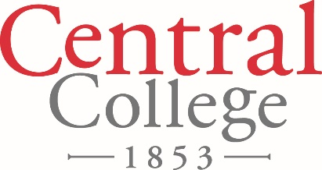

FOR IMMEDIATE RELEASE

September 10, 2018

Contact: Denise Lamphier

641-628-5279

[lamphierd@central.edu](mailto:lamphierd@central.edu)

**Central College’s Mills Gallery Presents a Celebration of Asian Art**

Central College presents a Celebration of Asian Art at the Mills Gallery, located in the Lubbers Center for the Visual Arts on Central’s campus.

The event will open Wednesday, Sept. 19, and will run until Wednesday, Oct. 10. The public is invited to an opening reception at 5:30 p.m. Thursday, Sept. 20, in the gallery. The Mills Gallery is open 9 a.m. to 5 p.m. Monday-Friday.

The exhibition will feature items from the collections of Chia Ning, professor of history, and of Pella residents and world travelers Susan Kuyper and Tom Stanley.

“Works will represent a variety of eras, media, artists and Asian cultures,” says Treva Reimer, professor of art and the gallery’s exhibit curator.

Central College is a private, residential four-year liberal arts college located in Pella, Iowa. Central is known for its academic rigor; strength in global experiential learning; STEM (science, technology, engineering and math) education; sustainability education; athletics; leadership and service. For more information about Central College: [www.central.edu](http://www.central.edu).

**CAPTION**

An accordion book made by artist Meng Qingjiang of the poem “Song of the Everlasting Regret” by Tang Dynasty poet Bai Juyi. The book is from the collection of Chia Ning, professor of history at Central College, and will be on display at the Mills Gallery, located in the Lubbers Center for the Visual Arts on Central’s campus, Sept. 19 to Oct. 10.