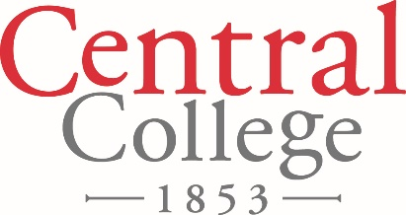

FOR IMMEDIATE RELEASE

August 22, 2018

Contact: Denise Lamphier

641-628-5279

[lamphierd@central.edu](mailto:lamphierd@central.edu)

**Central College Hosts NCAA Choices Program on the Misuse of Alcohol**

The misuse of alcohol and its consequences will be the focus of a program at Central College in September.

In partnership with Central, the Prevention Research Institute and the National Collegiate Athletic Association Choices program, Derek Jorden, a former college swimmer, will present “The Light was Green When I Last Looked: Warning Signs on the Road of High-Risk Choices.” His presentation will be held at 7:30 p.m. Thursday, Sept. 6 in the H.S. Kuyper Fieldhouse at Central.

Jorden’s high-risk alcohol choice led to a fatal car crash and, subsequently, a prison sentence for him.

“I grew up in a loving family as the second of four children,” Jorden says. “I was in scouts and went to church every Sunday.”

Despite being a “great kid,” Jorden began making high-risk choices at the age of 13 that set the stage for what would happen seven years later.

“I was 20 years old when I woke up in a hospital bed with a sheriff’s deputy looming over me,” Jorden recalls.

The deputy informed Jorden someone died in the car crash he was in a few hours before when Jorden’s blood alcohol level was twice the legal limit. He faced nearly 20 years in prison.

Through his deeply personal account, Jorden weaves the science of alcohol and drug use to describe his progression from good kid to impaired driver.

“Just like I didn’t see the green light change to yellow then red, I was too caught up in my high-risk choices to see the dangers ahead,” Jorden says. “A clearer vision shows the warning signs of increasing risk and how to reverse course through low-risk choices.”

Central received an NCAA Choices Grant to integrate athletics into campus-wide efforts to reduce alcohol abuse. The grant supports projects that partner athletics with other campus departments to develop campus-wide alcohol-education projects that encourage personal alcohol-related choices that are legal, healthy, appropriate and safe. This program is free and open to the public.

Central College is a private, residential four-year liberal arts college known for academic rigor, strength in global experiential learning, STEM (science, technology, engineering and math) education, sustainability education, athletics, and leadership and service, located in Pella, Iowa. For more information about Central College: [www.central.edu](http://www.central.edu).