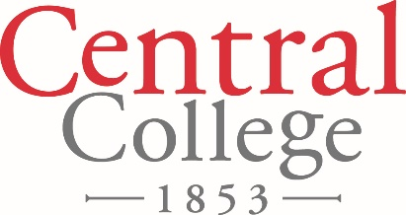

FOR IMMEDIATE RELEASE

August 15, 2018

Contact: Denise Lamphier

641-628-5279

[lamphierd@central.edu](mailto:lamphierd@central.edu)

**Central College Presents Pella Community Invitational at Mills Gallery**

Central College presents the Pella Community Invitational at the Mills Gallery, located in the Lubbers Center for the Visual Arts on Central’s campus. The exhibit will open Wednesday, Aug. 22, through Friday, Sept. 14. The gallery is open Monday-Friday 9 a.m. – 5 p.m.

Every few years, members of the Pella community are invited to exhibit art in the Pella Community Invitational at the Mills Gallery on the Central College campus. Each exhibition features a diverse group of artists representing several media including ceramics, photography, painting and more.

“I vary the group from exhibition to exhibition to include artists from our richly artistic community,” says Treva Reimer, professor of art at Central.

This year’s featured artists are Sallie DeReus, Robert Franks, Joe Hoksbergen, Marlyn Hoksbergen, Mathew Kelly, Brian Roberts and Heidi Schulte. Meet the creators at a reception for the artists, 5:30 p.m. Thursday, Aug. 30 in Mills Gallery.

Central College is a private, residential four-year liberal arts college known for academic rigor strength in global experiential learning, STEM (science, technology, engineering and math) education, sustainability education, athletics, and leadership and service, located in Pella, Iowa. For more information about Central College: [www.central.edu](http://www.central.edu).