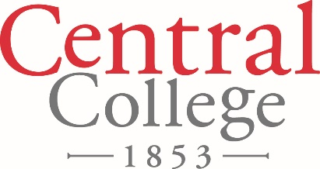

FOR IMMEDIATE RELEASE

August 15, 2018

Contact: Denise Lamphier

641-628-5279

[lamphierd@central.edu](mailto:lamphierd@central.edu)

**Life Beyond the Storm “The Rest of the (Ed Thomas) Story”**

Join the Pella Community Common Reading Experience 2018 for a presentation by Joan Becker, author of “Sentenced to Life: Mental Illness, Tragedy and Transformation.” Becker is the mother of Mark Becker, the young man who shot and killed Ed Thomas, renowned football coach at Aplington-Parkersburg High School, in 2009.

“Joan Becker has a generous spirit and kind heart that come forward in this book,” says U.S. Sen. Chuck Grassley. “By sharing her family’s experience she’ll help other families struggling with mental illness feel less alone. That’s a tremendous accomplishment when the illness causes feelings of isolation and hopelessness for parents who are desperate to help their suffering child. The mental health system can and should be better, and this book inspires all of us to do everything we can to make it so.”

Becker’s presentation, titled “Life Beyond the Storm ‘The Rest of the Ed Thomas Story,’” is scheduled for 7 p.m. Wednesday, Oct. 3 in the Kuyper Fieldhouse on the Central College campus. Participants may also join in a discussion of Becker’s book at 11 a.m. Tuesday, Sept. 25 in Room 202 of Central’s Geisler Library, or noon Thursday, Sept. 27 at the Pella Public Library. To purchase a copy of “Sentenced to Life: Mental Illness, Tragedy and Transformation,” contact The Sanctuary, Gifts on Jefferson or the Central College Spirit Shoppe. The book is also available to check out at the Pella Public Library.

The Pella Wellness Consortium mission drives and encourages collaborative work to implement innovative and sustainable strategies to achieve ultimate health and well-being for all ages within the Pella community.

This program is free and open to the public. Parking for the presentation is available at the corner of Independence and West 5th Street, with handicap parking available on the west side of P.H. Kuyper Gymnasium. The Pella Community Common Reading Experience 2018 is sponsored by Central College and the Pella Wellness Consortium: Central College, Pella Corporation, Pella Regional Health Center, Pella Community School District, City of Pella, Families First of Pella, Precision Pulley & Idler and Vermeer Corporation.

Central College is a private, residential four-year liberal arts college known for academic rigor strength in global experiential learning, STEM (science, technology, engineering and math) education, sustainability education, athletics, and leadership and service, located in Pella, Iowa. For more information about Central College: [www.central.edu](http://www.central.edu).