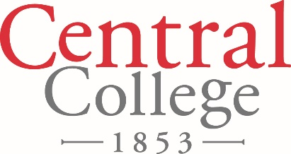

FOR IMMEDIATE RELEASE

September XX, 2018

Contact: Denise Lamphier

641-628-5279

[lamphierd@central.edu](mailto:lamphierd@central.edu)

**Central College Service Day Scheduled for Tuesday, October 30, 2018**

Each year since 2006, Central College hosts a community-wide service day. Classes are cancelled for the day and students, faculty and staff join in serving the local community. This year, for the first time in 12 years, service day will take place in the fall instead of the spring.

Cheri Doane, Central’s director of community-based learning explains why.

“Community partners often express a need for assistance with projects that are unique to fall,” she says. “We also wanted the Intersections classes—interdisciplinary classes required of all Central first-year students—to work together on a project. Research establishes that service is an effective means of helping students bond with each other and their professors. We think connecting students, faculty and staff with our greater community enriches civic life, augments student learning and fosters stronger community relationships.”

A tremendous amount of real work gets done. Each service day, hundreds of Central students, faculty and staff contribute thousands of volunteer hours—valued at approximately $75,000—to complete dozens of projects. Classes are cancelled and Central provides transportation to ensure every student can participate.

And it’s not just for students. Anyone can participate by contacting Central’s Center for Community-Based Learning at [VISTA@central.edu](mailto:VISTA@central.edu) or 641-628-5424.

This years’ project sites include schools, food banks, hospice and health care organizations, community gardens, parks, senior centers and more.

Central College is a private, residential four-year liberal arts college known for academic rigor strength in global experiential learning, STEM (science, technology, engineering and math) education, sustainability education, athletics, and leadership and service, located in Pella, Iowa. For more information about Central College: [www.central.edu](http://www.central.edu).