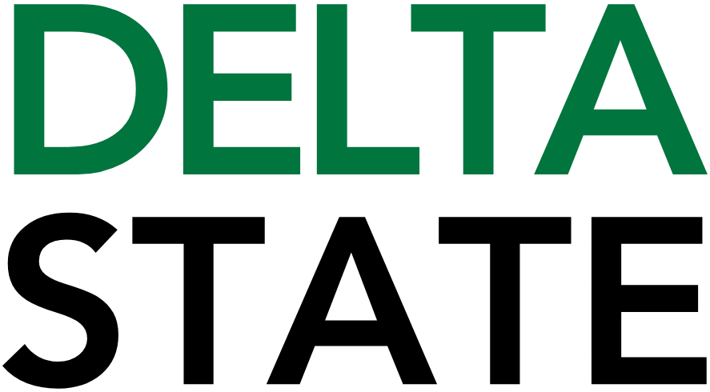

Contact: Nathan Duff FOR IMMEDIATE RELEASE
Phone: (662) 846-4678
Email: nduff@deltastate.edu

Delta State student gains industry insight at global Esri User Conference

CLEVELAND, Miss. — Delta State University geospatial intelligence student Christa Farmer of San Diego, California explored emerging technologies, connected with industry professionals and strengthened ties within the Delta State geospatial community during the 2026 Esri User Conference, held last month in San Diego.
The annual conference brought together more than 18,000 attendees from over 100 countries to examine how geographic information systems and location intelligence are being used to address challenges across government, business, defense, conservation and emergency response.
Farmer attended technical sessions covering artificial intelligence, crime analysis, defense and intelligence security, indoor mapping, satellite imagery and cartographic design. The experience gave her a firsthand look at the technologies and practices shaping the future of the geospatial profession.
Artificial intelligence emerged as a central focus throughout the conference. Farmer learned how Esri is incorporating GeoAI models, AI-assisted workflows and agentic AI into its platforms. Applications presented during the conference included identifying storm damage from imagery, classifying land cover, analyzing crime patterns and querying satellite coverage.
The conference also demonstrated the breadth of the education available through Delta State’s geospatial programs. Farmer encountered current and former Delta State students and instructors throughout the week, reflecting the University’s growing presence within the national and international geospatial community.
“A highlight of the week was connecting with DSU students and instructors, both past and present,” Farmer said. “The sense of community among those who, in one way or another, had a presence within Delta State’s Geospatial program spoke to the impact GIS can have outside the technical space.”
Farmer said sessions on AI-assisted applications showed how emerging tools can help geospatial professionals move more efficiently from data and models to practical solutions. Other presentations offered techniques she can apply directly, including hotspot identification, incident clustering, data normalization, layered security and map design.
“For the geospatial community, and for students getting their first real look at the field’s breadth, the Esri User Conference remains a reminder of just how much ‘where’ can shape what comes next,” Farmer said.
Farmer’s experience reflects Delta State’s emphasis on connecting academic preparation with the people, technologies and professional practices driving the geospatial industry. Through the Interdisciplinary Center for Geospatial Information Technology, students work with the same data, tools and analytical methods used by government agencies, private companies, nonprofit organizations and emergency response professionals.
Delta State professor and alumnus Bobby Horne also attended the conference, strengthening the University’s representation at one of the geospatial industry’s largest professional gatherings. Horne, an Esri employee with experience as a geospatial engineer in the U.S. Army National Guard, supported customers, learned about their applications of GIS and reconnected with Delta State colleagues he had not seen in more than a decade. Horne described the conference as “an inspiring showcase of the latest innovations in GIS” and said the technologies and ideas presented will help prepare Delta State students to use GIS to make meaningful contributions to their communities and the world.
Director of the Interdisciplinary Center for Geospatial Information Technology Talbot Brooks said, "Our students are more than names at the end of a wire. They are our future colleagues, and an online classroom alone will not prepare them for the work. That is why we put sponsor them on the ground in San Diego at the Esri International User’s Conference and arrange to get them in the room with industry leaders. Real-world experience at conferences, working sessions, and small-group mentorship are where our BAS-GAI degree turns into a career."
Delta State recently earned five-year reaccreditation from the United States Geospatial Intelligence Foundation for its Geospatial Analysis and Intelligence Certificate Program and Bachelor of Applied Science in Geospatial Analysis and Intelligence. The bachelor’s program remains the nation’s only USGIF-accredited bachelor’s degree program in the field, while the certificate is among the longest continuously accredited GEOINT programs.
The University’s practitioner-led approach allows students to learn from professionals working with organizations including the Department of Homeland Security, U.S. Army and Esri. Its curriculum emphasizes geographic information systems, remote sensing, intelligence analysis, programming, spatial data management, cartography and visualization.
Combined with opportunities to participate in major professional gatherings such as the Esri User Conference, that approach positions Delta State students to move confidently from the classroom into an industry increasingly central to national security, disaster response, infrastructure management and informed decision-making around the world.
Learn more about Delta State’s geospatial programs at deltastate.edu/git-center.

Cutline: DSU geospatial intelligence student Christa Farmer (2nd from right) joined DSU Adjunct Professor Bobby Horne (center) and other GIT industry professionals the 2026 Esri User Conference, held July 13-17 in San Diego.

###
About Delta State University: Delta State University is a four-year public institution whose nearly 2,800 students come from most U.S. states and more than 45 countries. Acknowledging its beginning as a teacher’s college, the University sustains excellence in teacher education while continuing to expand offerings in traditional as well as unique fields of study. Programs such as those available through the Delta Music Institute, the Commercial Aviation Department, and the Center for Interdisciplinary Geospatial Information highlight the University’s commitment to meeting the evolving needs of the students it serves with world-leading, industry-acclaimed programs. Situated in the heart of the Mississippi Delta, Delta State offers top-notch academic programs in business, arts, sciences, nursing, education, and more. DSU Athletics has won 15 national championships, 70 conference championships, and 37 regional titles.

