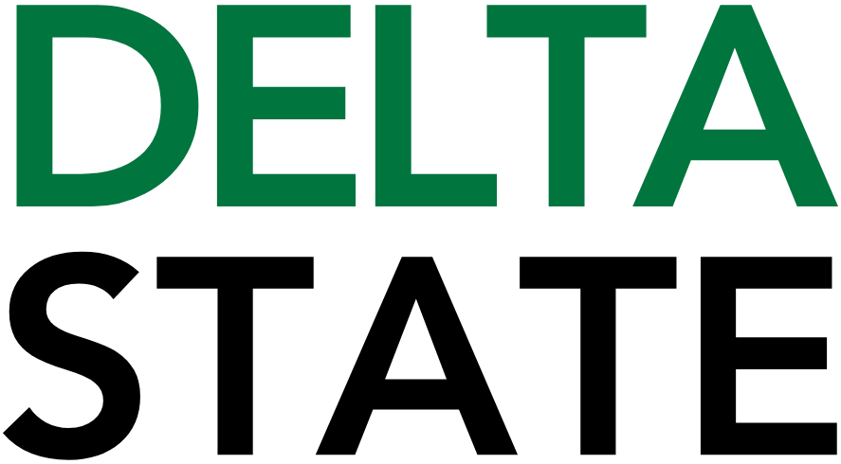

Contact: Nathan Duff FOR IMMEDIATE RELEASE
Phone: (662) 846-4678
Email: nduff@deltastate.edu

Fall 2026 BPAC Mainstage Series unveiled

CLEVELAND, Miss. — The Bologna Performing Arts Center (BPAC) has announced four exciting performances spanning multiple genres and formats for its upcoming Fall 2026 mainstage series, in addition to a comedic add-on and a rescheduled concert. Each of the upcoming shows offers live entertainment to suit a variety of tastes. A special reception with information about each of the acts was held July 7 for annual members at the Farm Rows in Boyle, featuring chef David Crews of Delta Supper Club. Members received a sneak peak of fall season performances before all shows were announced via the BPAC’s social media channels.
The upcoming fall season marks the first season under Executive Director Matty Bengloff's leadership. A local business owner and Delta transplant, Bengloff is focused on bringing the excitement of live performance to the heart of the region.
“We’ve got a new team settling in for our first season together,” said Bengloff. “As we built the lineup, we kept coming back to what an incredible resource this venue is. It’s not every day you find a world-class performing arts center in a rural community, and that allows us to bring in outstanding artists across genres—from rock and R&B to country, like our season opener. It’s something we’re truly proud to offer the Delta.”
Kicking off the fall series is Jamey Johnson, scheduled for Thursday, September 10 at 7:30 PM. Supported by opener Sadie McLayne, Johnson, a ten-time GRAMMY nominee, has been called “one of the greatest country singers of our time,” by The Washington Post. His music has garnered international acclaim and is embraced by fans of classic and contemporary country, as well as Americana and mainstream rock. He is one of only two people in the history of country music (along with Kris Kristofferson) to win two Song of the Year awards in the same year – for “Give It Away” and “In Color” – from the Academy of Country Music and the Country Music Association.
Following the opening concert, a special add-on stand-up performance featuring Heather McMahan is slated for Thursday, September 17 at 7:30 PM. Heather McMahan is an American stand-up comedian, actor, and writer known for transforming everyday chaos into sharply observed, wildly relatable comedy. Born and raised in Atlanta, Georgia, she grew up in a loud, close-knit Southern family, and much of her material springs from that background—her outspoken mother, her Italian-American relatives, and the joyful absurdity of Southern culture. This add-on performance is sponsored by Whole Cellars Package Store.
On Wednesday, September 30 at 7:30 PM, Broadway returns to the Delta with a mid-week performance of Mrs. Doubtfire, The New Musical Comedy. Everyone’s favorite Scottish nanny is headed to Cleveland in “a feel-good, family-friendly comedy that delivers” (The Hollywood Reporter). Based on the beloved film, it’s “the lovable, big-hearted musical comedy we need right now” (Chicago Tribune). Out-of-work actor Daniel Hillard will do anything for his kids. After losing custody in a messy divorce, he creates the kindly alter ego of Scottish nanny Euphegenia Doubtfire in a desperate attempt to stay in their lives. Great for families and classic Broadway lovers, Mrs. Doubtfire is the musical comedy that proves we’re better together.

Following the Broadway performance is the rescheduled Dwight Yoakam concert, which was cancelled due to artist illness in March 2026. The new date for the performance is Thursday, October 15 at 7:30 p.m. Limited seats remain for this performance, as ticket holders to the original show were offered the opportunity to exchange their tickets for the rescheduled date. However, remaining ticket stock will go on sale at the same time as all other performances for the Fall 2026 Mainstage Season during the annual member pre-sales and public on-sale dates, respectively.
Next up is the Atlanta Rhythm Section, scheduled for Thursday, October 29th. They’ve been part of the Southern Rock scene for over 50 years. Their biggest hits include So Into You, Champagne Jam, Imaginary Lover, Homesick, and Spooky. But there’s so much more. With 15 albums of outstanding songwriting and performances, the Atlanta Rhythm Section represents the good things the phrase “classic rock” implies.
Wrapping up the fall 2026 performance roster is Cirque Musica Holiday Wonderland, slated for Tuesday, December 8. A must-see holiday event and beloved tradition for families everywhere, Cirque Musica Holiday Wonderland blends world-class circus artistry with your favorite holiday music for a show unlike anything you’ve experienced. Breathtaking acrobatics, soaring aerial performances, and heart-pounding feats bring the season’s most beloved melodies to live, delivering an unforgettable holiday experience for the whole family.
Additionally, for younger audiences, Pete the Cat by TheatreWorks USA will take place on Friday, November 6 as part of the School-Time Matinee Series. For Pete the Cat, life is an adventure no matter where you wind up. So the minute the groovy blue cat meets The Biddles, he gets the whole family rocking. That is, except for young Jimmy Biddle, the most organized second grader on planet Earth. But when Jimmy draws a blank in art class during the last week of school, it turns out Pete is the perfect pal to help him out! Tickets for this special event are $7 and are available for purchase by contacting the BPAC’s Arts Education office.
Tickets and Sponsorship Information: Annual Members of the Bologna Performing Arts Center will have exclusive access to a ticket presale from July 13-24. To become a member and enjoy early access to ticket sales, visit bolognapac.com/support or call 662-846-4625. Tickets will go on sale to the public on Monday, July 27, along with Series Packages, which include one season ticket to all four performances. Series packages offer a 15% discount across all shows.
The BPAC’s Fall 2026 Series is made possible through the generous support of corporate sponsors, including premier sponsors Bolivar Medical Center, Cannon Motors of Mississippi, Delta Regional Foundation, Gainspoletti Financial Services, Needle Specialty Products Inc., Robinson Electric, Wade Inc., and Whole Cellars Package Store; executive sponsors include Delta Dairy, the Image Specialist of Mississippi, Guaranty Bank, Planters Bank, and Quality Steel. VIP Sponsors are BankPlus, Cleveland Lumber Company, Cleveland State Bank, Cotton House Hotel, Entergy, Flatlanders Printing Company, Renasant Bank, Sunset Florist and Gifts, and Visit Cleveland.
For more information or to purchase tickets, please visit bolognapac.com or call the BPAC box office at 662-846-4626.

Cutline: The Bologna Performing Arts Center has announced its Fall 2026 Mainstage Series. The season features Jamey Johnson, Mrs. Doubtfire, Dwight Yoakam, Atlanta Rhythm Section, Cirque Musica Holiday Wonderland, comedian Heather McMahan, and the School-Time Matinee production of Pete the Cat.

###
About Delta State University: Delta State University is a four-year public institution whose nearly 2,800 students come from most U.S. states and more than 45 countries. Acknowledging its beginning as a teacher’s college, the University sustains excellence in teacher education while continuing to expand offerings in traditional as well as unique fields of study. Programs such as those available through the Delta Music Institute, the Commercial Aviation Department, and the Center for Interdisciplinary Geospatial Information highlight the University’s commitment to meeting the evolving needs of the students it serves with world-leading, industry-acclaimed programs. Situated in the heart of the Mississippi Delta, Delta State offers top-notch academic programs in business, arts, sciences, nursing, education, and more. DSU Athletics has won 15 national championships, 70 conference championships, and 37 regional titles.

