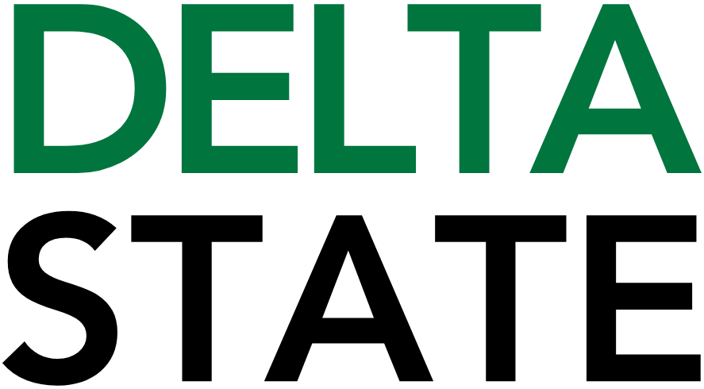

Contact: Nathan Duff FOR IMMEDIATE RELEASE
Phone: (662) 846-4678
Email: nduff@deltastate.edu

Delta Music Institute receives Mississippi Arts Commission grant to support 2027 Summer Camp

CLEVELAND, Miss. — The Delta Music Institute (DMI) at Delta State University has been awarded a $5,000 grant from the Mississippi Arts Commission to support the 2027 DMI Summer Camp, a residential program that introduces high school students to careers in the music and entertainment industry through immersive, hands-on instruction.
The award is part of more than $1.7 million in Fiscal Year 2027 grants distributed by the Mississippi Arts Commission to strengthen arts programming across the state.
The DMI Summer Camp provides students with professional-level experiences in audio engineering, commercial music performance, songwriting and music business while giving participants an opportunity to explore college life and potential career paths in the entertainment industry. Grant funding will help expand access to the program and reinforce Delta State's commitment to arts education, workforce development and creative entrepreneurship.
“We are grateful to the Mississippi Arts Commission for supporting the DMI Summer Camp,” said Dr. Richard Tremmel, Director of the Delta Music Institute. “This grant helps us provide meaningful arts education experiences for young people while encouraging the next generation of Mississippi musicians, producers, songwriters and entertainment industry professionals.”
"The arts consistently demonstrate a positive impact on communities and local economies and are an essential aspect of Mississippi's rich cultural landscape," said David Lewis, Executive Director of the Mississippi Arts Commission. "MAC grants support artists, arts programs, and arts organizations, who in turn reinvest in their communities and enhance quality of life across Mississippi."
Funding for Mississippi Arts Commission grants is provided by the National Endowment for the Arts and the Mississippi State Legislature.
The Mississippi Arts Commission is the state agency responsible for supporting the arts through grants and initiatives that strengthen communities, promote arts education, assist artists and arts organizations and celebrate Mississippi's cultural heritage.
For more information about the Delta Music Institute, visit deltastate.edu/dmi.
For information about the Mississippi Arts Commission, please contact Ellie Banks, Communications Director, 601-359-6546 or ebanks@arts.ms.gov.

###
About Delta State University: Delta State University is a four-year public institution whose nearly 2,800 students come from most U.S. states and more than 45 countries. Acknowledging its beginning as a teacher’s college, the University sustains excellence in teacher education while continuing to expand offerings in traditional as well as unique fields of study. Programs such as those available through the Delta Music Institute, the Commercial Aviation Department, and the Center for Interdisciplinary Geospatial Information highlight the University’s commitment to meeting the evolving needs of the students it serves with world-leading, industry-acclaimed programs. Situated in the heart of the Mississippi Delta, Delta State offers top-notch academic programs in business, arts, sciences, nursing, education, and more. DSU Athletics has won 15 national championships, 70 conference championships, and 37 regional titles.

About The Mississippi Arts Commission: The Mississippi Arts Commission (MAC) is a state agency serving more than two million people through grants and special initiatives that enhance communities, assist artists and arts organizations, promote arts education, and celebrate Mississippi's cultural heritage. MAC is funded by the Mississippi Legislature, the National Endowment for the Arts, and other private sources. For more information, visit www.arts.ms.gov.

