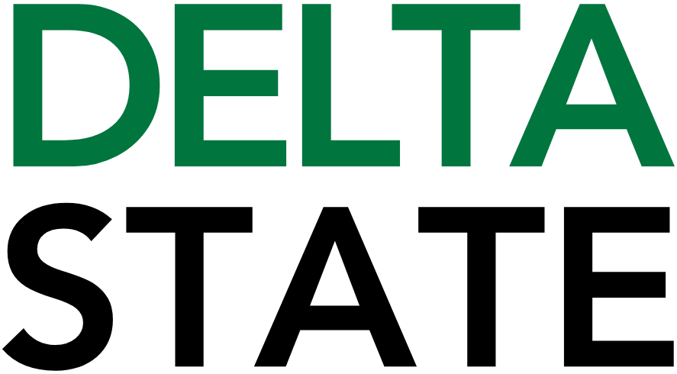

Contact: Nathan Duff FOR IMMEDIATE RELEASE
Phone: (662) 846-4678
Email: nduff@deltastate.edu

Delta Music Institute summer camp inspires future music industry professionals

CLEVELAND, Miss. — Fifteen high school students from Mississippi, Arkansas and Georgia spent a week exploring careers in music and entertainment during the 2026 Delta Music Institute Summer Camp at Delta State University.
Held June 14-19, the residential camp introduced students ages 14-18 to music performance, songwriting, audio production and entertainment industry studies through hands-on experiences with Delta Music Institute faculty, staff and industry professionals.
Throughout the week, students worked in DMI's professional recording studios, classrooms and performance spaces while learning about music creation, recording, production and collaboration. Campers also participated in activities designed to encourage creativity, teamwork and leadership development.
The week included a tour of the Bologna Performing Arts Center, a visit to GRAMMY Museum® Mississippi, a virtual session with DMI Artist-in-Residence Steve Azar and recording sessions in DMI's professional studios. Students also had opportunities to interact with entertainment industry professionals and participate in recreational activities including swimming, bowling, movies and live music events.
"The DMI Summer Camp gives students an opportunity to experience many different aspects of the music and entertainment industry," said Dr. Richard Tremmel, director of the Delta Music Institute. "Whether their interests are in performance, recording, production, artist management or live entertainment, the camp helps them explore potential career paths while developing valuable skills and connections."
A major component of the camp was collaboration. Students spent the week working together on musical projects that were presented during a public showcase performance on the final day of camp. Family members and guests attended the showcase to celebrate the students' accomplishments and the work they completed throughout the week.
The annual camp reflects Delta Music Institute's commitment to providing educational experiences that prepare students for careers across the music and entertainment industries. Delta State University and DMI recently received recognition among Billboard's Top Music Business Schools.
Support for the 2026 Delta Music Institute Summer Camp was provided through grants from the National Endowment for the Arts, the Mississippi Arts Commission and The Kings Daughters & Sons Circle No. 2.
Housed within Delta State University's College of Business and Aviation, the Delta Music Institute offers a Bachelor of Science degree in Entertainment Industry Studies with concentrations in Audio Engineering Technology, Music Business and Live Entertainment Technology. For more information, visit deltastate.edu/business-aviation/delta-music-institute/.

Cutline: High school students from Mississippi, Arkansas and Georgia got hands-on experience in the DMI’s recording studios during the 2026 Delta Music Institute Summer Camp at Delta State University.

###
About Delta State University: Delta State University is a four-year public institution whose nearly 2,800 students come from most U.S. states and more than 45 countries. Acknowledging its beginning as a teacher’s college, the University sustains excellence in teacher education while continuing to expand offerings in traditional as well as unique fields of study. Programs such as those available through the Delta Music Institute, the Commercial Aviation Department, and the Center for Interdisciplinary Geospatial Information highlight the University’s commitment to meeting the evolving needs of the students it serves with world-leading, industry-acclaimed programs. Situated in the heart of the Mississippi Delta, Delta State offers top-notch academic programs in business, arts, sciences, nursing, education, and more. DSU Athletics has won 15 national championships, 70 conference championships, and 37 regional titles.

