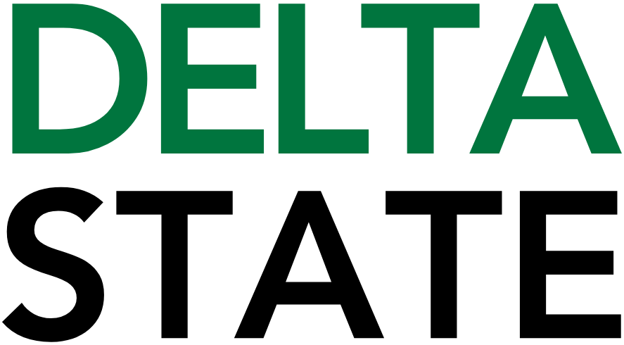

Contact: Nathan Duff FOR IMMEDIATE RELEASE
Phone: (662) 846-4678
Email: nduff@deltastate.edu

BPAC PLUS Camp Registration Now Open

CLEVELAND, Miss. — The Bologna Performing Arts Center on the campus of Delta State University is excited to announce the return of PLUS Camp, a one-week performance and visual arts camp that has been a part of the Janice Wyatt Mississippi Summer Arts Institute for decades. Designed for children ages 5-11 years old, PLUS Camp offers a fun-filled week of creativity, exploration and hands-on learning through the arts. Camp begins on Monday, July 13 and ends with a final performance on the mainstage on Saturday, July 18.
Interested families are encouraged to sign up quickly as there are limited spots available for each age group and some age groups have already reached half capacity.
Held at the Bologna Performing Arts Center on the campus of Delta State University, PLUS campers will learn a choreographed medley of songs while singing individually and with fellow campers. The final performance with professional sound, lighting and production will focus on America’s 250th “Birthday” with a medley of classic patriotic songs, as well as American-themed pop hits released through the decades.
Campers will participate in a variety of visual arts-based classes and workshops in addition to the performance that encourage imagination, teamwork and creativity on the campus of Delta State University. Slated classes will include natural cyanotype development and photography projects, led by Faith Grubb-Sullivan. PLUS Camp is also excited to bring back ceramics, a popular class from previous years led by Pat E. Parker, a Delta State Art Department Alumnus and the 2026 Mississippi Art Instructor of the Year for secondary education.
“I am thrilled to return to my alma mater, Delta State, and share my love of pottery with the campers,” said Parker. “We are going to have a fantastic time making art together!”
PLUS Camp is $250 per camper and includes all art supplies, a camp t-shirt and a daily snack. Registration forms can be picked up at the BPAC ticket office, or families can register online at www.bolognapac.com/mississippi-summer-arts-institute/msai-plus-camp. A $50 non-refundable deposit holds the camper’s spot and parents and guardians can sign up for a flexible installment payment schedule if registering online. A select number of scholarships are available to students with financial need. Contact the Bologna Performing Arts Center at 662-846-4621 for information on how to apply for the scholarship.
“We are so excited to be preparing for one of our favorite events of the year,” said Cade Holder, Director of Marketing and Education at the BPAC. “The kids are full of giggles and nerves at the beginning – they’re shy with their counselors and instructors. But it is amazing to watch those shy kids transform by the end of week and really shine on stage with the support from our instructors, counselors and their new friends.”
Registration for the 2026 camp is now open. Space is limited and early registration is encouraged. For more information, reach out to Bologna Performing Arts Center’s Director of Marketing and Education, Cade Holder, by email at cholder@deltastate.edu or call 662-846-4621.

Cutline: PLUS campers are given the opportunity to participate in a variety of artistic activities and events during the week-long camp held at the Bologna Performing Arts Center.

###
About Delta State University: Delta State University is a four-year public institution whose nearly 2,800 students come from most U.S. states and more than 45 countries. Acknowledging its beginning as a teacher’s college, the University sustains excellence in teacher education while continuing to expand offerings in traditional as well as unique fields of study. Programs such as those available through the Delta Music Institute, the Commercial Aviation Department, and the Center for Interdisciplinary Geospatial Information highlight the University’s commitment to meeting the evolving needs of the students it serves with world-leading, industry-acclaimed programs. Situated in the heart of the Mississippi Delta, Delta State offers top-notch academic programs in business, arts, sciences, nursing, education, and more. DSU Athletics has won 15 national championships, 70 conference championships, and 37 regional titles.

