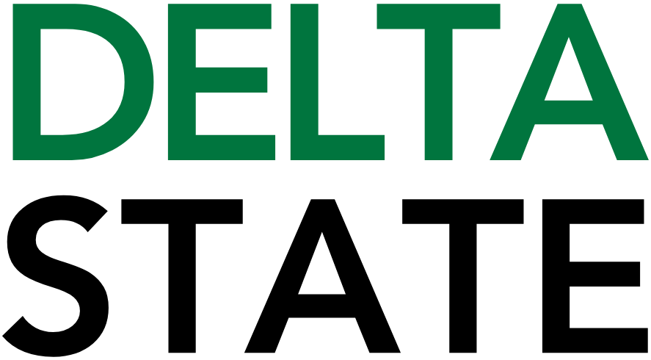

Contact: Nathan Duff FOR IMMEDIATE RELEASE
Phone: (662) 846-4678
Email: nduff@deltastate.edu

BPAC and BMC Partner for $5 Summer Movie Series and Education Activities

CLEVELAND, Miss. — The Bologna Performing Arts Center (BPAC) on the campus of Delta State University is proud to announce the return of its highly anticipated Summer Movie Series for 2026, offering families, summer program students, and movie lovers across the Mississippi Delta an unforgettable season of cinematic entertainment on the big screen.
Running on Tuesdays throughout the summer, this year’s series will feature a carefully curated selection of beloved animated adventures, family-friendly comedies, and heartwarming stories that appeal to multiple generations.
“Our Summer Movie Series has become a fun summer activity for the community, and especially summer program groups,” said Cade Holder, Director of Marketing and Education. “We’re especially excited to feature educational activities prior to the films hosted by our premier sponsor, Bolivar Medical Center.”
Before each film, Bolivar Medical Center (BMC) will be offering engaging wellness adventures combining physical activity, creativity, and nutrition education to help children better understand their bodies—and have fun doing it.
“We absolutely love collaborating with the Bologna Performing Arts Center to offer fun, engaging wellness activities and educational opportunities for our community,” said Caitlyn Thompson, Director of Marketing, Growth and Outreach at Bolivar Medical Center. “The Summer Movie Series provides the perfect setting for kids to enjoy a memorable theater experience while participating in health-focused activities. We’re especially excited for the first show and can’t wait to see all the smiling faces.”
For the first movie slated for June 2, BMC will set up in the BPAC Sculpture Garden with the interactive “Hop Into Their World” Wellness Adventure. This family-friendly experience invites children to “hop” into the world of animals while learning about movement and healthy habits in a playful, hands-on environment.
Kids will stay active in the “Move Like a Hopper” Animal Movement Zone, where they can jump across lily pads like frogs and test their balance like flamingos. The excitement continues with a themed obstacle course where kids hop, crawl, and carry “logs” to construct their own beaver dam—encouraging teamwork, coordination, and problem-solving skills.
In addition to active play, the event promotes creativity and healthy choices. Kids can design their own animal in the Create Your Animal Avatar station and learn what it takes to stay healthy, while the “Fuel Like an Animal” Snack Station offers nutritious options such as “Beaver Bites” and “Bunny Crunch.”
After the activities, kids can move inside to view the film in the state-of-the-art Delta and Pine Land theater at the BPAC, ensuring audiences enjoy high-quality sound and visuals in a cool, comfortable setting—perfect for escaping the summer heat. Showtimes are at 10 am and 2 pm, and films will run on the following dates: June 2, June 16, June 23, June 30, July 7, and July 21.
In keeping with BPAC’s mission to make the arts accessible, tickets for each screening are only $5. Seating will be available on a first-come, first-served basis. Concessions, including popcorn, candies, and beverages, will be available for purchase at each screening.
The BPAC Summer Movie Series is made possible by support from the following Premier Sponsors: Bolivar Medical Center, Cannon Motors, Needle Specialty Products, Robinson Electric Company, Wade, Inc., and Whole Cellars Package Store; Executive Sponsors the Image Specialist, Gainspoletti Financial, Guaranty Bank, Planters Bank, and Quality Steel; and VIP Sponsors BankPlus, Bayer, Cleveland State Bank, Cotton House, the Delta News, Entergy, Renasant Bank, Sunset Florist and Gifts, McAlister’s Deli, and Visit Cleveland.
A complete schedule with titles, ratings, and screening times can be found online at bolognapac.com. For more information about the Summer Movie Series or other upcoming events at the Bologna Performing Arts Center, visit www.bolognapac.com or contact the box office directly at 662-846-4626.

###
About Delta State University: Delta State University is a four-year public institution whose nearly 2,800 students come from most U.S. states and more than 45 countries. Acknowledging its beginning as a teacher’s college, the University sustains excellence in teacher education while continuing to expand offerings in traditional as well as unique fields of study. Programs such as those available through the Delta Music Institute, the Commercial Aviation Department, and the Center for Interdisciplinary Geospatial Information highlight the University’s commitment to meeting the evolving needs of the students it serves with world-leading, industry-acclaimed programs. Situated in the heart of the Mississippi Delta, Delta State offers top-notch academic programs in business, arts, sciences, nursing, education, and more. DSU Athletics has won 15 national championships, 70 conference championships, and 37 regional titles.

