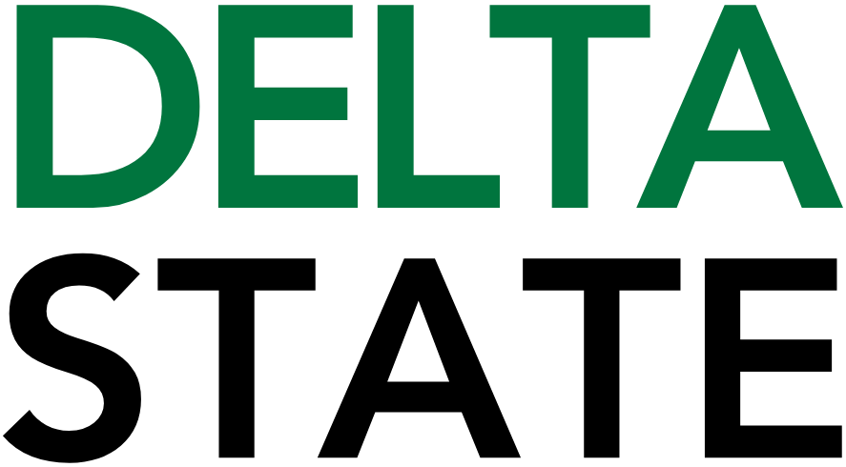

Contact: Nathan Duff FOR IMMEDIATE RELEASE
Phone: (662) 846-4678
Email: nduff@deltastate.edu

Delta State University FBLA partners with RCI Marketing for dynamic workshop

CLEVELAND, Miss. — Delta State University’s chapter of Future Business Leaders of America (FBLA) recently partnered with RCI Marketing to host a hands-on workshop designed to connect students with career opportunities in radio broadcasting and digital marketing.
Led by FBLA President LaTamara Oubre, a senior from Woodville, and supported by chapter advisors Christie Sledge and Tamasa Jackson, the event brought together students from across campus to explore career pathways, internships, and emerging trends in the marketing industry. The workshop reflects FBLA’s continued focus on providing real-world experiences that complement classroom learning.
Representatives from RCI Marketing shared insight into the day-to-day realities of working in media and marketing, highlighting internship opportunities that offer practical experience and a direct pipeline to full-time employment. Students also learned about the flexibility of modern marketing careers, including remote work options, as well as opportunities to travel for broadcasts, engage with diverse audiences, and build experience in an evolving digital landscape.
“This workshop was an incredible opportunity for our members and the student body to connect with industry professionals and explore career possibilities beyond the classroom,” said Oubre. “We are committed to bringing experiences like this to campus that inspire, educate and prepare students for their future careers.”
With approximately 25 active members, Delta State’s FBLA chapter continues to create programming that strengthens professional development, encourages networking and prepares students for success in today’s competitive business environment.
For more information about Delta State University FBLA and upcoming events, visit the College of Business and Aviation website at deltastate.edu/business-aviation/.

Cutline: Representatives from RCI Marketing met with students from DSU’s Future Business Leaders of America to explore career opportunities and marketing strategies during a recent workshop held in Bailey Hall.

###

About Delta State University: Delta State University is a four-year public institution whose nearly 2,800 students come from most U.S. states and more than 45 countries. Acknowledging its beginning as a teacher’s college, the University sustains excellence in teacher education while continuing to expand offerings in traditional as well as unique fields of study. Programs such as those available through the Delta Music Institute, the Commercial Aviation Department, and the Center for Interdisciplinary Geospatial Information highlight the University’s commitment to meeting the evolving needs of the students it serves with world-leading, industry-acclaimed programs. Situated in the heart of the Mississippi Delta, Delta State offers top-notch academic programs in business, arts, sciences, nursing, education, and more. DSU Athletics has won 15 national championships, 70 conference championships, and 37 regional titles.

