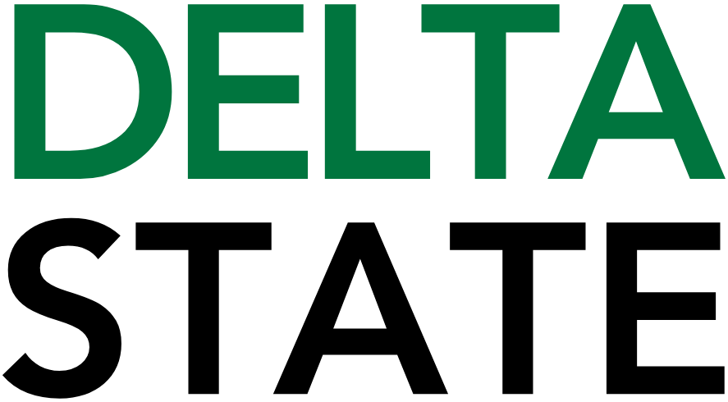

Contact: Nathan Duff FOR IMMEDIATE RELEASE
Phone: (662) 846-4678
Email: nduff@deltastate.edu

Delta State University announces “Centennial Under the Stars” celebration

CLEVELAND, Miss. — Delta State University will bring its historic centennial year to a close with Centennial Under the Stars, a community celebration scheduled for Saturday, April 11, at 6 p.m. at Parker Field–McCool Stadium.
Presented in partnership with the City of Cleveland, the event will serve as the grand finale of Delta State’s Centennial Celebration, marking 100 years since the university opened its doors in 1925 as Delta State Teachers College.
Centennial Under the Stars will feature an evening of live music, Delta cuisine and celebration beneath the Mississippi Delta sky. The program will open with a performance by GranBoiz, followed by a headlining set from City Mix. Guests will also enjoy an open bar and a spectacular drone show finale designed to close out the university’s yearlong centennial observance.
“For 100 years, Delta State University has helped shape the lives of students and the future of the Mississippi Delta,” said DSU President Dr. Daniel J. Ennis. “Centennial Under the Stars is an opportunity for alumni, students, faculty, staff and friends of the university to come together and celebrate the people, traditions and achievements that have defined Delta State for a century.”
The celebration is open to the public and welcomes members of the entire Delta State community.
“Delta State has always been deeply connected to the Cleveland community and the broader Delta region,” said Dr. Suzette Matthews, Vice President of University Advancement and Executive Director of the DSU Foundation. “This event reflects that shared history and invites everyone who cares about Delta State to gather, celebrate and look ahead to the next hundred years.”
Tickets are $50 each, and available now. Guests can reserve their spot online at
https://www.eventcreate.com/e/centennialunderthestars. For any questions, please contact the DSU Foundation at 662-846-4704.
In the event of inclement weather, the event will be relocated to the Delta State Student Union.
Centennial Under the Stars concludes Delta State University’s centennial celebration, a series of events held throughout the year honoring the institution’s legacy of academic excellence, community engagement and cultural impact across the Mississippi Delta.
For more information about Delta State University’s centennial events, visit deltastate.edu/centennial/.

###

About Delta State University: Delta State University is a four-year public institution whose nearly 2,800 students come from most U.S. states and more than 45 countries. Acknowledging its beginning as a teacher’s college, the University sustains excellence in teacher education while continuing to expand offerings in traditional as well as unique fields of study. Programs such as those available through the Delta Music Institute, the Commercial Aviation Department, and the Center for Interdisciplinary Geospatial Information highlight the University’s commitment to meeting the evolving needs of the students it serves with world-leading, industry-acclaimed programs. Situated in the heart of the Mississippi Delta, Delta State offers top-notch academic programs in business, arts, sciences, nursing, education, and more. DSU Athletics has won 14 national championships, 70 conference championships, and 37 regional titles.

