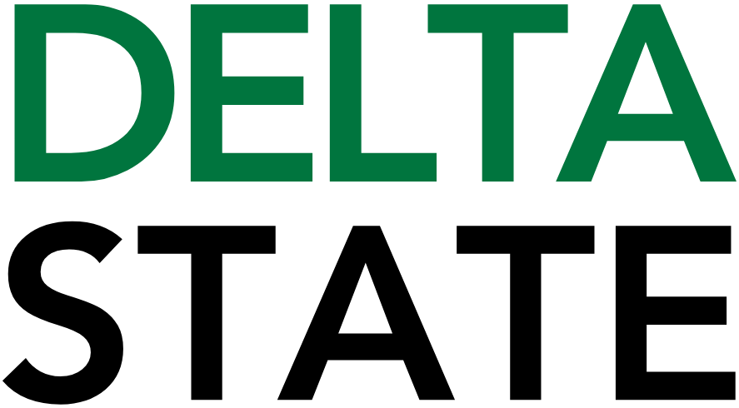

Contact: Nathan Duff FOR IMMEDIATE RELEASE
Phone: (662) 846-4678
Email: nduff@deltastate.edu

DSU marketing students shine at Ole Miss sales competition

CLEVELAND, Miss. — Delta State University marketing students showcased poise and precision at the 2026 Ole Miss Business Applied Sales Experience (BASE) competition in Oxford, held on February 23. Associate Professors of Marketing Dr. Zina Taran and Dr. Lisa Cooley led a three-student team into the intensive two-round event, where top sales students from across the region tested their skills in real-world scenarios.
Representing Delta State were Andrew Dunn of Memphis, Tennessee, Filip Ratkovic of Serbia and Aidan Hayes of Trinidad and Tobago. The competition challenged participants to build rapport, conduct meaningful needs discovery and deliver strategic sales presentations under pressure.
Hayes, the 2025 BASE champion, once again distinguished himself among a strong field of competitors, earning the silver medal this year. Dunn also delivered an impressive performance, advancing through the initial discovery round to compete in the final presentation round.
“These students continue to prove that Delta State can compete with anyone in the room,” said Taran. “BASE is designed to simulate the demands of the professional sales world. Watching our students navigate complex conversations, think critically and close with confidence affirms the strength of our program and their commitment to excellence.”
The team’s preparation extended beyond the classroom. Taran expressed appreciation to the Okra Closet and First United Methodist Church of Cleveland for helping outfit the students for competition, ensuring they represented the University with professionalism and confidence.
Cooley noted that the experience reflects the culture of preparation within the program. “We emphasize applied learning and accountability,” Cooley said. “Competitions like BASE require students to listen carefully, adapt quickly and communicate value clearly. Our students rose to that challenge.”
The two-round format required mastery of both the initial approach and the final close. In Round 1, students focused on gaining attention and uncovering a prospect’s needs. Those advancing to Round 2 delivered a comprehensive solution presentation and asked for a purchase commitment.
“Delta State University’s marketing program prepares students for today’s competitive business environment through hands-on experiences, faculty mentorship and regional and national competitions,” Taran added. “Our goal is to equip graduates with practical skills grounded in behavioral science and real-world application, so they are ready to lead from day one.”
For more information about marketing programs at Delta State University, visit the College of Business and Aviation’s website at www.deltastate.edu/business-aviation/.

Cutline, BASE 1: (L to R) Dr. Zina Taran, Dr. Lisa Cooley, Filip Ratkovic, Aidan Hayes and Andrew Dunn represented Delta State at the 2026 Ole Miss BASE competition held recently in Oxford.
Cutline, BASE 2: Aidan Hayes (right) receives his award from Dr. Matthew Shaner, Director, Ole Miss BASE.
###

About Delta State University: Delta State University is a four-year public institution whose nearly 2,800 students come from most U.S. states and more than 45 countries. Acknowledging its beginning as a teacher’s college, the University sustains excellence in teacher education while continuing to expand offerings in traditional as well as unique fields of study. Programs such as those available through the Delta Music Institute, the Commercial Aviation Department, and the Center for Interdisciplinary Geospatial Information highlight the University’s commitment to meeting the evolving needs of the students it serves with world-leading, industry-acclaimed programs. Situated in the heart of the Mississippi Delta, Delta State offers top-notch academic programs in business, arts, sciences, nursing, education, and more. DSU Athletics has won 14 national championships, 70 conference championships, and 37 regional titles.

