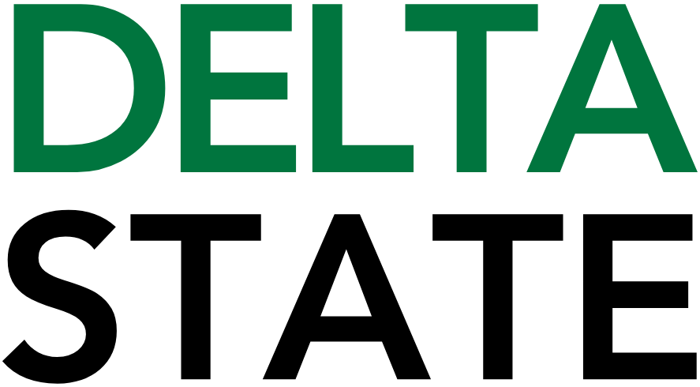

Contact: Nathan Duff FOR IMMEDIATE RELEASE
Phone: (662) 846-4678
Email: nduff@deltastate.edu

Delta State University SGA announces 2026 Big Green Event

CLEVELAND, Miss. — The Student Government Association at Delta State University is excited to announce its upcoming signature community service day, the annual Big Green Event, scheduled for Saturday, March 28, from 9:00 a.m. to 12:00 p.m. This spring tradition unites students, faculty, staff and community members in meaningful service across Cleveland and Bolivar County.
Each spring, the Big Green Event brings Delta State students together to contribute hands-on help wherever it is needed most. From yard work and clean-ups to painting and other service tasks that strengthen our shared spaces and support local organizations, this collective effort lets students express gratitude to the Cleveland community while making a positive impact.
This year’s Big Green Event is seeking project sites that would benefit from volunteer assistance. Projects should be planned to last between one and three hours and can encompass a wide variety of tasks such as yard clean-ups, gardening, organization efforts, basic repairs and more.
Community members, nonprofits, schools, care facilities, parks, animal shelters and other organizations with service needs are encouraged to submit a project request. Interested parties should complete the online form linked through the Campus Life SGA Big Green Event (https://www.deltastate.edu/campus-life/sga/big-green-event/) page by Friday, March 6.
The submission form requests basic details including the best contact information, project location and a description of what assistance is needed. Delta State will provide basic tools for volunteers — such as bags, gloves, rakes, and shovels — while additional specialized supplies must be furnished by the requesting site.
“The Big Green Event is a meaningful way for Delta State students to give back to the Cleveland community,” said Mikayla Kloth, Director of the Big Green Event and a member of the Delta State University SGA Cabinet. “We look forward to supporting local needs and strengthening the bonds between our campus and our neighbors through service.”
For questions or more information, contact the Big Green Event team at sgatbge@deltastate.edu.

Cutline: Each spring, DSU students fan out across Bolivar County to assist with service projects during the Big Green Event.
###

About Delta State University: Delta State University is a four-year public institution whose nearly 2,800 students come from most U.S. states and more than 45 countries. Acknowledging its beginning as a teacher’s college, the University sustains excellence in teacher education while continuing to expand offerings in traditional as well as unique fields of study. Programs such as those available through the Delta Music Institute, the Commercial Aviation Department, and the Center for Interdisciplinary Geospatial Information highlight the University’s commitment to meeting the evolving needs of the students it serves with world-leading, industry-acclaimed programs. Situated in the heart of the Mississippi Delta, Delta State offers top-notch academic programs in business, arts, sciences, nursing, education, and more. DSU Athletics has won 14 national championships, 70 conference championships, and 37 regional titles.

