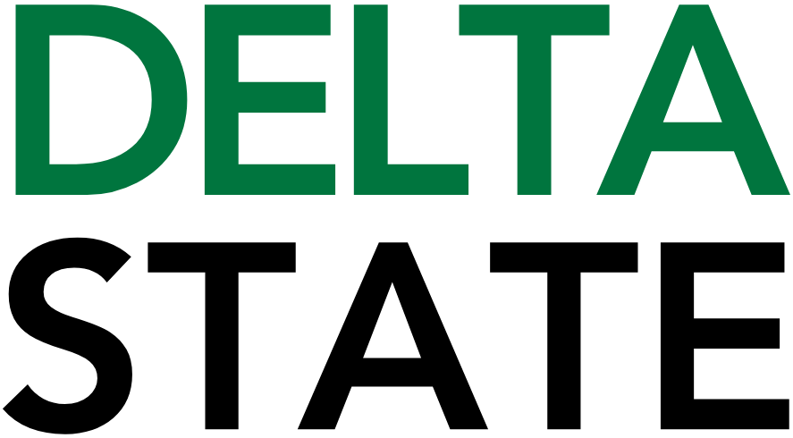

Contact: Nathan Duff FOR IMMEDIATE RELEASE
Phone: (662) 846-4678
Email: nduff@deltastate.edu

Sodexo Dining at Delta State University awarded Swipe Away Hunger grant

CLEVELAND, Miss. — Sodexo Dining at Delta State University has been awarded a Swipe Away Hunger grant in the amount of $3,000. Made possible through Sodexo’s ongoing partnership with the nonprofit Swipe Out Hunger, this grant will directly support local efforts to combat food insecurity on DSU’s campus and in the community.
Sodexo General Manager Taliah Brown applied for the funding to support The Statesman’s Shelf, the university’s on-campus food pantry. The pantry provides essential food and personal care items not only to students, but also to faculty, staff, and community members experiencing food disparities.
“We are thrilled to receive this grant and grateful to Sodexo and Swipe Out Hunger for their commitment to addressing food insecurity,” said Brown. “This funding will have a meaningful impact in expanding The Statesman’s Shelf and helping ensure that everyone in the Delta State family has access to nutritious food.”
The Statesman’s Shelf has become a vital resource for the Delta State community, offering year-round assistance to individuals and families who may be struggling to meet basic needs. With the support of this grant, the pantry plans to expand its inventory, improve accessibility, and continue fostering a campus culture of care and inclusivity.
Sodexo has been a valued partner to Delta State University through its comprehensive campus dining and food service operations. In collaboration with the university, Sodexo manages Delta Dining services, which includes the all-you-care-to-eat Young-Mauldin Cafeteria, convenience options like The Grid, and a food court with national brands in the student union. Delta Dining provides diverse menu options and flexible meal plans for students, faculty and staff.
Swipe Out Hunger is a national nonprofit powering the movement to end college student hunger. The organization collaborates with colleges, legislators, and communities to address food insecurity by championing hunger solutions, building an active network of campuses and partners, and evolving the narrative around today’s college students.
Delta State University and Sodexo Dining remain dedicated to promoting well-being and equity by helping to eliminate hunger and supporting those in need.
For more information about The Statesman’s Shelf or how to get involved, please contact Sodexo Dining at Delta State University or visit the campus dining office.

Cutline: The Statesman’s Shelf is a vital resource for the Delta State and Bolivar County community, as seen during the recent ice storm, when over 200 people in and around campus were able to obtain needed supplies.

###

About Delta State University: Delta State University is a four-year public institution whose nearly 2,800 students come from most U.S. states and more than 45 countries. Acknowledging its beginning as a teacher’s college, the University sustains excellence in teacher education while continuing to expand offerings in traditional as well as unique fields of study. Programs such as those available through the Delta Music Institute, the Commercial Aviation Department, and the Center for Interdisciplinary Geospatial Information highlight the University’s commitment to meeting the evolving needs of the students it serves with world-leading, industry-acclaimed programs. Situated in the heart of the Mississippi Delta, Delta State offers top-notch academic programs in business, arts, sciences, nursing, education, and more. DSU Athletics has won 14 national championships, 70 conference championships, and 37 regional titles.

