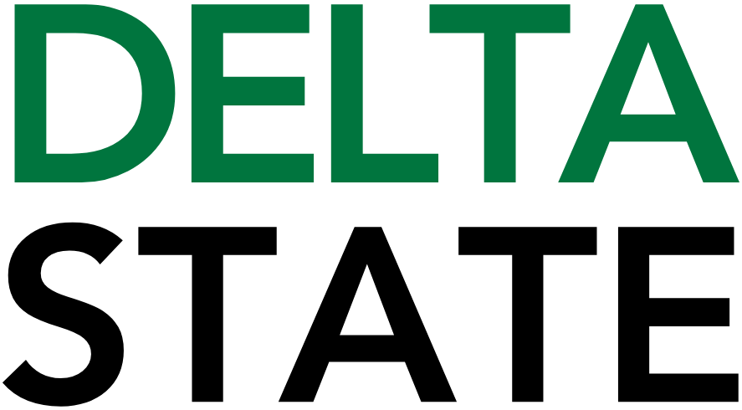

Contact: Nathan Duff FOR IMMEDIATE RELEASE
Phone: (662) 846-4678
Email: nduff@deltastate.edu

DSU biology honors group visits Bell Academy for Halloween

BOYLE, Miss. — On Halloween morning, the usual tricks and treats took a backseat to something far more educational – and delightfully eerie. Four members of Delta State University's (DSU) chapter of TriBeta National Biological Honor Society transformed Bell Academy's 2nd and 5th grade classrooms into interactive biology labs, armed with a full-sized human skeleton model, real vertebrate skeletons (including a turtle, cat, and chicken), assorted bones, and even a preserved horse embryo with its developing bones stained a vivid purple.
Leading the charge was John Clay Hong, a senior Honors Program fellow and TriBeta chapter president from Indianola. Joined by Vice President Donald Coleman, Peyton Bevan, and Layan Asmar—all biology majors—the group borrowed materials from DSU's College of Nursing, Health, and Sciences to deliver hands-on lessons on skeletal structures. "As this year's TriBeta President, I wanted our chapter to focus on four points: academics, professional development, fundraising, and community service," Hong said. "I saw the opportunity to do community outreach and promote science and education by having a thematically appropriate presentation on Halloween with a local elementary school."
Peyton Bevan brought her own inspiration to the project. "One of the main reasons I chose to present the skeletal system overview to the 2nd graders was to uplift the community surrounding Delta State University," she said. "Uplift is one of the Four Cardinal Principles of Omega Psi Phi Fraternity Inc. As Miss Purple and Gold for the Upsilon Delta Delta Chapter here on campus, I take pride in every opportunity to serve. Through this project with some of my fellow members of TriBeta, I was able to give back to the community, inspire young minds, and continue to represent the spirit of Uplift for Omega at DSU."
TriBeta members, drawing on their biology expertise, guided discussions on functional anatomy and evolutionary comparisons. Candy flowed freely, adding to the merriment, while the Halloween timing turned potential "scares" into teachable moments. "Across my years at DSU, I've learned that learning about science can be a matter of asking the right questions," Hong said. "I was glad to see the curiosity those students had about what we showed them on Friday. I hope this event makes the kids think more about biology, makes further connections and opportunities between DSU and Bell Academy, and paves the way for more service through our TriBeta chapter."
This initiative didn't happen in a vacuum. Key partners included Dr. Todd Davis and Krista Davis, who coordinate gardening and nutrition programs at Bell through the Friends of the Cleveland School District. Principal Miranda Hawkins welcomed the group, noting Bell's STEM focus. "The Hallowe’en Skeleton Show presented by John Clay Hong and Beta Beta Beta reflects the best of Delta State," said Professor Don Allan Mitchell, DSU Honors Program advisor. "Partnerships like these show how our Honors Fellows can think big and serve boldly across the Cleveland School District."
Overall, both students and TriBeta members proved that science education can be as engaging as any ghost story. Here's to more bone-rattling outreach from DSU's brightest biology stars. For more information about STEM degrees at Delta State, visit www.deltastate.edu/nursing-health-sciences/.

Cutline: DSU Biology major Donald Coleman shows Bell Academy students (L to R) Kohen Burnside, Carson Walker, Kainan King and Lainey Grimes skeletal models during Beta Beta Beta’s visit to the school.

###

About Delta State University: Delta State University is a four-year public institution whose nearly 2,800 students come from most U.S. states and more than 45 countries. Acknowledging its beginning as a teacher’s college, the University sustains excellence in teacher education while continuing to expand offerings in traditional as well as unique fields of study. Programs such as those available through the Delta Music Institute, the Commercial Aviation Department, and the Center for Interdisciplinary Geospatial Information highlight the University’s commitment to meeting the evolving needs of the students it serves with world-leading, industry-acclaimed programs. Situated in the heart of the Mississippi Delta, Delta State offers top-notch academic programs in business, arts, sciences, nursing, education, and more. DSU Athletics has won 14 national championships, 70 conference championships, and 37 regional titles.

