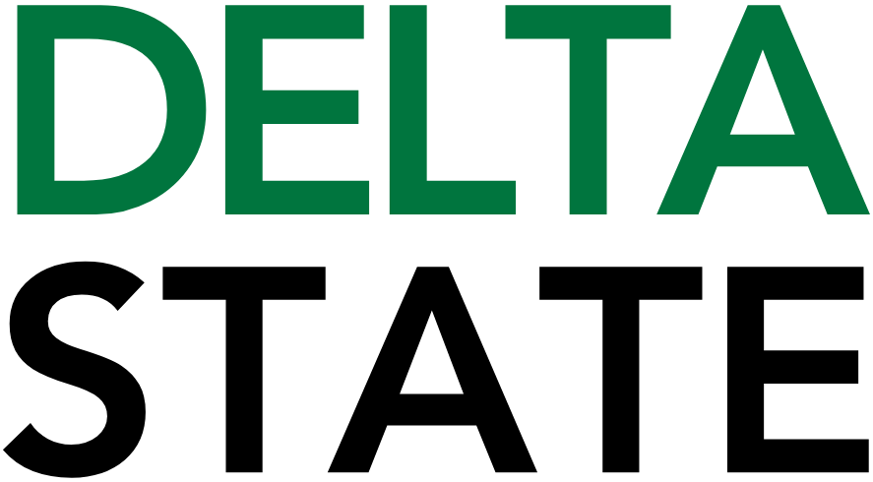

Contact: Nathan Duff FOR IMMEDIATE RELEASE
Phone: (662) 846-4678
Email: nduff@deltastate.edu

BPAC announces Spring ’26 season

CLEVELAND, Miss. — The Bologna Performing Arts Center is thrilled to announce its Spring 2026 season, a vibrant lineup blending Broadway classics, legendary rock icons, country greats and a family-friendly adventure. From the heartwarming spirit of Meredith Willson’s The Music Man to the cosmic thrills of The Magic School Bus Lost in the Solar System, the season promises unforgettable experiences for audiences of all ages.
The season features the Tony Award–winning musical The Music Man; a high-energy performance by classic rock pioneers Blue Öyster Cult; an evening of honky-tonk and soul with country legend Dwight Yoakam; progressive rock mastery from Kansas; the educational and entertaining The Magic School Bus Lost in the Solar System; and a blues-and-soul finale with Taj Mahal and the Phantom Blues Band.
Annual members enjoy exclusive pre-sale access from November 11–21. Memberships, which include pre-sale privileges and other benefits, are available at bolognapac.com.
Tickets go on sale to the public Monday, November 24 at 9:30 a.m. For more information, visit bolognapac.com or contact the Box Office at 662-846-4626.
Season Lineup:
Meredith Willson’s The Music Man
Friday, January 30 7:30 pm
Step right up for a beloved Broadway classic! Join fast-talking Harold Hill and the citizens of River City, Iowa, in this Tony Award–winning musical filled with timeless tunes like “Seventy-Six Trombones” and “Till There Was You.”
Blue Öyster Cult
Thursday, February 19 7:30 PM
Rock out with one of the most influential bands in classic rock history. Blue Öyster Cult takes the stage for a night of electrifying hits and powerful performances.
Dwight Yoakam
Thursday, March 5 7:30 pm
Country legend Dwight Yoakam brings his signature Bakersfield sound and chart-topping favorites for an unforgettable evening of honky-tonk, heart, and soul.
Kansas
Thursday April 9 7:30 pm
Carry on, wayward sons! Experience decades of progressive rock mastery as Kansas performs their iconic hits and fan favorites live on stage.
The Magic School Bus Lost in the Solar System
Tuesday, April 14 6:00 pm
Join us for a special family show and take a wild ride with Ms. Frizzle and her students as they blast off on an out-of-this-world musical adventure! Perfect for families and young explorers, this show combines learning and laughter in one magical journey.
Taj Mahal and the Phantom Blues Band
Tuesday, April 21 7:30 pm
Close out the season with a powerhouse of blues and soul. Legendary artist Taj Mahal joins forces with Phantom Blues Band for a rich, rootsy celebration of American music — the perfect finale to a standout season.
Annual Member Pre-Sale: November 11–21
Members get exclusive early access before tickets go on sale to the public. Join today to enjoy pre-sale access, special perks, and support live arts in our community.
Tickets go on sale Monday, November 24 at 9:30 AM.
For ticket information and more, visit bolognapac.com or contact our Box Office at 662-846-4626.
###
About Bologna Performing Arts Center
The Bologna Performing Arts Center, located at Delta State University in Cleveland, Mississippi, serves as a premier venue for arts and cultural experiences in the region. Offering a wide range of performances from music and dance to theater and education, the Center is committed to bringing world-class talent to the Mississippi Delta while enriching the cultural life of the local community.

About Delta State University: Delta State University is a four-year public institution whose nearly 2,800 students come from most U.S. states and more than 45 countries. Acknowledging its beginning as a teacher’s college, the University sustains excellence in teacher education while continuing to expand offerings in traditional as well as unique fields of study. Programs such as those available through the Delta Music Institute, the Commercial Aviation Department, and the Center for Interdisciplinary Geospatial Information highlight the University’s commitment to meeting the evolving needs of the students it serves with world-leading, industry-acclaimed programs. Situated in the heart of the Mississippi Delta, Delta State offers top-notch academic programs in business, arts, sciences, nursing, education, and more. DSU Athletics has won 14 national championships, 70 conference championships, and 37 regional titles.

