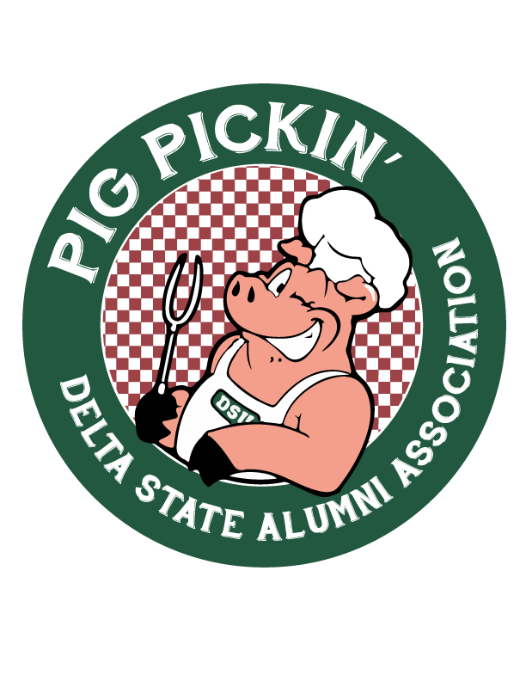

FOR IMMEDIATE RELEASE

Media Contact: Amanda Robinson, Delta State University Advancement Email: [arobinson@deltastate.edu](mailto:arobinson@deltastate.edu)

Phone: (662) 846-4709

Delta State University Alumni Association to Host 40th Annual Pig Pickin’

**CLEVELAND, MS** — The Delta State University Alumni Association is proud to announce the 40th Annual Pig Pickin’, scheduled for Friday and Saturday, September 5-6, 2025, at Statesmen Park.

A cherished tradition since 1985, Pig Pickin’ has grown from a simple alumni gathering into one of the most anticipated events of the year. The tradition was started by Mr. Hugh Ellis Walker and the Alumni-Foundation staff, who invited alumni to gather around Shumate Park to celebrate the first home football game of the season.

Events will include a Mississippi Barbecue Network-sanctioned BBQ competition, live entertainment from the Delta Music Institute, food vendors, pep rally, and Delta State vs. North Greenville football game at Parker Field–McCool Stadium.

BBQ tickets are available for $15 each, which includes a Yo Eddie BBQ plate featuring a pulled pork sandwich, baked beans, coleslaw, and a drink. Guests are encouraged to purchase the official 40th Pig Pickin’ T-shirt and, new this year, a limited edition Pig Pickin’ hat, all available while supplies last.

Tailgating in Statesmen Park has become a Pig Pickin’ tradition. Anyone and everyone is invited to set up a tent and enjoy the activities throughout the day. Tailgating spaces will be available on a first-come, first-served basis—no registration required for general attendees. Attendees are required to bring your own tents, chairs, etc. Campus and student organizations planning to host an official tailgate must complete the tailgating reservation form and register through the Office of the Vice President for Student Affairs to secure designated space.

“For 40 years now, the Alumni Association has been hosting Pig Pickin’ to kick off the football season. This year is no exception,” said Corley Mullins ’06, ’10, ’23, Director of Alumni Affairs. “In addition to the Delta BBQ Brawl competition hosted by MBN, there will be lots of things happening out at Statesmen Park. Visit dsupigpickin.com to see the full schedule of events, and while you’re there, make sure you order this year’s t-shirt or our brand-new camouflage cap

before they sell out. I can’t wait to see Statesmen Park full of alumni, students, and friends on September 6! Bring your tents and chairs and get ready to kick off football season the Delta State way!”

*For more information, full schedule of events, tailgating reservations, and to purchase BBQ tickets, visit* [*www.dsupigpickin.com.*](http://www.dsupigpickin.com/) *To purchase game day tickets, visit* [*www.gostatesmen.com.*](http://www.gostatesmen.com/)

*Link to image*

*Link to full press release from Delta State University Alumni Association*