­­

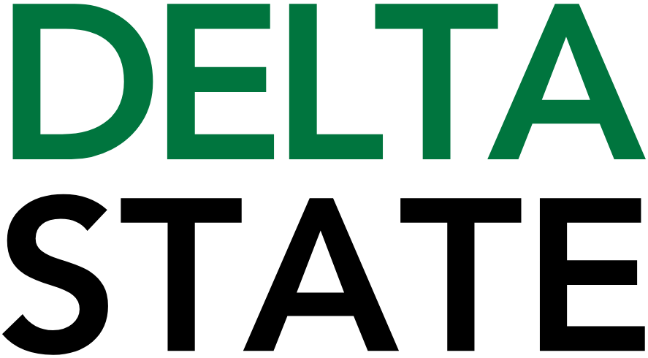

**Contact:** Nathan Duff **FOR IMMEDIATE RELEASE**

**Phone:** (662) 846-4678

**Email:** nduff@deltastate.edu

**Delta State faculty and staff join ChatGPT workshop to advance AI in education**

**CLEVELAND, Miss. —** Faculty and staff from Delta State University recently participated in a ChatGPT workshop at Jackson State University hosted by the Mississippi Artificial Intelligence Network (MAIN) in partnership with the OpenAI Academy. The national initiative is designed to equip educators and academic leaders with cutting-edge knowledge and skills in artificial intelligence (AI).

The workshop connected Delta State with a growing network of forward-thinking institutions committed to using AI to enhance teaching, research, and administrative practices. Attendees engaged in hands-on training, expert-led sessions, and collaborative projects focused on integrating tools such as OpenAI’s ChatGPT into the university’s academic and operational environments.

“Delta State is committed to preparing both our students and our campus for the future of AI,” said Dr. Heather Miller, director of Sponsored Programs and the Gertrude C. Ford Center for Teaching and Learning. “Participation in this workshop positions our faculty and staff at the forefront of this technological shift, where ethical and effective AI use will be critical to higher education.”

Dr. Leslie Griffin, provost and vice president for academic affairs, emphasized the university’s strategic commitment to innovation.

“Our involvement with MAIN and the OpenAI Academy supports Delta State’s focus on academic excellence,” Griffin said. “This initiative gives our faculty and staff the tools they need to thoughtfully and responsibly integrate AI into their work—benefiting students and enriching the educational experience across campus.”

Delta State’s workshop cohort included faculty and staff from a range of university departments, including instructional design, academics, and administration. Participants are contributing to the development of best practices and policies to guide responsible AI use in higher education—supporting Delta State’s mission to cultivate intellectual growth and individual enrichment in service to local, regional, and global communities.

Key takeaways and pilot projects from the MS OpenAI Academy will be shared with the broader campus community beginning in fall 2025.

“Delta State’s participation in this workshop reflects exactly what MAIN was designed to achieve: empowering institutions across Mississippi with the tools, training, and partnerships needed to lead in the age of artificial intelligence,” said Dr. Kollin Napier, director of the Mississippi Artificial Intelligence Network. “It’s inspiring to see faculty and staff embracing AI to enhance education, research, and service.”

Cutline: Faculty and staff from DSU participated in a conference recently to learn more about the latest AI applications for education.

###

**About Delta State University:**Delta State University is a four-year public institution whose nearly 2,700 students come from most U.S. states and more than 45 countries. Acknowledging its beginning as a teacher’s college, the University sustains excellence in teacher education while continuing to expand offerings in traditional as well as unique fields of study. Programs such as those available through the Delta Music Institute, the Commercial Aviation Department, and the Center for Interdisciplinary Geospatial Information highlight the University’s commitment to meeting the evolving needs of the students it serves with world-leading, industry-acclaimed programs. Situated in the heart of the Mississippi Delta, Delta State offers top-notch academic programs in business, arts, sciences, nursing, education, and more. DSU Athletics has won 14 national championships, 70 conference championships, and 37 regional titles.