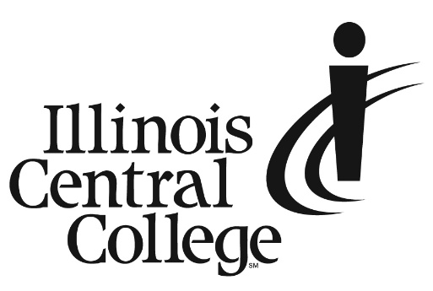

Media Advisory

*MEDIA CONTACT:*   
 *Amanda Lewis*  
*Senior Communications Specialist*

Cell: 309-218-2305

Email: [PR@icc.edu](mailto:PR@icc.edu)

**Press Conference: Local Schools and Organizations Announce $4 Million Perkins Innovation and Modernization Grant**

Date: Thursday, February 15   
Time: 10:00 a.m.   
Location: ICC Peoria Campus Student Center, 5407 N. University St., Peoria, IL (Parking Lot 2)

The U.S. Department of Education awarded a $4 million Perkins Innovation and Modernization Grant to a group of local schools and organizations, including Illinois Central College, Peoria Public Schools, Pekin High School, Illini Bluffs High School, the Peoria Regional Office of Education, SkillsUSA Illinois and the West Central Illinois Building and Construction Trades Council. They will use the grant to centralize work-based learning experiences for high school students to address critical workforce shortages and provide them with pathways to good jobs after graduation.

**Available for interviews:**

* Dr. Sheila Quirk-Bailey, Illinois Central College President
* Dimitri Almas, Illini Bluffs High School Principal
* Dr. Danielle Owens, Pekin Community High School District #303 Superintendent
* Susan Grzanich, Peoria Public Schools District 150 Innovation and Grants Officer and Director, Woodruff Career and Technical Center
* Clint Drury, West Central Illinois Building and Construction Trades Council Executive Director
* Eric Hill, SkillsUSA Illinois Executive Director
* Beth Crider, Peoria Regional Office of Education Regional Superintendent

###

Illinois Central College is a two-year community college with campuses in East Peoria, Peoria, and Pekin, Illinois, providing a high-quality, affordable education to prepare students to enter the workforce or to transfer to a four-year college or university. For more information on ICC, visit icc.edu.