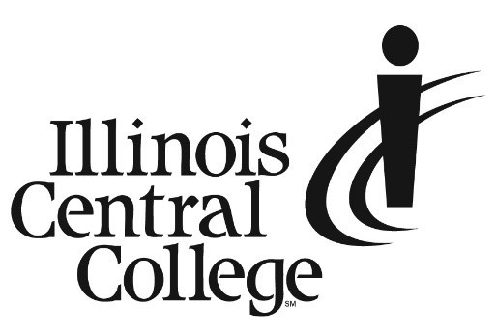 PRESS RELEASE

*MEDIA CONTACT:*

Jennifer O’Neil

Lead Coordinator,

Communications & Media Relations  
Office: (309) 694-5527

Cell: (309) 218-2305

Email: [jennifer.oneil@icc.edu](mailto:jennifer.oneil@icc.edu)

FOR IMMEDIATE RELEASE

**ICC Hosts 60+ Colleges and Universities at College Admissions Fair**

Illinois Central College invites students of all ages to explore over 60 in-state and out-of-state colleges and universities at the upcoming Central Illinois College Fair. Students can meet and talk with admission representatives, discover various programs, learn about the admission process, scholarship and financial aid opportunities, and ask questions.

The fair will take place on Wednesday, October 18, from 6 to 8 PM, at the Illinois Central College CougarPlex in East Peoria.

This expo–style event is perfect for high school students, students looking to transfer, and their families who are seeking to familiarize themselves with many different 4-year colleges or universities.

Advance registration is highly recommended. To register and for a list of colleges and universities attending, please visit <https://go.icc.edu/CollegeFair>.

This event is hosted at Illinois Central College by the Illinois Association for College Admission Counseling.

**Event Details**

**Time/ Date:** 6 – 8 PM, Wednesday, October 18

**Location:** ICC East Peoria Campus, CougarPlex

###

Illinois Central College is a two-year community college with campuses in East Peoria, Peoria, and Pekin, Illinois providing a high-quality, affordable education to prepare students to enter the workforce or to transfer to a four-year college or university. For more information on ICC, visit icc.edu.