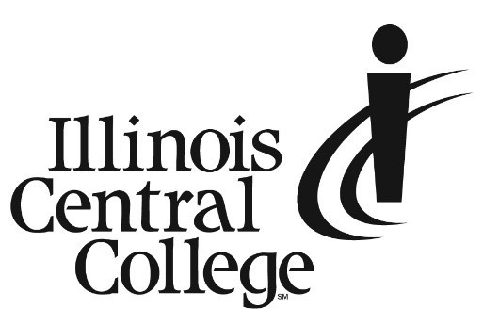

PRESS RELEASE
MEDIA CONTACT:
Jennifer O’Neil
Lead Coordinator,
Communications & Media Relations
Office: (309) 694-5527
Cell: (309) 218-2305
Email: PR@icc.edu

FOR IMMEDIATE RELEASE

Fall Semester Enrollment is Up at Illinois Central College Any Way you Measure It

ICC is celebrating a 7.6% growth in the number of students enrolled (more than 7,500) and an 8.6% increase in the number of credits hours enrolled compared to the previous Fall semester. This represents the biggest freshmen class in 4 years with enrollment up across all major categories including recent high school graduates, dual credit, continuing students, returning stop outs, and upskilling adults. This increase can be attributed to several factors, including better access to financial support through MAP and Pell grants, ICC Scholarships, and apprenticeships. ICC has also expanded workforce development programming, including grant-funded programming for individuals of poverty and short-term programming designed to upskill individuals into waiting jobs. Our IT Workforce Accelerator Grant project continues to provide free IT credentials to individuals looking to certify in the growing and lucrative IT industry.

The President of Illinois Central College, Dr. Sheila Quirk-Bailey, said, “I could not be prouder of everyone on team ICC who continue to align and adjust our schedules, modalities, levels of student support, website design, and other intentional outreach to ensure every student knows they belong at ICC. This upward trend is encouraging and indicates the work we have done as a College over the last several years to remove barriers to student engagement and success is paying off. Increasingly, students are back on campus and the place is just buzzing. It is wonderful to see the cafeteria full and hear students complaining about the walk from the parking lot again.” The student clubs, organizations, and athletics teams are fostering new levels of student engagement after a banner year last year with national champions in SkillsUSA HVAC and Early Childhood as well as 7 additional national and state placement results from the following organizations: Vocal Jazz, Agribusiness Club, Horticulture, Future Business Leaders of America, Phi Theta Kappa, Harbinger Student Media, and Women’s Volleyball.

With over 150 areas of study, extensive financial aid, 700+ scholarships, low-cost and no-cost programs, and countless on- and off-campus services to support students academically, personally, and professionally, Illinois Central College is prepared to meet every student where they are and partner with regional employers to strengthen the workforce.

###
Illinois Central College is a two-year community college with campuses in East Peoria, Peoria, and Pekin, Illinois providing a high-quality, affordable education to prepare students to enter the workforce or to transfer to a four-year college or university. For more information on ICC, visit icc.edu.

