

PRESS RELEASE
MEDIA CONTACT:
Jennifer O’Neil
Lead Coordinator,
Communications & Media Relations
Office: (309) 694-5527
Cell: (309) 218-2305
Email: jennifer.oneil@icc.edu

FOR IMMEDIATE RELEASE

Illinois Central College Selects New Board of Trustees Member

The Illinois Central College Board of Trustees has elected Ron Budzinski of Peoria to join the Board. Budzinski holds a 5-year Bachelor of Architecture degree and has a career background in both architecture and criminal justice.
His other Board of Trustees experience includes the Jobs Partnership Program, Peoria Art Guild, and the League of Women Voters of Greater Peoria. Budzinski has served as Chairman of the Heart of Peoria Commission, as President of the Greater Peoria Area Habitat for Humanity, and as a grant writer and teacher for the Jobs Partnership Program, a program offered in Illinois State Prisons that prepares inmates to retain employment upon release.
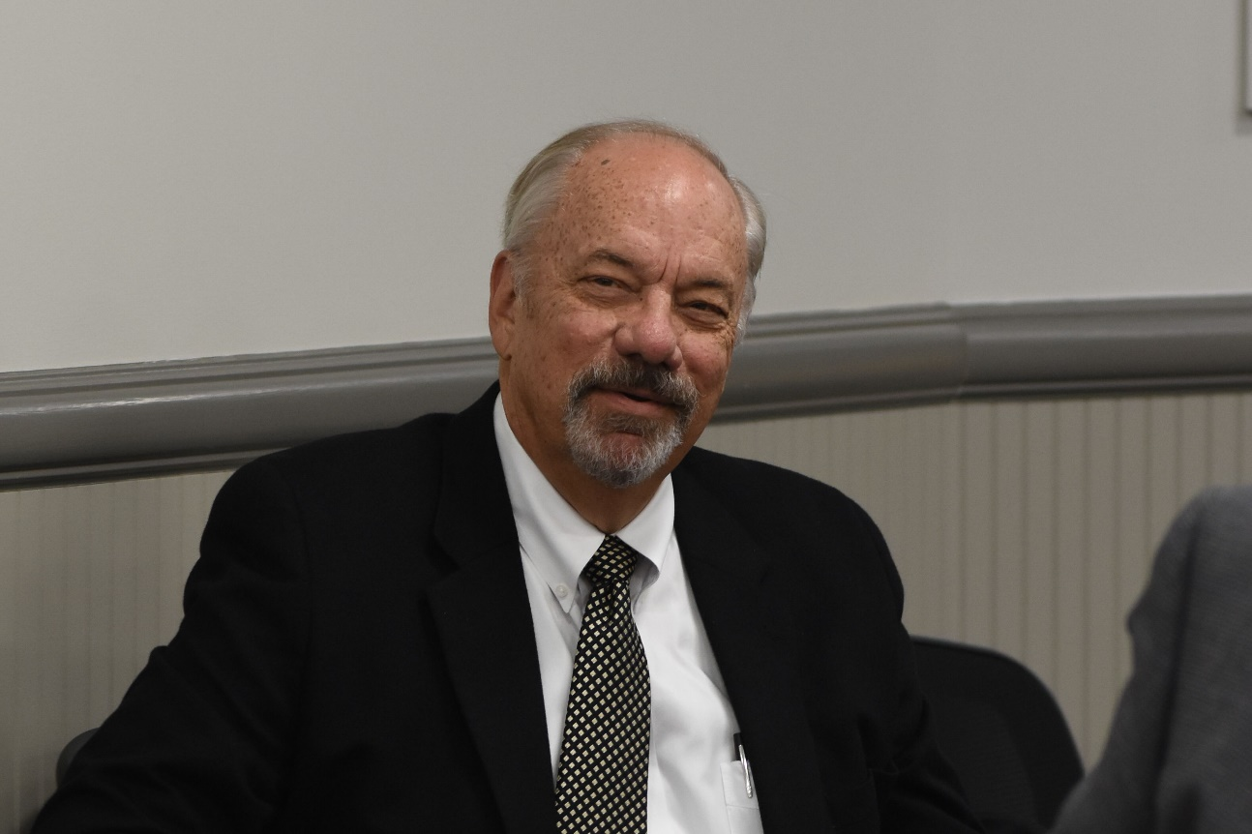
Budzinski’s work with correctional facilities includes being elected to a 6-year term to the American Correctional Association’s Commission on Corrections, where he then served on their Standards and Design Committee. He has also been involved in international conferences on Justice Architecture. Dr. Sheila Quirk-Bailey, President of ICC, said of Budzinski’s posting, “Ron is an excellent addition to the Board.”
This appointment to the ICC Board is not Budzinski’s first encounter with the College. He has taught Architectural Drafting for ICC and has, himself, taken classes in Real Estate and Culinary Arts. He has promoted educational opportunities at ICC to participants in the Jobs Partnership program, focusing on workforce programs like Highway Construction, Health Careers, and Solar.
In serving on the ICC Board of Trustees, Budzinski intends to advance the mission of the College by helping to expand awareness of the opportunities at ICC. He says, “I have seen how ICC can provide educational growth to the unemployed and underemployed” that allows them to achieve family-sustaining wages.
Budzinski fills the seat of retired Board member Bettsey Barhorst and will serve in the role until the next election in April 2025.

###
Illinois Central College is a two-year community college with campuses in East Peoria, Peoria, and Pekin, Illinois providing a high-quality, affordable education to prepare students to enter the workforce or to transfer to a four-year college or university. For more information on ICC, visit icc.edu.

