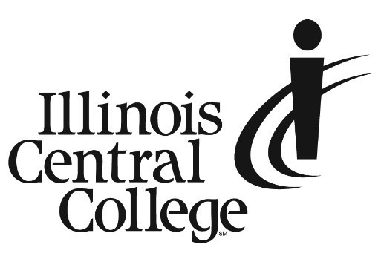

PRESS RELEASE
MEDIA CONTACT:
Jennifer O’Neil
Lead Coordinator,
Communications & Media Relations
Office: (309) 694-5527
Cell: (309) 218-2305
Email: jennifer.oneil@icc.edu
FOR IMMEDIATE RELEASE

Illinois Central College Hosting 9 Other Midwest Agricultural Programs and National Ag Partners at C2A3 Conference

On August 1-3, ICC will host the 2023 conference for the Community College Alliance for Agriculture Advancement (C2A3). The Alliance, formed in 2016, is a partnership among 10 colleges across nine states who have joined together to provide quality education, training, and demonstrations to future farm producers and agriculture service providers. Members of the Alliance partner to share resources, faculty expertise, curriculum, and tools to advance agriculture in their regions. C2A3 Colleges include: Central Lakes College (MN); Clark State College (OH); Illinois Central College (IL); Ivy Tech Community College-Lafayette (IN); Lake Area Technical College (SD); Northcentral Technical College (WI); North Dakota State College of Science (ND); Northeast Community College (NE); Northeast Iowa Community College (IA); and Richland Community College (IL).
On August 3, participants will tour the newly opened Workforce Sustainability Center on the East Peoria ICC Campus and see the College’s state-of-the-art labs and 70-acre research farm. The farm includes a soil pit for testing, cover crops, and wetlands for research of agricultural runoff with the goal of creating safer aquatic ecosystems within our waterways. This research occurs across all C2A3 member colleges to better understand and find a solution to Gulf Hypoxia, an environmental condition in which dissolved oxygen in the water can no longer support aquatic life.
This year, students of participating C2A3 institutions are joining the conference for the first time, which will allow for more robust cross-disciplinary education through exchange of ideas and experiences with students from other states.
The C2A3 conference allows community college leaders, faculty, and now students to discuss ag legislation and policy, attend in-service learning sessions, and collaborate with each other on research in different areas of the country. This will give faculty the latest content to share in class and give students new perspectives about the ag industry.
As a member of C2A3, ICC is committed to constantly improving agricultural processes in our region. This commitment is demonstrated by our responsiveness to local agriculture equipment companies. When Precision Planting approached ICC with a question about a possible new program that would combine agriculture classes with diesel technology, we researched the need of regional ag employers for employees who were qualified to go out in the field to work on precision equipment for farmers. ICC then collaborated with Precision Planting to design a one-year Precision Agriculture Technician Certificate program, which starts in August 2023. Students who complete the program have immediate job prospects with regional employers, including Precision Planting. Participants in the C2A3 conference have the opportunity to visit the Precision Planting Headquarters in Tremont, IL on Wednesday, August 2, to see what the company does and how it is changing agriculture for the better.
ICC ag students can partner with employers in their field for internships and apprenticeships, where the employers evaluate their overall performance based on 23 competencies. These employers are typically located in Central Illinois, but students have gone as far away as Wyoming, Colorado, and even Brazil. Students can choose from four different fields: agronomy, animal science, ag business, and precision agriculture.
Other notable elements of ICC ag programs include a hands-on land lab; state-of-the-art teaching facilities and equipment technology; advanced, funded undergraduate research in topics such as water quality, cover crop usage, soil health, nutrient stewardship, and biological fertilizers; and strong relationships with regional partners, including apprenticeships/earn-and-learn opportunities with Syngenta, Helena, Evergreen FS, and Ag View FS. ICC also boasts a nationally recognized livestock judging team.

For more information about C2A3, go to agalliance.net.

###
Illinois Central College is a two-year community college with campuses in East Peoria, Peoria, and Pekin, Illinois providing a high-quality, affordable education to prepare students to enter the workforce or to transfer to a four-year college or university. For more information on ICC, visit icc.edu.

