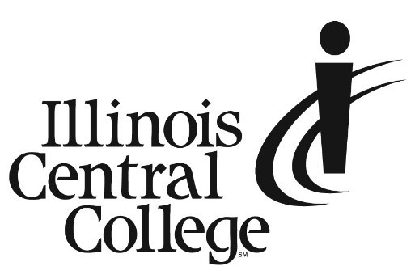

MEDIA ADVISORY
MEDIA CONTACT:
Jennifer O’Neil
Lead Coordinator,
Communications & Media Relations
Office: (309) 694-5527
Cell: (309) 218-2305
Email: jennifer.oneil@icc.edu

MEDIA ADVISORY

7th Annual C2A3 Conference to be Held at Illinois Central College

ICC will host the 2023 conference for the Community College Alliance for Agricultural Advancement (C2A3). The Alliance, formed in 2016, is a collaboration of ten colleges across nine states who have joined together to provide quality education, training, and demonstrations to future farm producers and agriculture service providers. Members of the Alliance partner to share resources, faculty expertise, curriculum, and tools to advance agriculture in their regions. Visit agalliance.net for more information.
On Thursday, August 3, event registrants will rotate through the Land Improvement Contractors of America (LICA) Conservation Expo (licanational.com), the newly opened ICC Workforce Sustainability Center, Soil Pit and Cover Crop Plots, and the Wetland/Bioreactor/Rainfall Simulators on the 70-acre research farm at ICC. Member institutions of C2A3 are committed to constantly improving agricultural processes across the country and this set of campus tours aims to share the work that Illinois Central College is doing in pursuit of that goal.
Press is invited to join the tour and conduct interviews during this event.

THURSDAY, AUGUST 3, 2023
9:00 AM – 12:30 PM

ICC WORKFORCE SUSTAINABILITY CENTER
1 COLLEGE DRIVE
EAST PEORIA, IL 61635

###
Illinois Central College is a two-year community college with campuses in East Peoria, Peoria, and Pekin, Illinois providing a high-quality, affordable education to prepare students to enter the workforce or to transfer to a four-year college or university. For more information on ICC, visit icc.edu.

