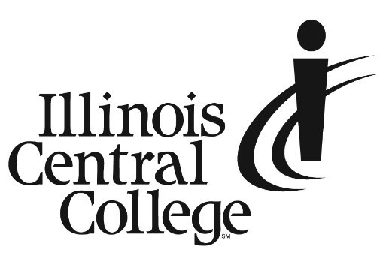

PRESS RELEASE
MEDIA CONTACT:
Jennifer O’Neil
Lead Coordinator,
Communications & Media Relations
Office: (309) 694-5527
Cell: (309) 218-2305
Email: PR@icc.edu

FOR IMMEDIATE RELEASE

Illinois Central College Earns Gold at Skills USA Competition

Illinois Central College brought home gold this year from the 59th annual Skills USA National Leadership and Skills Conference (NLSC), a set of career competition events showcasing the best career and technical education students in the nation.
ICC congratulates Wyatt Rumbold, who brought home gold as our HVACR (Heating, Ventilation, Air Conditioning, and Refrigeration) student. As a gold medalist, Rumbold qualifies to compete internationally. Congratulations also to Noah Wynkoop, who took 5th place in Diesel-Powered Equipment Technology (DPET), and Dawson Stone, who finished 16th in the nation for welding. Dual-credit students from Pekin Community High School represented the ICC Cisco program, as well. Cade Perfetti placed 9th in Internetworking; Jon Wiles finished 7th in Telecommunications Cabling; and Kent Olson took gold in Information Technology Services. Congratulations!
ICC would also like to congratulate HVACR (Heating, Ventilation, Air Conditioning, and Refrigeration) Program Advisor and Professor Brian Weaver and Cisco instructor Eric McCann for their national gold medalists, as well as our DPET instructor Tyler Smith and welding instructor John Runser for helping their students achieve these impressive results.
Visit the Illinois Central College Skills USA Facebook page to view photos and videos of the awards ceremony: https://www.facebook.com/ICCSkillsUSAChapter.
For more information about Skills USA, go to skillsusa.org.

###
Illinois Central College is a two-year community college with campuses in East Peoria, Peoria, and Pekin, Illinois providing a high-quality, affordable education to prepare students to enter the workforce or to transfer to a four-year college or university. For more information on ICC, visit icc.edu.

